CSS BRITISH HISTORY · MA
The Master Anatomy
The syllabus, the thirteen papers of 2015–2026, and the plan — the map you read before anything else

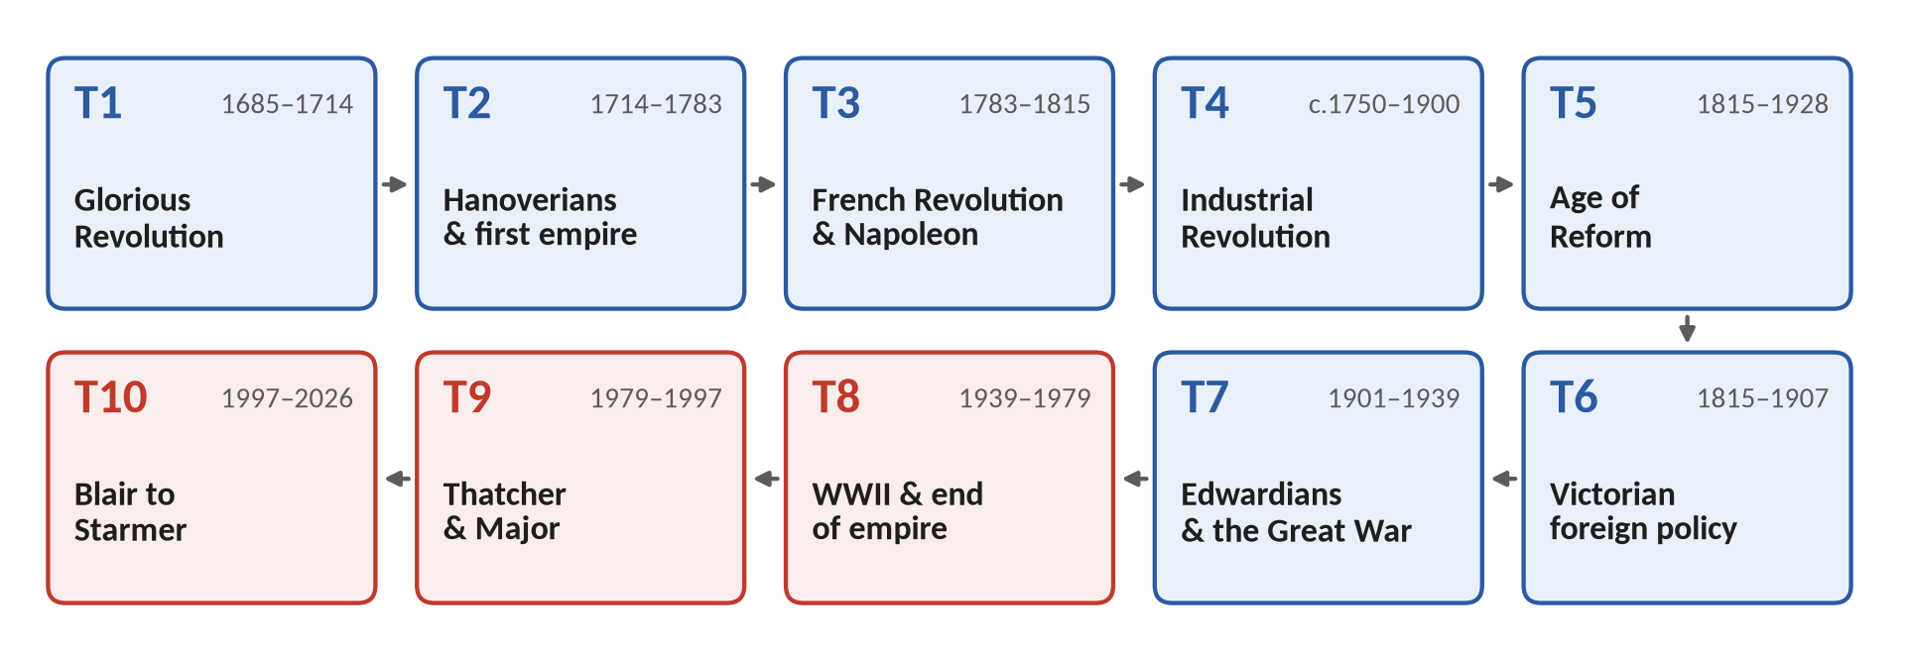
Ten topics, told in the order they happened. Every descriptive question (84), every short-note option (21) and every recoverable MCQ (60) set between 2015 and 2026 has been placed, counted and read. Written for a reader who begins knowing nothing of British history.
Edition of September 2026 · covers the papers of 2015–2026 and British history from 1685 to 2026
Contents
HOW TO USE THIS · Updating the contents and page numbers
The contents below are a live Word field. After any edit, and always before you save as PDF: right-click anywhere in the list → Update Field → Update entire table → OK. The page numbers will then match your copy exactly.

How to Use This Document 7
What this document is 7
Who it is written for 7
The family of documents 8
How the pages are built 8
The reading order 9
Part Zero — British History from Zero 10
0.1 What "British history" means in this paper 10
0.2 Four nations and three unions 11
The four nations 11
The three unions and the partition 12
0.3 The words you must know before anything else 12
0.4 The whole story in fifteen minutes 14
Topic 1 · 1685–1714 · The Glorious Revolution and the later Stuarts 14
Topic 2 · 1714–1783 · Hanoverians, Whigs and the first empire 14
Topic 3 · 1783–1815 · Pitt, the French Revolution, Napoleon and Ireland 15
Topic 4 · c.1750–1900 · The Industrial and Agricultural Revolutions and the new society 15
Topic 5 · 1815–1928 · The Age of Reform, the parties and Ireland 15
Topic 6 · 1815–1907 · Victorian Britain and the world 16
Topic 7 · 1901–1939 · Edwardian Britain, the Great War and the road to 1939 16
Topic 8 · 1939–1979 · The Second World War, Attlee, the Cold War and the end of empire 16
Topic 9 · 1979–1997 · Thatcher and Major 17
Topic 10 · 1997–2026 · Blair to Burnham 17
0.5 Who reigned — and which topic you are in 18
The Prime Ministers you will meet 18
0.6 The syllabus on one map 20
0.7 Five habits of mind for a history paper 21
Part One — The Paper Itself 22
1.1 Where British History sits in CSS 22
1.2 The syllabus, word for word 22
1.3 The suggested readings — which ones actually help 23
1.4 How the paper is built 25
Part I — the objective questions 25
Part II — the descriptive questions 25
The 2015 exception 26
1.5 The asymmetry that decides scores 26
1.6 The marks and the minutes 27
1.7 The thirteen papers at a glance 27
Part Two — Ten Topics: Rebuilding the Syllabus as One Story 30
2.1 Why ten topics, and why in time order 30
2.2 From fourteen heads to ten topics 31
2.3 What each topic adds beyond the syllabus's words 32
2.4 Why the syllabus stops in 2012 — and these notes run to 2026 33
2.5 The two documents each topic gets 33
The Knowledge Base (TnKB) 34
The Question Answers (TnQA) 34
Part Three — The Record: What Has Been Asked, 2015–2026 35
3.1 How the record was built 35
3.2 The heat map 36
How to read it 36
3.3 How much each topic weighs 37
3.4 The repeat engine 38
The families asked three times or more 39
The families asked twice 39
The families asked once 40
Exact and near repeats 40
3.5 The leaks between the sections 42
3.6 The blind spots — syllabus lines never asked 42
3.7 Beyond the syllabus — what the examiner asked that the syllabus never names 43
3.8 The objective paper, 2024–2026 44
What the sixty MCQs teach 46
3.9 How the questions are shaped 46
3.10 The command words, decoded 48
3.11 What changed between 2015 and 2026 49
3.12 Where the next paper could come from 49
Tier 1 — prepare to full-answer depth from every angle 50
Tier 2 — prepare to a full plan and a short-note answer 50
Tier 3 — the blind spots most likely to be broken 50
Part Four — The Ten Topic Dossiers 51
T1 · The Glorious Revolution and the Later Stuarts, 1685–1714 51
What the syllabus asks for 51
What the examiner has asked 51
What the record reveals 52
Blind spots and likely next questions 52
The core in one page 52
What the T1 documents will carry 53
T2 · Hanoverian Britain, the Whig Oligarchy and the First Empire, 1714–1783 53
What the syllabus asks for 53
What the examiner has asked 53
What the record reveals 54
Blind spots and likely next questions 54
The core in one page 54
What the T2 documents will carry 55
T3 · Pitt, the French Revolution, Napoleon and the Union with Ireland, 1783–1815 55
What the syllabus asks for 55
What the examiner has asked 55
What the record reveals 56
Blind spots and likely next questions 56
The core in one page 56
What the T3 documents will carry 56
T4 · The Industrial and Agricultural Revolutions and the New Society, c.1750–1900 57
What the syllabus asks for 57
What the examiner has asked 57
What the record reveals 58
Blind spots and likely next questions 58
The core in one page 59
What the T4 documents will carry 59
T5 · The Age of Reform: Parliament, Parties, Peel, Gladstone and Ireland, 1815–1928 59
What the syllabus asks for 59
What the examiner has asked 60
What the record reveals 60
Blind spots and likely next questions 61
The core in one page 61
What the T5 documents will carry 61
T6 · Victorian Britain and the World: Palmerston to Splendid Isolation, 1815–1907 61
What the syllabus asks for 62
What the examiner has asked 62
What the record reveals 62
Blind spots and likely next questions 63
The core in one page 63
What the T6 documents will carry 63
T7 · Edwardian Britain, the Great War and the Road to 1939 64
What the syllabus asks for 64
What the examiner has asked 64
What the record reveals 65
Blind spots and likely next questions 65
The core in one page 65
What the T7 documents will carry 65
T8 · The Second World War, Attlee, the Cold War and the End of Empire, 1939–1979 66
What the syllabus asks for 66
What the examiner has asked 66
What the record reveals 67
Blind spots and likely next questions 67
The core in one page 67
What the T8 documents will carry 68
T9 · Thatcher and Major: Thatcherism, the Falklands and Europe, 1979–1997 68
What the syllabus asks for 68
What the examiner has asked 68
What the record reveals 69
Blind spots and likely next questions 69
The core in one page 69
What the T9 documents will carry 70
T10 · Blair to Burnham: New Labour, the War on Terror, Crisis and Brexit, 1997–2026 70
What the syllabus asks for 70
What the examiner has asked 70
What the record reveals 71
Blind spots and likely next questions 71
The core in one page 72
What the T10 documents will carry 72
Part Five — How a British History Answer Scores 73
5.1 What the examiner is actually marking 73
5.2 The eight moves 74
Move 1 — the answer map (90 seconds) 74
Move 2 — the introduction (3–5 sentences) 74
Move 3 — the background (one short paragraph) 74
Move 4 — the map or figure 74
Move 5 — the body: the limbs of the question 75
Move 6 — the counter-view 75
Move 7 — the assessment 75
Move 8 — the conclusion 75
5.3 The answer map — the house rule 75
How to build it — five steps 77
5.4 The introduction that earns marks 77
5.5 Headings that repeat the question 77
5.6 Evidence — and the historians worth quoting 78
5.7 Maps and diagrams in a history answer 79
The twelve master maps to practise 80
5.8 The counter-view and the verdict 80
5.9 Short notes — ten marks each 81
5.10 Ten mistakes that cost marks 81
5.11 The objective part in thirty minutes 81
Part Six — The Plan 83
6.1 A sixteen-week plan 83
6.2 How to use each document 84
The Knowledge Base, in three readings 84
The Question Answers, in three passes 84
6.3 The last fortnight 84
6.4 The day of the paper 85
6.5 After the ten topics 85
Appendix A — Every Descriptive Question, 2015–2026, by Year 86
2015 — the former two-paper scheme 86
2016 87
2017 87
2018 88
2019 88
2020 89
2021 89
2022 90
2023 90
2024 91
2025 91
2026 92
Appendix B — The Objective Papers, 2024–2026 93
2024 objective paper 93
2025 objective paper 94
2026 objective paper 95
Appendix C — Sources and Editorial Note 96

How to Use This Document

What this document is
This is not a book of British history. It contains very little history. It is the map you study before you study — and the map you come back to in the last fortnight, when you have to decide what to revise and what to leave.
It does four jobs:
1. It explains the paper. What the syllabus says, how the paper is printed, how many questions you answer, how much time each one gets, and how marks are actually earned.
2. It dissects the record. Every descriptive question from 2015 to 2026 (84 full questions and 21 short-note options) and every recoverable MCQ (60 items, 2024–2026) has been tagged by topic, by "family" (the kind of question it is), by syllabus head and by shape. Out of that come the heat map, the repeat engine, the blind spots and the priorities.
3. It sets up the ten topics. The fourteen syllabus heads are rebuilt into ten topics told in time order, so that the whole paper becomes one continuous story from 1685 to 2026.
4. It gives you a method and a plan. How a British History answer is built, how to draw the answer map (mind map) and the sketch maps, and a sixteen-week timetable.
KEY IDEA · The one idea to hold on to
British History is a story before it is a syllabus. If you know the story in order — who came before whom, what caused what — every question becomes a matter of choosing the right part of the story and arguing about it. That is why these notes are arranged by time, not by the order in which the syllabus happens to list its heads.

Who it is written for
It is written for someone who does not know the ABC of British history: who is not sure of the difference between England and Britain, or between a Whig and a Tory, or why a king would need Parliament's permission to raise money. Nothing is assumed.
- Every technical word is explained the first time it appears, and again in the glossary tables of Part Zero.
- Every date that matters is given, and dates you must memorise are printed in bold teal, like 1688.
- Every key term you must be able to define is printed in bold crimson, like constitutional monarchy.
- The language is deliberately simple. Where a historian's phrase is worth quoting in the exam, it is given in full and explained.

The family of documents
This Master Anatomy is the first of a set. Each of the ten topics then gets two Word documents, and when all ten are finished, four combined documents are built from them.
Document | What it contains | When you use it
MA · Master Anatomy (this) | The syllabus, the dissection of 2015–2026, the ten topics, the method, the plan | First; then again in the last fortnight
T1KB … T10KB · Knowledge Base | The topic told as a story, then broken down: causes, events, results, people, maps, time-lines, historians, one-liner MCQs and a stand-alone revision sheet | While learning each topic
T1QA … T10QA · Question Answers | Every past question on the topic, fully answered with an answer map, sketch map or figure; every short note; the topic's MCQs solved; at most five predicted questions with outlines | After the Knowledge Base; again before the exam
OL · One-Liner Bank | All the topics' one-liner MCQs combined into one bank | Daily, from the first week
QA print volume | Only the questions and answers from all ten QA documents, nothing else, for printing | For reading on paper, away from the screen
RN · Exam-Night Revision | All ten revision sheets combined, each one complete on its own | The night before the paper
PR · Prediction Papers | Three complete predicted papers with answer plans | The last three weeks

How the pages are built
Every document in the set uses the same page furniture, so that you always know what you are looking at.
What you see | What it means
Heading 1 (navy, underlined in crimson) | A Part or a Chapter. It always starts a new page.
Heading 2 (crimson) | A section inside a chapter, numbered like 2.4.
Heading 3 (teal) | A sub-section.
Heading 4 (blue) | A sub-sub-section — the smallest division.
Crimson bold | A key term you must be able to define in one sentence.
Teal bold | A date, number or name you must memorise exactly.
Coloured boxes | Special material — see the samples below.

THE STORY IN SIMPLE WORDS
The story box tells a piece of history in the simplest possible words, as you might tell it to a friend. Read these first.

KEY IDEA
The key idea box holds the one thought that organises a whole section.

WHAT THE EXAMINER HAS ASKED
The examiner box lists where a thing has actually been asked in 2015–2026, so you can see why it matters.

MCQ FACT
The MCQ fact box holds a single fact that has been — or could easily be — asked as an objective question.

TRAP — DO NOT FALL INTO IT
The trap box warns you about a mistake candidates commonly make.

VERDICT
The verdict box gives a clear judgement you can reproduce in an answer's conclusion.

The reading order
1. Read Part Zero slowly. It is the whole of British history from 1685 to 2026 in simple language, with the maps and the monarchs. If you read nothing else today, read that.
2. Read Parts One to Three once, quickly. They explain the paper and the record. You do not need to memorise them.
3. Read the topic dossier in Part Four for each topic just before you begin that topic's Knowledge Base.
4. Read Part Five (method) before you write your first practice answer, and again before your first prediction paper.
5. Return to Part Three and Part Six in the last fortnight to decide what to revise.

Part Zero — British History from Zero
THE STORY IN SIMPLE WORDS · Start here if you know nothing
This Part tells you, in plain words, everything you need before the ten topics begin: what the countries are, what the institutions are, what the main words mean, and — in about fifteen minutes of reading — the whole story from 1685 to 2026. Later documents go into detail. This Part gives you the frame to hang the detail on.

0.1 What "British history" means in this paper
The CSS paper is called British History, but for most of the period it covers there was no single country called Britain. The paper begins in 1688 with a revolution in England; Scotland joins in 1707, Ireland in 1801; most of Ireland leaves in 1922. So the word you use must fit the date you are writing about.
TRAP — DO NOT FALL INTO IT · England, Britain and the UK are not the same thing
Before 1707, write England (or "England and Scotland"). From 1707 to 1800, write Great Britain or Britain. From 1801, write the United Kingdom or Britain. Examiners notice "Britain in 1688" or "England in 1982" — it tells them you do not know the frame. (The past papers themselves often say "England" loosely; you should not.)

The paper covers three things at once, and every good answer keeps all three in view:
- Politics at home — kings and queens, Parliament, parties, Prime Ministers, and how power moved from the Crown to Parliament and then to the voters.
- Society and economy — the Agricultural and Industrial Revolutions, towns, religion, workers' movements, the welfare state, Thatcherism, the 2008 crash.
- Britain and the world — wars with France, the Empire, the Eastern Question, two World Wars, decolonisation, the Cold War, Europe, the War on Terror, Brexit.

0.2 Four nations and three unions
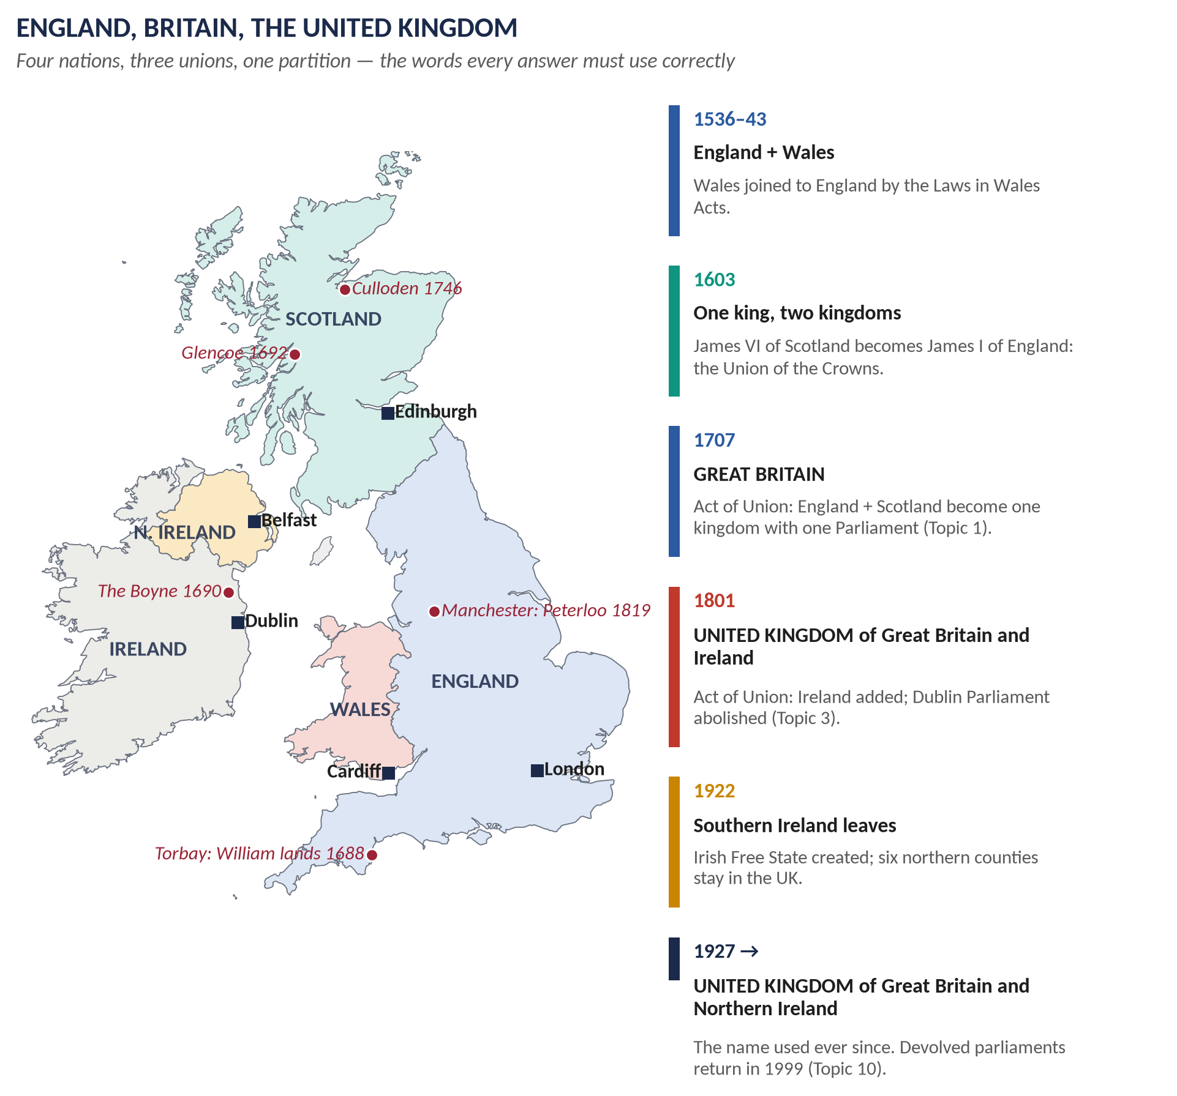
Figure 1 · The British Isles: the four nations, the capitals, and the places where the story turns. The panel on the right shows how England became Great Britain and then the United Kingdom.

The four nations
- England — the largest and richest part, capital London. Most of the story happens here, and Parliament sits here at Westminster.
- Scotland — in the north, capital Edinburgh. A separate kingdom until 1707; it kept its own church (Presbyterian), its own law and its own schools even after union.
- Wales — in the west, capital Cardiff. Joined to England legally in the 1530s–40s, so for this paper it is almost always treated together with England.
- Ireland — the separate island to the west, capital Dublin. Mostly Catholic, ruled by a Protestant landowning class. United with Britain in 1801; the south left in 1922; Northern Ireland (capital Belfast) stayed.

The three unions and the partition
Date | What happened | Why it matters in the paper
1603 | Union of the Crowns: James VI of Scotland also becomes James I of England | Two kingdoms, one king, two parliaments — an unstable arrangement
1707 | Act of Union: England and Scotland become the Kingdom of Great Britain, with one Parliament | Topic 1. Asked directly in 2021
1801 | Act of Union: Great Britain and Ireland become the United Kingdom of Great Britain and Ireland | Topic 3. Asked in 2025; MCQ in 2026
1922 | Southern Ireland leaves as the Irish Free State; six northern counties stay | Topic 5 and 7. The end of the Irish Question as it stood in the 19th century
1999 | Devolution: Scottish Parliament, Welsh Assembly (now Senedd), Northern Ireland Assembly | Topic 10. Part of Blair's constitutional reforms

0.3 The words you must know before anything else
These words appear on almost every page of every topic. Learn them now; each Knowledge Base repeats and deepens them.
Word | What it means, simply
The Crown / monarch | The king or queen. In 1688 the monarch still chose ministers and ran the government; by 1900 the monarch reigned but did not rule.
Parliament | The law-making body at Westminster: the monarch, the House of Lords and the House of Commons together.
House of Commons | The elected house. It controls money (taxes). Over the whole period it becomes the centre of power.
House of Lords | The unelected upper house of nobles and bishops. Its power was cut by the Parliament Act of 1911.
Prime Minister | The head of the government. The first is usually taken to be Robert Walpole (1721–1742). The PM governs because he or she commands a majority in the Commons.
Cabinet | The group of senior ministers who decide policy together under the Prime Minister.
Constitutional monarchy | A system where the monarch is head of state but must govern through ministers responsible to Parliament. Born in 1688–89.
Divine right of kings | The belief that kings are appointed by God and answer only to God. The Stuarts believed it; 1688 ended it.
Whig | The party that supported the Glorious Revolution, the Protestant Hanoverian kings, and Parliament's power. Later becomes the Liberal Party.
Tory | The party of the Crown, the Church of England and the landed gentry. Later becomes the Conservative Party (from the 1830s, under Peel).
Labour Party | Founded 1900 (as the Labour Representation Committee) to put working men into Parliament. Replaces the Liberals as the main rival of the Conservatives after 1918–1924.
Protestant / Catholic | The two great divisions of Western Christianity. England's official church (the Church of England) is Protestant; a Catholic king in the 1680s terrified most of the political class.
Dissenters / Nonconformists | Protestants outside the Church of England (Baptists, Quakers, later Methodists). Tolerated after 1689 but kept out of public office until 1828.
Jacobite | A supporter of the exiled Catholic Stuart line (from Jacobus, Latin for James). They rose in 1715 and 1745.
Franchise | The right to vote. Widened by the Reform Acts of 1832, 1867, 1884, 1918 and 1928.
Rotten borough | A constituency with almost no voters that still elected MPs — a symbol of the unreformed Parliament before 1832.
Empire / colony / Dominion | The Empire is all the lands ruled from London. A colony is ruled directly. A Dominion (Canada 1867, Australia 1901, New Zealand 1907, South Africa 1910) is self-governing.
Commonwealth | The free association of Britain and its former colonies. Its modern form dates from the London Declaration of 1949.
Free trade / protection | Free trade means no taxes on imports; protection means tariffs to shield home producers. The great Victorian argument, decided for free trade by the repeal of the Corn Laws in 1846.
Splendid Isolation | Britain's late-Victorian policy of avoiding permanent alliances. Abandoned between 1902 and 1907.
Appeasement | Avoiding war by giving in to reasonable-looking demands — Chamberlain's policy towards Hitler, ending at Munich in 1938.
Welfare state | The system of state benefits, free health care (NHS 1948) and social insurance built by Attlee's Labour government.
Decolonisation | The process by which the colonies became independent — mostly between 1947 and the late 1960s.
Thatcherism | Margaret Thatcher's mix of free markets, privatisation, curbing trade unions, low inflation and a strong state (1979–1990).
New Labour | Tony Blair's re-branded Labour Party (1994 onwards): market economy plus social investment — the "Third Way".
Brexit | Britain's exit from the European Union: referendum 23 June 2016, departure 31 January 2020.

0.4 The whole story in fifteen minutes
THE STORY IN SIMPLE WORDS · Read this as one continuous story
Each paragraph below is one of the ten topics, in order. The detail comes later. For now, just follow the thread: power moves from the Crown to Parliament, then from Parliament to the people; Britain rises to world power through war, trade and industry; then the Empire ends and Britain searches for a new role.

Topic 1 · 1685–1714 · The Glorious Revolution and the later Stuarts
In 1685 James II, a Catholic, became king of a Protestant country. He tried to give Catholics equal rights by royal command (the Declarations of Indulgence), appointed Catholics to the army and universities, and in 1688 his wife gave birth to a Catholic son. Leading politicians invited his Protestant son-in-law, William of Orange, ruler of the Dutch Republic, to invade. William landed at Torbay on 5 November 1688; James's support collapsed and he fled to France. Parliament gave the crown jointly to William III and Mary II and passed the Bill of Rights (1689): the monarch could no longer suspend laws, raise taxes or keep an army in peacetime without Parliament. This was the Glorious Revolution — "glorious" because it was almost bloodless in England and because it settled for ever that the Crown rules under Parliament. William took England into his wars against Louis XIV of France (the Nine Years' War, ended by the Treaty of Ryswick, 1697). Queen Anne (1702–1714) fought the War of the Spanish Succession, won by the Duke of Marlborough at Blenheim (1704) and ended by the Treaty of Utrecht (1713), which gave Britain Gibraltar and a place among the great powers. In 1707 the Act of Union joined England and Scotland into Great Britain. The Act of Settlement (1701) had already fixed that the crown would pass to the Protestant House of Hanover.

Topic 2 · 1714–1783 · Hanoverians, Whigs and the first empire
In 1714 George I, a German prince, became king. The Tories were suspected of favouring the exiled Stuarts, so the Whigs ruled for almost fifty years — the Whig oligarchy. Their greatest leader, Sir Robert Walpole (1721–1742), is counted as the first Prime Minister: he kept the peace, kept taxes low and managed Parliament through patronage ("let sleeping dogs lie"). The exiled Stuarts tried twice to return — the Jacobite rebellions of 1715 and 1745; the second, led by "Bonnie Prince" Charles Edward Stuart, reached Derby before being crushed at Culloden (1746). Meanwhile Britain built an empire of trade based on the Old Colonial System (mercantilism: colonies exist to enrich the mother country), on sugar islands in the Caribbean, and on the Atlantic slave trade. Under William Pitt the Elder (later Lord Chatham) Britain won the Seven Years' War (1756–1763): Canada from France, dominance in India after Plassey (1757). But the cost led Parliament to tax the American colonists, who had no MPs — "no taxation without representation". The American War of Independence (1775–1783) ended with the Treaty of Paris (1783) and the loss of thirteen colonies under George III and Lord North.

Topic 3 · 1783–1815 · Pitt, the French Revolution, Napoleon and Ireland
The young William Pitt became Prime Minister at 24 in 1783 and rebuilt the nation's finances. Then in 1789 the French Revolution overthrew the French monarchy. At first many Britons cheered; then came the Terror, the execution of Louis XVI, and war (from 1793). Frightened of revolution at home, Pitt's government suspended habeas corpus, banned "seditious" meetings and outlawed trade unions (the Combination Acts, 1799–1800). Edmund Burke attacked the Revolution; Thomas Paine defended it — the great argument of the age. In 1798 Ireland rose in rebellion with French help; Pitt's answer was the Act of Union (1801), abolishing the Irish Parliament and creating the United Kingdom. The war against Napoleon was won at sea by Nelson at Trafalgar (1805) and on land by Wellington in Spain and finally at Waterloo (18 June 1815). The Congress of Vienna (1815) redrew Europe and left Britain the world's leading power.

Topic 4 · c.1750–1900 · The Industrial and Agricultural Revolutions and the new society
Across the same years, Britain's economy changed as no economy had before. Enclosure and new farming methods (the Agricultural Revolution) fed a growing population and pushed labourers off the land. Coal, iron, steam power (James Watt's engine, patented 1769), canals, cotton factories and, after 1830, railways created the Industrial Revolution. Britain became "the workshop of the world". New towns like Manchester grew fast and filthy; children worked in mills; wages and hours were brutal. New ideas and movements answered this new world: Methodism (founded by John Wesley from the 1730s), which brought religion to the poor; Utilitarianism (Jeremy Bentham: "the greatest happiness of the greatest number"); Liberalism (free trade, individual liberty); Socialism (Robert Owen, later the Fabian Society, 1884); and Chartism (1838–1848), a mass movement demanding votes for all men, which failed at the time but whose demands were almost all granted later.

Topic 5 · 1815–1928 · The Age of Reform, the parties and Ireland
After 1815 the unreformed Parliament faced angry demands for change — the Peterloo massacre in Manchester (1819) showed how brutal the old order could be. The Tories under Lord Liverpool, then Canning and Wellington, reformed slowly (Catholic Emancipation, 1829). The Whigs under Earl Grey passed the Great Reform Act (1832), abolishing rotten boroughs and giving the vote to the middle class; the short reign of William IV (1830–1837) saw a flood of reforms (abolition of slavery in the Empire, 1833; the Factory Act, 1833; the New Poor Law, 1834; municipal reform, 1835). Sir Robert Peel turned the Tories into the Conservative Party (Tamworth Manifesto, 1834) and, as Prime Minister (1841–1846), repealed the Corn Laws (1846) during the Irish Famine — splitting his party. Out of that split came the modern two-party system: Gladstone's Liberals against Disraeli's Conservatives. Further Reform Acts (1867, 1884) gave the vote to working men; secret ballot came in 1872. Gladstone's great mission was Ireland — disestablishing the Irish Church (1869), land acts, and two failed Home Rule Bills (1886, 1893). Women over 30 won the vote in 1918, and on equal terms with men in 1928.

Topic 6 · 1815–1907 · Victorian Britain and the world
Abroad, Britain's aim was simple: keep the balance of power in Europe, protect the sea routes to India, and trade freely everywhere. Lord Palmerston (Foreign Secretary and later Prime Minister) defended British interests aggressively — "gunboat diplomacy" and the Don Pacifico affair (1850). The Eastern Question — what should happen as the Ottoman Empire weakened, and how to stop Russia gaining from it — produced the Crimean War (1854–1856) and, under Disraeli, the Congress of Berlin (1878), from which he returned claiming "peace with honour". Disraeli bought shares in the Suez Canal (1875) and made Victoria Empress of India (1876). Late in the century Britain joined the Scramble for Africa and fought the Boer War (1899–1902). Under Lord Salisbury Britain stood apart from Europe's alliances — Splendid Isolation — until the rise of Germany ended it: the Anglo-Japanese Alliance (1902), the Entente Cordiale with France (1904) and the Anglo-Russian Convention (1907).

Topic 7 · 1901–1939 · Edwardian Britain, the Great War and the road to 1939
Edward VII (1901–1910) gave his name to a short, confident age. The Liberal governments of Campbell-Bannerman and Asquith (from 1905) laid the foundations of the welfare state (old-age pensions 1908, National Insurance 1911) and, after Lloyd George's "People's Budget", cut the power of the Lords (Parliament Act, 1911). The new Labour Party won 29 seats in 1906. Then Europe went to war: Britain declared war on Germany on 4 August 1914 after the invasion of Belgium. The First World War killed about 750,000 British servicemen, brought conscription, women into factories and the vote for women, and destroyed the Liberal Party, which split between Asquith and Lloyd George. The Treaty of Versailles (28 June 1919) and the League of Nations were meant to prevent another war. They did not. After the Great Depression (1929 onwards) and the rise of Hitler, Neville Chamberlain tried appeasement, culminating in the Munich Agreement (1938), while rearming — until Germany invaded Poland and Britain declared war on 3 September 1939.

Topic 8 · 1939–1979 · The Second World War, Attlee, the Cold War and the end of empire
Winston Churchill led Britain from May 1940 through Dunkirk, the Battle of Britain and the Blitz to victory in 1945 in alliance with the USA and the USSR; the wartime conferences (Tehran, Yalta, Potsdam) and the United Nations (1945) shaped the post-war world. Voters then chose Clement Attlee's Labour government (1945–1951), which built the welfare state and the NHS (1948) and nationalised coal, rail and the Bank of England. The Cold War divided the world; Britain helped found NATO (1949) and kept a "special relationship" with the USA. The Empire ended: India and Pakistan became independent in August 1947; Britain left Palestine in 1948; the Suez Crisis (1956) showed that Britain could no longer act against American wishes; Macmillan's "wind of change" speech (1960) signalled the end in Africa. Britain turned to Europe, was vetoed twice by France (1963, 1967), and joined the EEC in 1973. The 1970s brought inflation, strikes and the "Winter of Discontent" (1978–79) under James Callaghan.

Topic 9 · 1979–1997 · Thatcher and Major
Margaret Thatcher, Britain's first woman Prime Minister (1979–1990), set out to reverse decline: she fought inflation, cut the power of the trade unions (defeating the miners' strike, 1984–85), privatised state industries, sold council houses and freed the City of London. She won the Falklands War against Argentina (1982) and stood with Reagan in the last years of the Cold War, while fighting Brussels over money and sovereignty. Her own party removed her in 1990 over Europe and the poll tax. John Major (1990–1997) signed the Maastricht Treaty (1992) that created the European Union, won a surprise election in 1992, then lost authority after "Black Wednesday" (Britain forced out of the ERM, 16 September 1992) and party splits over Europe, losing heavily in 1997.

Topic 10 · 1997–2026 · Blair to Burnham
Tony Blair's New Labour won a landslide in 1997: Bank of England independence, devolution to Scotland and Wales, the Good Friday Agreement in Northern Ireland (1998), the minimum wage and the Human Rights Act. After the attacks of 11 September 2001 Blair stood "shoulder to shoulder" with the USA in Afghanistan (2001) and Iraq (2003) — the War on Terror — and London suffered the 7/7 bombings (2005). Gordon Brown (2007–2010) faced the 2008 global financial crisis. David Cameron led a Conservative–Liberal Democrat coalition (2010–2015) that imposed austerity, then called the EU referendum, which Leave won on 23 June 2016. Theresa May and Boris Johnson negotiated Brexit (left the EU 31 January 2020); Johnson led through the COVID-19 pandemic; Elizabeth II died in September 2022 and Charles III succeeded; Liz Truss lasted 49 days; Rishi Sunak steadied the finances; and Keir Starmer won a Labour landslide on 4 July 2024.

0.5 Who reigned — and which topic you are in
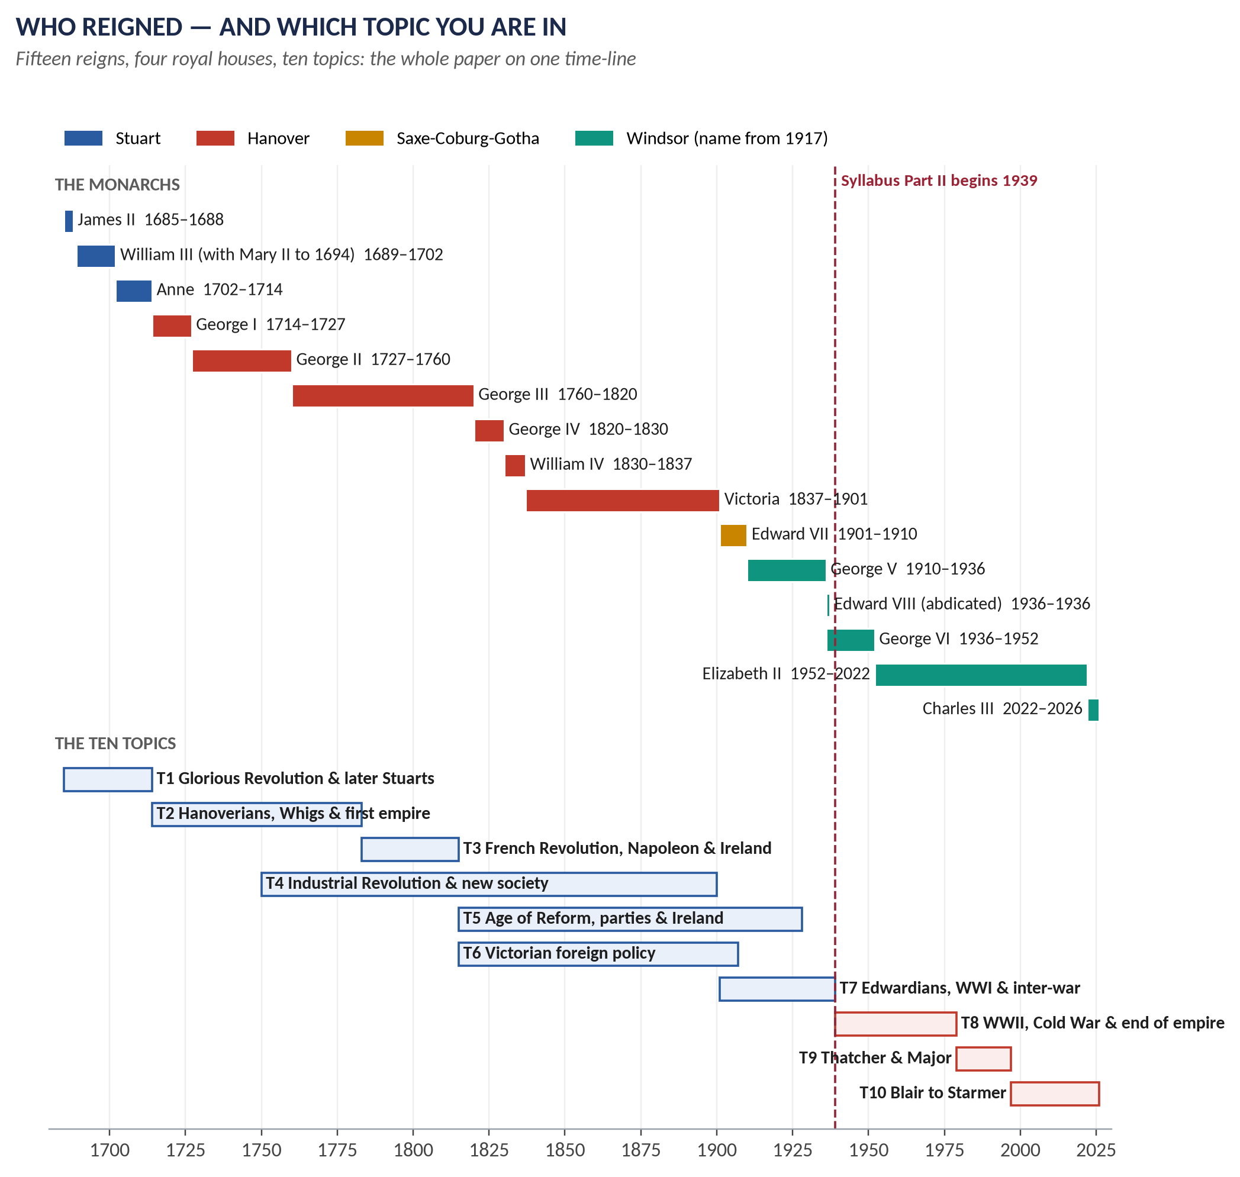
Figure 2 · The fifteen reigns from James II to Charles III, coloured by royal house, set against the ten topics. The dashed line at 1939 is where the syllabus divides into Part I and Part II.
MCQ FACT · Monarch facts that have been asked
Mary II ruled jointly with William III (2026). The Act of Settlement 1701 secured the crown for Hanover (2026). George III was king during the American war (2024). The longest-reigning Hanoverian was Victoria, 63 years (2024 — the options were wrong, so the answer was "None of these"). Edward VII gave the Edwardian era its name (2025). Edward VIII abdicated on 11 December 1936 (2024). Elizabeth II was crowned on 2 June 1953 (2024).

The Prime Ministers you will meet
You do not need every Prime Minister. You do need these, with their party and their dates, because the questions are built around them.
Prime Minister | Party | In office | Why he or she matters (topic)
Sir Robert Walpole | Whig | 1721–1742 | First "Prime Minister"; peace, low taxes, patronage (T2)
William Pitt the Elder (Earl of Chatham) | Whig | war leader 1756–61; PM 1766–68 | Won the Seven Years' War (T2)
Lord North | Tory | 1770–1782 | Lost America (T2)
William Pitt the Younger | Tory | 1783–1801, 1804–06 | Finances, war with France, Union with Ireland (T3)
Lord Liverpool | Tory | 1812–1827 | Repression after 1815, then "liberal Tory" reform (T5)
George Canning | Tory | 1827 | Liberal Tory foreign policy (T5, T6)
Duke of Wellington | Tory | 1828–1830 | Victor of Waterloo; Catholic Emancipation 1829 (T3, T5)
Earl Grey | Whig | 1830–1834 | Great Reform Act 1832 (T5)
Sir Robert Peel | Conservative | 1834–35, 1841–46 | Modern Conservatism; Corn Law repeal 1846 (T5)
Lord Palmerston | Whig/Liberal | 1855–58, 1859–65 | Foreign Secretary for 15 years; gunboat diplomacy (T6)
Benjamin Disraeli | Conservative | 1868, 1874–1880 | 1867 Reform Act; Suez shares; Berlin 1878 (T5, T6)
William Ewart Gladstone | Liberal | 1868–74, 1880–85, 1886, 1892–94 | Peace, retrenchment, reform; Irish Home Rule (T5, T6)
Lord Salisbury | Conservative | 1885–1902 (three terms) | Splendid Isolation (T6)
H. H. Asquith | Liberal | 1908–1916 | Liberal reforms, Parliament Act 1911, war (T7)
David Lloyd George | Liberal | 1916–1922 | War leader, Versailles (T7)
Neville Chamberlain | Conservative | 1937–1940 | Appeasement, Munich (T7)
Winston Churchill | Conservative | 1940–45, 1951–55 | War leader (T8)
Clement Attlee | Labour | 1945–1951 | Welfare state, NHS, Indian independence (T8)
Anthony Eden | Conservative | 1955–1957 | Suez (T8)
Harold Macmillan | Conservative | 1957–1963 | "Wind of change"; first EEC application (T8)
Harold Wilson | Labour | 1964–70, 1974–76 | 1975 EEC referendum (T8)
Edward Heath | Conservative | 1970–1974 | Took Britain into the EEC, 1973 (T8)
James Callaghan | Labour | 1976–1979 | IMF loan; Winter of Discontent (T8)
Margaret Thatcher | Conservative | 1979–1990 | Thatcherism, Falklands (T9)
John Major | Conservative | 1990–1997 | Maastricht, 1992 win, 1997 defeat (T9)
Tony Blair | Labour | 1997–2007 | New Labour, Iraq (T10)
Gordon Brown | Labour | 2007–2010 | 2008 financial crisis (T10)
David Cameron | Conservative | 2010–2016 | Coalition, austerity, EU referendum (T10)
Theresa May | Conservative | 2016–2019 | Brexit negotiations (T10)
Boris Johnson | Conservative | 2019–2022 | "Get Brexit done"; COVID-19 (T10)
Liz Truss | Conservative | Sept–Oct 2022 | Mini-budget crisis; shortest-serving PM (T10)
Rishi Sunak | Conservative | 2022–2024 | First British Asian PM; lost 2024 election (T10)
Sir Keir Starmer | Labour | 2024– | Labour landslide of 4 July 2024 (T10)

MCQ FACT · Prime-minister facts that have been asked
The longest-serving PM was Walpole (2024). Two PMs served during the First World War: Asquith and Lloyd George (2024). Major succeeded Thatcher (2024). Lord North was PM at the American Declaration of Independence (2026). Callaghan was PM during the Winter of Discontent (2026). Peel repealed the Corn Laws (2025). The 2010–15 coalition was led by Cameron (2026), with the Liberal Democrats (2026).

0.6 The syllabus on one map
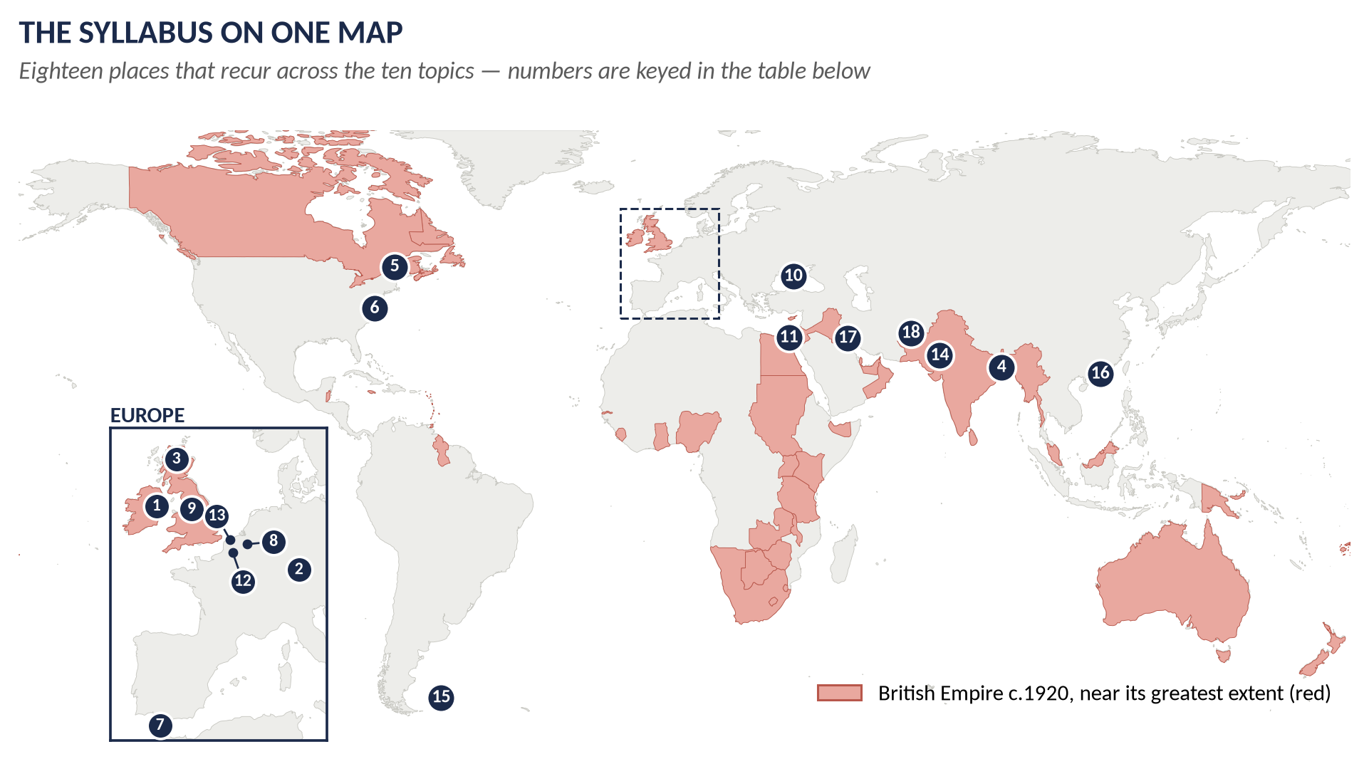
Figure 3 · The British Empire around 1920 (shaded red) with eighteen places that recur across the ten topics. The dashed box on the main map is enlarged as the Europe inset.
# | Place | Year | Topic | What happened there
1 | The Boyne (Ireland) | 1690 | T1 | William III defeats James II; Protestant rule in Ireland secured
2 | Blenheim (Bavaria) | 1704 | T1 | Marlborough's great victory in the War of the Spanish Succession
3 | Culloden (Scotland) | 1746 | T2 | The last Jacobite rising crushed; last pitched battle on British soil
4 | Plassey (Bengal) | 1757 | T2 | Clive's victory; the East India Company begins to rule India
5 | Quebec (Canada) | 1759 | T2 | Wolfe takes Quebec; Canada won from France
6 | Yorktown (Virginia) | 1781 | T2 | British surrender; the American war is lost
7 | Trafalgar (off Spain) | 1805 | T3 | Nelson destroys the French and Spanish fleets
8 | Waterloo (Belgium) | 1815 | T3 | Wellington and Blücher defeat Napoleon
9 | Manchester | 1819 | T4 · T5 | Cotton capital of the Industrial Revolution; Peterloo massacre
10 | Sevastopol (Crimea) | 1854–55 | T6 | Siege at the heart of the Crimean War
11 | Suez Canal (Egypt) | 1869 / 1956 | T6 · T8 | Route to India; Disraeli's shares 1875; the crisis of 1956
12 | The Somme (France) | 1916 | T7 | 57,470 British casualties on the first day, 1 July 1916
13 | Dunkirk (France) | 1940 | T8 | Evacuation of 338,000 troops (Operation Dynamo)
14 | Delhi and Karachi | 1947 | T8 | Independence and partition of India and Pakistan
15 | Falkland Islands | 1982 | T9 | Argentine invasion defeated
16 | Hong Kong | 1997 | T10 | Handed back to China — the symbolic end of empire
17 | Basra (Iraq) | 2003 | T10 | British sector in the Iraq War
18 | Helmand (Afghanistan) | 2006–14 | T10 | Main British combat mission of the War on Terror

0.7 Five habits of mind for a history paper
1. Always know the date. A British History answer without dates is an opinion. Put a date in almost every sentence of your evidence.
2. Always ask "why then?" Events have causes. Every answer should explain why something happened when it did — not earlier, not later.
3. Always see both sides. The examiner rewards balance: the case for, the case against, and your verdict.
4. Always connect. The Glorious Revolution explains the Hanoverians; the French Revolution explains the repression of 1815–1819; the Industrial Revolution explains Chartism and Labour; the World Wars explain decolonisation. Link backwards and forwards.
5. Always answer the question that was set. Not the question you prepared. The single most common failure in this paper is a good essay on the wrong question.

Part One — The Paper Itself

1.1 Where British History sits in CSS
The CSS written examination has 600 marks of compulsory papers and 600 marks of optional papers. The optional subjects are arranged in groups. British History is in Group IV, the history group, where you may choose one subject of 100 marks from five:
Code | Subject
26 | History of Pakistan & India
27 | Islamic History & Culture
28 | British History
29 | European History
30 | History of USA

So British History is always one paper of 100 marks. It was not always so: until 2015 it was examined in two papers (Paper I and Paper II), which is why the 2015 record in this document has two sets of questions. From 2016 the revised syllabus ("CE-2016 and onwards") made it a single paper.
KEY IDEA · Why candidates choose it — and why it rewards the prepared
British History overlaps heavily with other papers you already sit: Current Affairs and Pakistan Affairs (partition, the Commonwealth, the War on Terror), International Relations and Political Science (the British constitution, the Cold War, the EU), and even the Essay (empire, democracy, reform). Its syllabus is a single continuous story, which makes it easier to learn in order than a subject of scattered heads. And its questions repeat — as Part Three shows — more predictably than in most optional papers.

1.2 The syllabus, word for word
This is the syllabus exactly as FPSC published it for CE-2016 and onwards. It has fourteen heads, divided into Part I (50 marks) and Part II (50 marks). The spelling "Chartest", "Torries" and "Cameroun" is FPSC's own.
Head | Title | Sub-heads as printed
Part I | (Marks 50)
I | The Glorious Revolution (1688) | Causes, and Results · William III and Mary II (1689–1702) · Queen Anne (1702–1714)
II | Hanoverian Era (1714–1790) | Jacobite Rebellions (1715 and 1745) · Robert Walpole and Whig Oligarchy · American War of Independence (1776)
III | The Union of England and Scotland | —
IV | Union of England and Ireland | —
V | The Old Colonial System | —
VI | The French Revolution and Napoleonic Wars | Causes · Britain and Napoleonic Wars · Impact on Britain
VII | Industrial and Agricultural Revolution | Causes · Effects on Political and Social Life of Britain · Party Politics · The Methodist Movement · Socialism · Liberalism · Colonization · Chartest Movement
VIII | Robert Peel and return of Torries | Internal policies · Irish Problem
IX | Victorian Era (1837–1901) | Internal Reforms · Liberals · Foreign Policy · Disraeli, Gladstone and Problems in Ireland · Great Britain and Free Trade
X | Edwardian Era (1901–1910) | Domestic and Foreign Policies (1901–1910) · The Origins of Labor Party
XI | Britain, World War I and its Aftermath | Causes · Britain and Peace settlement · Effects of War on Britain · League of Nations · The Great Depression · Appeasement and Rearmament
Part II | (Marks 50)
XII | Britain, World War II and its Aftermath | Causes and events · Churchill, War Conferences · Creation of U.N.O · Effects of war · Reforms of Labour Government
XIII | Great Britain and Cold War | Creation of Common Wealth · NATO · Decolonization of the British Empire · Internal Policies and EEC · Foreign Policy
XIV | Thatcherism to Cameron (1979–2012) | Internal Policy · Society and culture · Foreign Policy · Falkland War · John Major and his Policies · European Common Market and the Great Britain · Formation of EU · Tony Blair "New Labour" Economic Crunch, War on Terror and his Policies · Global Financial Crisis 2008 and the Great Britain · Reforms under Cameroun

TRAP — DO NOT FALL INTO IT · Three things the syllabus's wording hides
First, Part I (eleven heads, 1688–1939) and Part II (three heads, 1939–2012) carry equal marks — so three heads are worth as much as eleven. Second, heads III, IV and V carry no dates and sit out of time order; this is why these notes rebuild the heads into ten topics told chronologically (Part Two). Third, the syllabus stops at 2012, but the examiner does not: Brexit (2016) was asked in 2017, Cameron's reforms in 2024 and 2025. These notes therefore run to 2026.

1.3 The suggested readings — which ones actually help
FPSC lists fifteen books. You cannot read them all, and some are hard to find. Here is an honest guide to what each is good for.
Book (as listed) | Covers | Verdict for a CSS candidate
Norman Lowe, Mastering Modern British History | 1760s–2000s | The single most useful book. Clear, exam-shaped chapters. Use it as your main text for T4–T10.
E. H. Carter (and R. A. F. Mears), A History of Britain | Whole period | The classic school text; strong for T1–T3 narrative.
G. W. Southgate, A Textbook of Modern English History 1714–1960 | 1714–1960 | Old but very exam-friendly; excellent for T2–T8.
V. H. H. Green, The Hanoverians, 1714–1815 | 1714–1815 | Good depth on Walpole, Chatham and George III (T2–T3).
Robert Blake, The Conservative Party from Peel to Thatcher | 1830–1980s | The source for Peel, Disraeli and Conservatism (T5, T9).
Michael Bentley, Politics without Democracy: Great Britain 1815–1914 (listed as "Democracy: Great Britain 1815–1914") | 1815–1914 | For the reform acts and parties (T5).
David Thomson, Europe since Napoleon | 1815–1950s | For the Eastern Question and alliances (T6, T7).
A. J. P. Taylor, The Struggle for Mastery in Europe 1848–1918 | 1848–1918 | For Crimea, Berlin and Splendid Isolation (T6).
A. J. P. Taylor, English History 1914–1945 | 1914–1945 | Brilliant, quotable; for T7–T8.
Kenneth O. Morgan, The People's Peace: British History 1945–1990 | 1945–1990 | For Attlee to Thatcher (T8–T9).
Chris Cook and John Ramsden (eds), Trends in British Politics since 1945 | 1945–1970s | Useful essays; secondary.
L. J. Butler, Britain and Empire | 1945 onwards | The book for decolonisation (T8).
G. M. Trevelyan, English Social History | Social history | For the Industrial Revolution and Methodism (T4).
A New History of England, 410–1975 (Pergamon, 1968) | Whole period | Reference only.
W. T. Selley, England in the Eighteenth Century | 18th century | For T1–T2 detail.

NOTE · Where the books stop
None of the listed books covers the period after about 2000 in depth. For T10 (Blair to Burnham) you need newer material; the T10 documents in this set are written from current sources to 2026.

1.4 How the paper is built
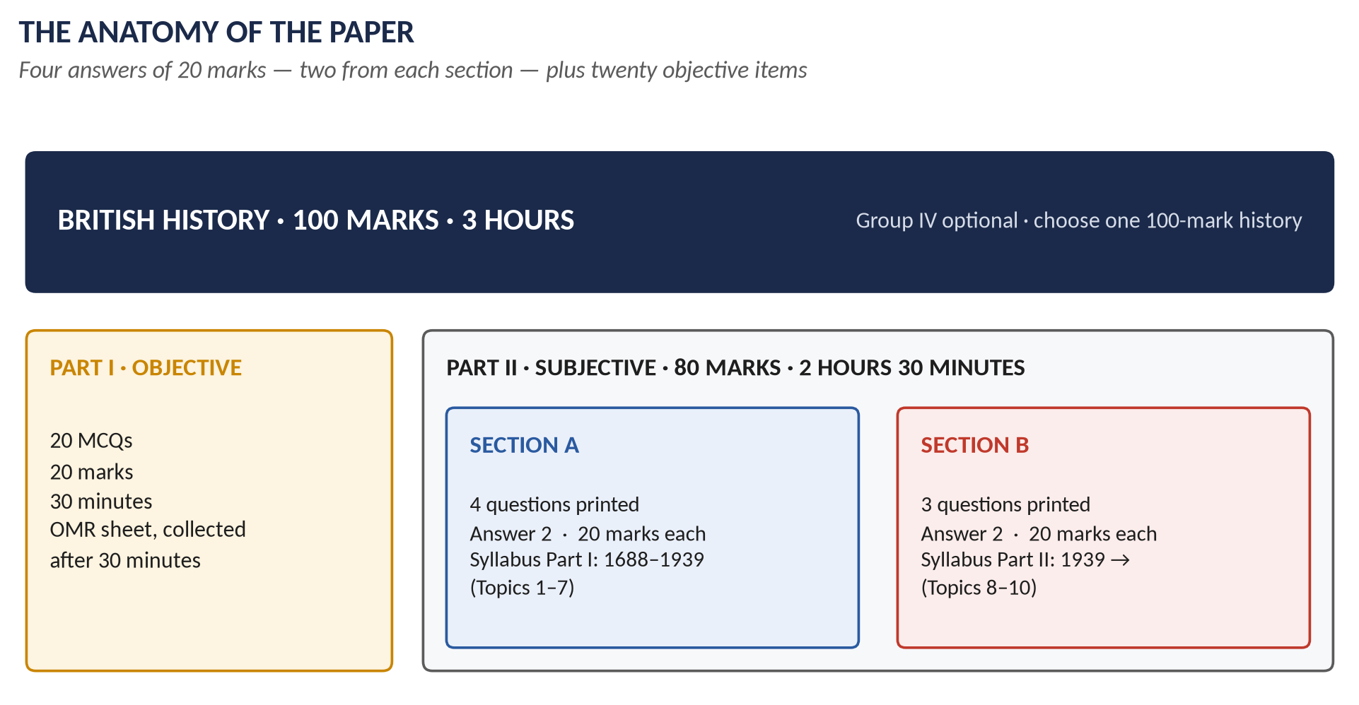
Figure 4 · The anatomy of the paper since 2016: twenty objective items, then four descriptive answers — two from each section.

Part I — the objective questions
- Twenty MCQs, one mark each, 20 marks in all.
- Thirty minutes, on a separate OMR answer sheet that is collected when the thirty minutes end.
- Options are always A, B, C and D "None of these" — and D is the right answer surprisingly often (Part 3.8).

Part II — the descriptive questions
- 80 marks, 2 hours 30 minutes.
- Seven questions are printed: Section A carries four (drawn from syllabus Part I) and Section B carries three (drawn from syllabus Part II).
- You attempt four questions, two from each section. All questions carry equal marks — 20 each. A short-notes question counts as one question: you write two notes of 10 marks each.
- An extra attempt is not marked, so never write a fifth answer.
NOTE · How the questions are numbered
Because the MCQs form Question 1, the descriptive questions are normally numbered Q2 to Q8 (Section A: Q2–Q5; Section B: Q6–Q8). The accessible transcription of the 2024 paper numbers them 1 to 7; the substance is the same. Always read the printed instructions in the hall — they are the only authority on the day.

The 2015 exception
In 2015, the last year of the old scheme, British History was two separate papers, each with seven descriptive questions and its own objective part. Their questions are included in this record because they are the closest thing to the modern paper's Part I heads, and because examiners still reuse their themes (Palmerston, Methodism, Splendid Isolation, the Commonwealth).

1.5 The asymmetry that decides scores
On paper the two parts of the syllabus are equal. In the hall they are not, and the difference decides a candidate's score.
 | Section A | Section B
Syllabus behind it | Part I: eleven heads, 1688–1939 | Part II: three heads, 1939 onwards
Questions printed | 4 | 3
You must answer | 2 (a choice of 2 from 4) | 2 (a choice of 2 from 3)
Freedom to skip | You may skip two | You may skip only one
What it means | A wide field with real choice | A narrow field with almost no choice

KEY IDEA · The first structural fact
Section B is close to compulsory. With three questions printed and two to be answered, you can avoid only one. And in six of the eleven papers since 2016 one of the three was a short-notes question, which forces you to know two of its three items. So T8, T9 and T10 must be prepared completely — every sub-head, every short-note possibility. They carry half the descriptive marks and allow the least escape.

KEY IDEA · The second structural fact — the leaks
Section B does not only ask Part II material. Nine Section-B items since 2016 came from Part I heads — the Eastern Question (2017), Splendid Isolation (2018), the League of Nations (2020), and six short-note options (Treaty of Berlin, Fabianism, Kitchener, Utilitarianism, the French Revolution's impact, Methodism). And in 2026 a Part II subject — the decline of the Empire after 1945 — appeared in Section A. The full list is in Part 3.5. A candidate who prepares only "their" section's topics can find a Section-B choice suddenly narrowed to one.

1.6 The marks and the minutes
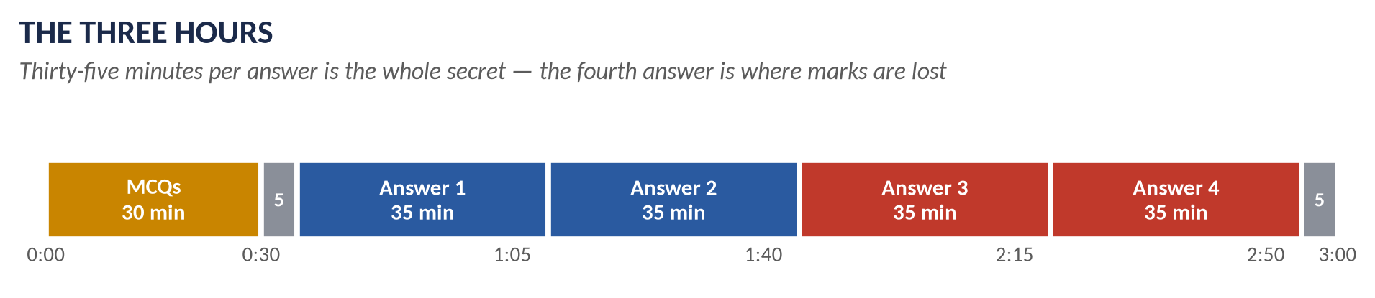
Figure 5 · The three hours. Thirty minutes for the objective part, then thirty-five minutes for each descriptive answer, with five minutes to choose and five to check.
The arithmetic is simple and unforgiving:
- 150 minutes for 80 marks in Part II. Four answers of 20 marks each.
- Take 5 minutes to read all seven questions and choose. Then 35 minutes per answer. Keep 5 minutes at the end to check headings and dates.
- Within each 35 minutes: 2 minutes for the answer map, 30 minutes writing, 3 minutes for the sketch map or figure (drawn while you write, not after).
- At a comfortable handwriting speed this is about 1,000–1,300 words per answer — roughly 7–9 sides of an answer book with headings, a map and a table. The model answers in the QA documents are written to this length, so they are practical models, not impossible ones.
- For a short-notes question: two notes of about 17 minutes each, 450–600 words each.
TRAP — DO NOT FALL INTO IT · Where marks are really lost
Not on the first answer, which is usually your best. Marks are lost on the fourth, which is written in twenty minutes because the first ran to fifty. A strong fourth answer is worth more than a brilliant first one. Watch the clock at 1:05, 1:40, 2:15 and 2:50.

1.7 The thirteen papers at a glance
The table below shows every paper since the single-paper scheme began, with each question's family and topic. The topics (T1–T10) are explained in Part Two. The full wording of every question is in Appendix A.
Year | Section A (answer two) | Section B (answer two)
2016 | Q2 The French Revolution and Britain (T3)  Q3 Parliamentary reform 1832–1928 (T5)  Q4 Palmerston (T6)  Q5 Gladstone vs Disraeli; Disraeli abroad (T6) | Q6 Thatcher and Thatcherism (T9)  Q7 David Cameron (T10)  Q8 short notes: Second World War (T8); Treaty of Berlin (T6); Fabianism (T4)
2017 | Q2 Walpole and the Whig oligarchy (T2)  Q3 The Industrial (and Agricultural) Revolution (T4)  Q4 Chartism (T4)  Q5 Gladstone's domestic policy (T5) | Q6 The Eastern Question, Crimea, Berlin (T6)  Q7 The Commonwealth (T8)  Q8 Brexit (T10)
2018 | Q2 The Glorious Revolution (T1)  Q3 The Industrial (and Agricultural) Revolution (T4)  Q4 Sir Robert Peel (T5)  Q5 Parliamentary reform 1832–1928 (T5) | Q6 Splendid Isolation and its end (T6)  Q7 The special relationship with the USA (T8)  Q8 short notes: Sir Winston Churchill (T8); Britain's role in the EU (T9); Lady Diana (T10)
2019 | Q2 The Glorious Revolution (T1)  Q3 The Hanoverian succession (T2)  Q4 The Industrial (and Agricultural) Revolution (T4)  Q5 Parliamentary reform 1832–1928 (T5) | Q6 Attlee’s Labour government 1945–51 (T8)  Q7 Decolonisation, India, Palestine, Suez (T8)  Q8 John Major (T9)
2020 | Q2 Walpole and the Whig oligarchy (T2)  Q3 The French Revolution and Britain (T3)  Q4 Parliamentary reform 1832–1928 (T5)  Q5 Sir Robert Peel (T5) | Q6 Decolonisation, India, Palestine, Suez (T8)  Q7 Inter-war foreign policy and the League (T7)  Q8 The Falklands War (T9)
2021 | Q2 Church parties after 1688 (Non-Jurors, High Church, Latitudinarians) (T1)  Q3 Union of England and Scotland, 1707 (T1)  Q4 The First World War and its effects (T7)  Q5 Edwardian era and the rise of Labour (T7) | Q6 The Falklands War (T9)  Q7 Britain and Europe (EEC/EU) (T9)  Q8 The War on Terror (T10)
2022 | Q2 Gladstone's domestic policy (T5)  Q3 Pitt the Elder (Chatham) (T2)  Q4 Edwardian era and the rise of Labour (T7)  Q5 The French Revolution and Britain (T3) | Q6 The Falklands War (T9)  Q7 The Second World War and Churchill (T8)  Q8 short notes: Lord Kitchener (T7); Suez Canal Crisis (T8); Utilitarianism (T4)
2023 | Q2 The Glorious Revolution (T1)  Q3 The French Revolution and Britain (T3)  Q4 Splendid Isolation and its end (T6)  Q5 The First World War and its effects (T7) | Q6 The Second World War and Churchill (T8)  Q7 The War on Terror (T10)  Q8 The 2008 financial crisis (T10)
2024 | Q1 Sir Robert Peel (T5)  Q2 The Irish Question and Home Rule (T5)  Q3 Chartism (T4)  Q4 The Methodist Movement (T4) | Q5 Thatcher and Thatcherism (T9)  Q6 Decolonisation, India, Palestine, Suez (T8)  Q7 short notes: Falkland War (T9); Reforms under David Cameron (T10); Creation of the Commonwealth (T8)
2025 | Q2 William's and Anne's wars (Augsburg, Spanish Succession) (T1)  Q3 Union with Ireland, 1801 (T3)  Q4 Rise of the Conservative and Liberal parties (T5)  Q5 Ideas: Liberalism, Socialism, Utilitarianism, Fabianism (T4) | Q6 Blair and New Labour (T10)  Q7 The 2008 financial crisis (T10)  Q8 short notes: Impact of the French Revolution on the British economy and society (T3); Methodist Movement (T4); Reforms under Cameron Government (T10)
2026 | Q2 Slavery, abolition and empire (T2)  Q3 The Industrial (and Agricultural) Revolution (T4)  Q4 Decolonisation, India, Palestine, Suez (T8)  Q5 The First World War and its effects (T7) | Q6 Britain and Europe (EEC/EU) (T9)  Q7 Blair and New Labour (T10)  Q8 short notes: Britain's role in the War on Terror (T10); Lady Diana Spencer (T10); John Major's foreign policy (T9)

And the two papers of 2015, under the former scheme:
Paper | Questions (attempt four of seven in each paper)
2015 Paper I | Q2 The Glorious Revolution (T1)  Q3 William's and Anne's wars (Augsburg, Spanish Succession) (T1)  Q4 Walpole and the Whig oligarchy (T2)  Q5 American War of Independence (T2)  Q6 Parliamentary reform 1832–1928 (T5)  Q7 Palmerston (T6)  Q8(a) short note: Industrial Revolution (T4)  Q8(b) short note: Methodist Movement (T4)  Q8(c) short note: Jacobite Revolt of Scotland (T2)
2015 Paper II | Q2 Palmerston (T6)  Q3 The Methodist Movement (T4)  Q4 Gladstone vs Disraeli; Disraeli abroad (T6)  Q5 The Eastern Question, Crimea, Berlin (T6)  Q6 The Commonwealth (T8)  Q7 Splendid Isolation and its end (T6)  Q8 Inter-war foreign policy and the League (T7)

WHAT THE EXAMINER HAS ASKED · What the glance shows at once
Section A has always been four full questions. Section B has been three questions — and a short-notes question in 2016, 2018, 2022, 2024, 2025 and 2026. Topics T8–T10 supplied 24 of the 27 full questions set in Section B since 2016.

Part Two — Ten Topics: Rebuilding the Syllabus as One Story

2.1 Why ten topics, and why in time order
The syllabus lists fourteen heads. Three of them — III (Union of England and Scotland), IV (Union of England and Ireland) and V (the Old Colonial System) — have no dates and are printed as separate themes after the Hanoverian era. Taken in the syllabus's own order, you would study the Hanoverians to 1790, then jump back to 1707 for the Scottish union, forward to 1801 for the Irish union, back to the seventeenth century for the colonial system, and forward again to 1789 for the French Revolution. For a reader who does not yet know the story, that order is a maze.
These notes follow time instead. Each of the three undated heads is placed where it actually happened:
Head | Placed in | Why there
III · Union with Scotland | T1 (1685–1714) | The Act of Union was passed in 1707, in the middle of Queen Anne's reign — which is Head I. You cannot explain it without the Act of Settlement (1701), the Scottish Act of Security (1704) and the war with France, all Topic 1 material.
IV · Union with Ireland | T3 (1783–1815) | The Act of Union of 1801 was Pitt the Younger's answer to the Irish rebellion of 1798, fought with French help during the war against Revolutionary France — which is Head VI.
V · The Old Colonial System | T2 (1714–1783) | The Old Colonial System (mercantilism, the Navigation Acts, the slave trade) was the empire of the eighteenth century. Its breakdown is the cause of the American War of Independence — which is Head II.

KEY IDEA · The rule behind the ten topics
A topic is a stretch of the story that an examiner can ask about as one question. Topic boundaries fall where the story changes direction: 1714 (the Hanoverians arrive), 1783 (America lost, Pitt arrives), 1815 (Napoleon defeated), 1901 (Victoria dies), 1939 (war, and the syllabus's own Part I/II line), 1979 (Thatcher), 1997 (Blair). Two topics — T4 (the Industrial Revolution) and T6 (Victorian foreign policy) — run alongside others because they are themes that the examiner asks about as wholes.

2.2 From fourteen heads to ten topics
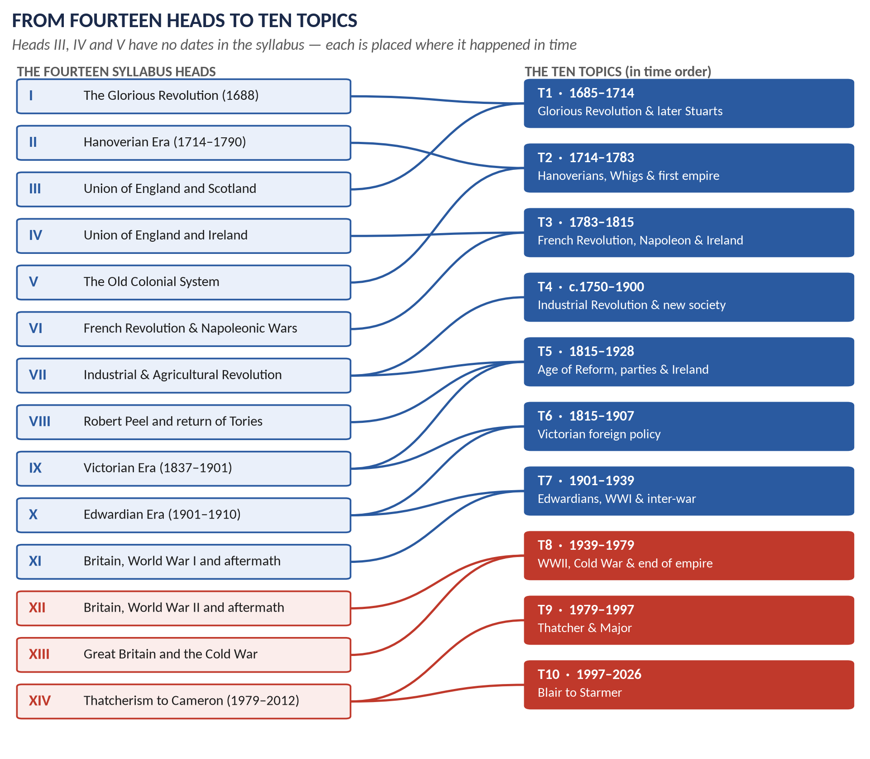
Figure 6 · How each of the fourteen syllabus heads feeds the ten topics. Blue = syllabus Part I; red = syllabus Part II.
Topic | Title | Syllabus heads | What the topic contains
T1 | The Glorious Revolution and the Later Stuarts, 1685–1714 | I, III | James II and his Declarations of Indulgence; the Revolution of 1688; the Bill of Rights; William III and Mary II; the Nine Years' War and Ryswick; the Church after 1688 (Non-Jurors, High Church, Latitudinarians); Queen Anne; the War of the Spanish Succession and Utrecht; the Act of Settlement; the Union of 1707
T2 | Hanoverian Britain, the Whig Oligarchy and the First Empire, 1714–1783 | II, V | The Hanoverian succession; the Jacobite risings of 1715 and 1745; Walpole and the Whig oligarchy; Pitt the Elder and the Seven Years' War; George III; the Old Colonial System; the slave trade; the American War of Independence; the downfall of the Whigs
T3 | Pitt, the French Revolution, Napoleon and the Union with Ireland, 1783–1815 | IV, VI | Pitt the Younger; the causes of the French Revolution; Burke and Paine; repression at home; the Revolutionary and Napoleonic Wars (Nile, Trafalgar, Peninsula, Waterloo); the Congress of Vienna; the 1798 rising and the Union of 1801; the impact of the wars on Britain
T4 | The Industrial and Agricultural Revolutions and the New Society, c.1750–1900 | VII | Causes; enclosure and the Agricultural Revolution; coal, iron, steam, textiles, canals, railways; effects on society, politics and culture; Methodism; Utilitarianism; Liberalism; Socialism and Fabianism; colonisation; Chartism; the abolition of the slave trade and slavery (with T2)
T5 | The Age of Reform: Parliament, Parties, Peel, Gladstone and Ireland, 1815–1928 | VIII, IX (VII) | Post-war repression and Peterloo; Liverpool, Canning, Wellington; William IV's reforming decade; the Reform Acts 1832–1928; Peel, the Tamworth Manifesto and Corn Law repeal; the rise of the Conservative and Liberal parties; Gladstone's domestic reforms; Disraeli at home; free trade; the Irish Question and Home Rule to 1922
T6 | Victorian Britain and the World: Palmerston to Splendid Isolation, 1815–1907 | IX, X | Castlereagh and Canning; Palmerston; the Eastern Question; the Crimean War; Disraeli's foreign and imperial policy; the Congress of Berlin; Gladstone abroad; the Scramble for Africa; Splendid Isolation and its end (1902, 1904, 1907)
T7 | Edwardian Britain, the Great War and the Road to 1939 | X, XI | The Edwardian era; the Liberal reforms; the origins and rise of the Labour Party; the causes and course of the First World War; its effects on Britain; the peace settlement; the League of Nations; the Great Depression; appeasement and rearmament
T8 | The Second World War, Attlee, the Cold War and the End of Empire, 1939–1979 | XII, XIII | Causes and events of WWII; Churchill and the war conferences; the UN; effects of the war; Attlee's reforms; the Cold War, NATO and the special relationship; the Commonwealth; decolonisation (India, Palestine, Suez, Africa); Britain's road into the EEC; home policies to 1979
T9 | Thatcher and Major: Thatcherism, the Falklands and Europe, 1979–1997 | XIV | Thatcherism at home; society and culture in the 1980s; the Falklands War; foreign policy and the end of the Cold War; Britain and the European Community; Major, Maastricht and the formation of the EU; the 1992 and 1997 elections
T10 | Blair to Burnham: New Labour, the War on Terror, Crisis and Brexit, 1997–2026 | XIV + beyond | New Labour and its reforms; the War on Terror (Afghanistan, Iraq); Brown and the 2008 crisis; Cameron's coalition and reforms; Brexit; May, Johnson, Truss, Sunak, Starmer; Diana and the monarchy; society and culture

2.3 What each topic adds beyond the syllabus's words
The syllabus names the headline items. The examiner asks about more than the headlines. Each topic therefore includes material the syllabus does not name but the record shows is needed.
Topic | Added beyond the syllabus's words | Evidence from the record
T1 | James II's Declarations of Indulgence; the Nine Years' War and Ryswick; the Church parties after 1688 | 2015 P1 Q2 and Q3; 2021 Q2
T2 | Pitt the Elder (Chatham); the Seven Years' War; the slave trade and abolition | 2022 Q3; 2026 Q2
T3 | Pitt the Younger; Burke and Paine; the repression of 1793–1820 | 2016 Q2; 2020 Q3; 2023 Q3
T4 | Utilitarianism and Fabianism (named only as "Socialism", "Liberalism") | 2016 and 2022 short notes
T5 | William IV's reign; Liverpool, Canning and Wellington; the Reform Acts to 1928 | 2015 P1 Q6; 2024 Q1; 2020 Q4
T6 | Palmerston; the Eastern Question; Crimea; Berlin; Splendid Isolation | Ten questions, 2015–2023
T7 | Kitchener; the Liberal decline; Kipling and wartime propaganda | 2022 short note; 2026 Q5; 2023 Q5
T8 | Palestine; the special relationship; Churchill as writer | 2020 Q6; 2018 Q7; 2022 Q7
T9 | The miners' strike; the 1992 election; Maastricht opt-outs | 2019 Q8; 2026 Q6
T10 | Brexit; post-2012 governments to 2026; Diana | 2017 Q8; 2018 and 2026 short notes

2.4 Why the syllabus stops in 2012 — and these notes run to 2026
The syllabus was written for the 2016 examination, so its last head ends with "Reforms under Cameron" (2010–2012). But the examiner has already gone beyond it:
- 2017 Q8 asked about the advantages and disadvantages of Brexit — an event of 2016.
- 2024 and 2025 set short notes on Cameron's reforms — his whole premiership, to 2016.
- 2026 Q7 framed the whole period 1997–2012 as a question about renewal or contradiction — which cannot be answered well without knowing how the story ended.
And the Europe question (asked 2018, 2021, 2026) cannot be answered well today without its final chapter — Britain's exit in 2020 — in view.
VERDICT · So these notes run to September 2026
Topic 10 covers Blair to Burnham: Brexit, the governments of May, Johnson, Truss and Sunak, the death of Elizabeth II, the accession of Charles III, and Starmer's government from July 2024. The material after 2012 is presented as history, with the same structure as the rest — not as an afterthought.

2.5 The two documents each topic gets
Every topic from T1 to T10 gets exactly two Word documents, in its own folder.

The Knowledge Base (TnKB)
- The story so far — a short bridge from the previous topic (from T2 onwards).
- The story itself — the topic told as a narrative in simple language, before any analysis.
- The cast — the people, with dates and one line each.
- The time-line — as a figure and as a table.
- The chapters — the topic broken into causes, course, results and significance, under many layers of headings, with maps, family trees, flow charts and comparison tables.
- The historians — who said what, and how to quote them.
- The examiner boxes — where each part has been asked.
- The one-liner MCQs — fifty to a hundred facts per topic, in question-and-answer form.
- The revision sheet — the whole topic on a few pages, written so that it makes complete sense on its own (it will be combined into the exam-night document).

The Question Answers (TnQA)
- Every past question on the topic, 2015–2026, answered in full: the question; decoding the question; the answer map (mind map) built on the question's own words; the model answer under numbered headings with a sketch map, figure or table; and why this answer scores.
- Every short-note option on the topic, answered.
- The topic's MCQs from 2024–2026, solved with a one-line explanation.
- At most five predicted questions, each with a short outline.
NOTE · Near-identical questions
Where the examiner has set the same question twice (for example 2020 Q3 and 2022 Q5, word for word), the answer is written once in full, and the second listing shows how to adapt it. Where two questions look similar but ask for different things, each gets its own answer.

Part Three — The Record: What Has Been Asked, 2015–2026

3.1 How the record was built
The record covers thirteen papers: the two papers of 2015 (former scheme) and the eleven single papers of 2016 to 2026.
- Descriptive: 84 full questions and 7 short-notes questions containing 21 options, all transcribed in full in Appendix A. Each item was tagged four ways: its topic (T1–T10), its family (the thing it is really about, such as "Walpole and the Whig oligarchy"), its syllabus head (I–XIV) and its shape (causes-and-results, quotation to evaluate, "how far", and so on).
- Objective: 60 MCQs — the complete objective papers of 2024, 2025 and 2026. The objective sheets of 2015–2023 could not be recovered from accessible scans and none has been invented. The 60 items are listed with their keyed answers in Appendix B.
- Weighting: in the charts, a full question counts 1 and a short-note option counts ½ (because you write two notes for one question's marks).
NOTE · What the record can and cannot tell you
It tells you what the examiner likes to ask and how he likes to ask it. It cannot tell you what will be asked next — 2023 and 2026 both set questions nobody had seen before (Kipling's quotation; abolition and imperialism). Use the record to decide what to prepare first and deepest, never what to leave out.

3.2 The heat map
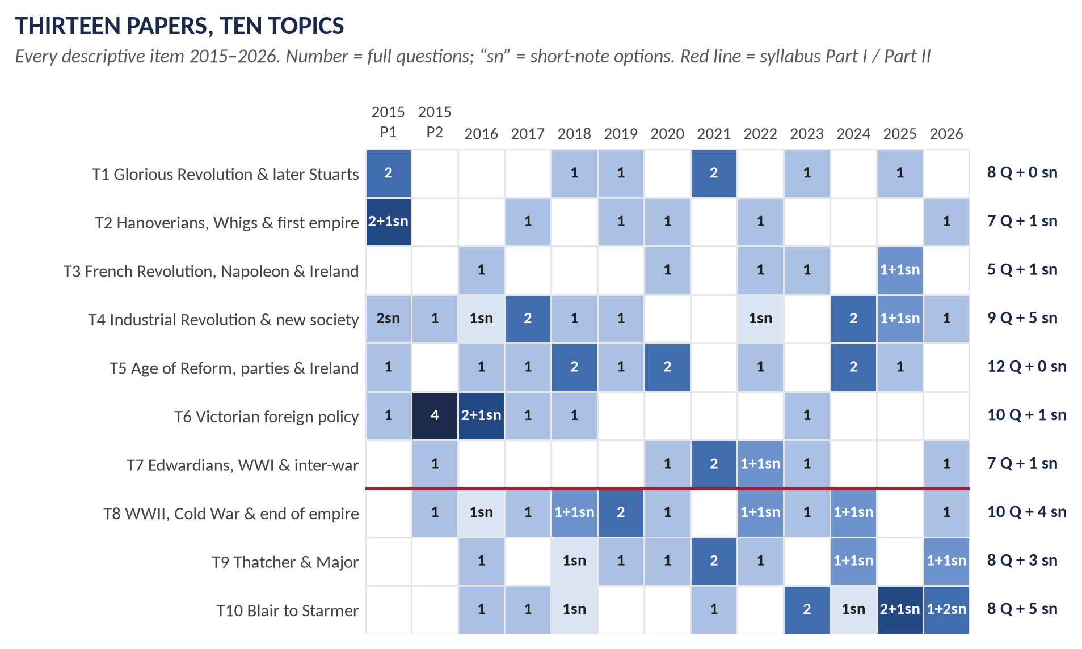
Figure 7 · Every descriptive item of 2015–2026 by topic and paper. Numbers are full questions; "sn" marks short-note options. Darker = more.

How to read it
- Across a row you see how regularly a topic appears. T4 (Industrial Revolution and society), T5 (Age of Reform) and T8 (WWII to decolonisation) appear in almost every paper.
- Down a column you see the shape of one paper. Above the red line is Section A territory; below it is Section B.
- The white gaps show where a topic rested — and topics that rest usually return. T6 (Victorian foreign policy) filled the 2015–2018 papers, disappeared after 2018 except for 2023, and is therefore due.

3.3 How much each topic weighs
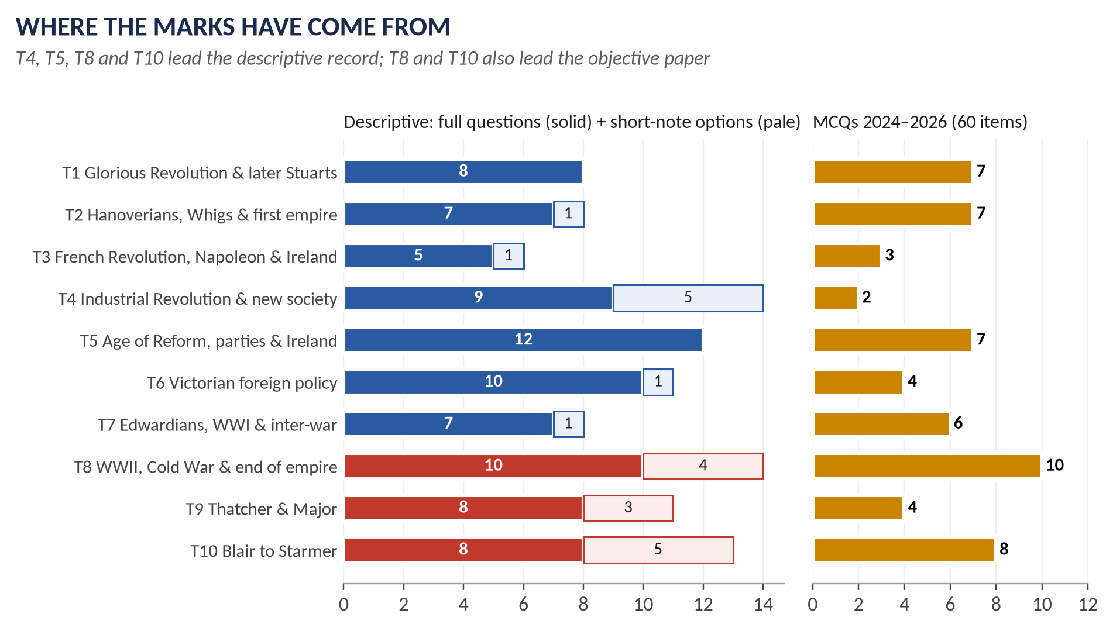
Figure 8 · Descriptive items per topic (left) and objective items 2024–2026 per topic (right).
Topic | Full Qs | Short notes | Weight* | Share | MCQs | Rank
T1 Glorious Revolution & later Stuarts | 8 | 0 | 8 | 8% | 7 | 7
T2 Hanoverians, Whigs & first empire | 7 | 1 | 7.5 | 8% | 7 | 8
T3 French Revolution, Napoleon & Ireland | 5 | 1 | 5.5 | 6% | 3 | 10
T4 Industrial Revolution & new society | 9 | 5 | 11.5 | 12% | 2 | 3
T5 Age of Reform, parties & Ireland | 12 | 0 | 12 | 13% | 7 | 1
T6 Victorian foreign policy | 10 | 1 | 10.5 | 11% | 4 | 4
T7 Edwardians, WWI & inter-war | 7 | 1 | 7.5 | 8% | 6 | 9
T8 WWII, Cold War & end of empire | 10 | 4 | 12 | 13% | 10 | 2
T9 Thatcher & Major | 8 | 3 | 9.5 | 10% | 4 | 6
T10 Blair to Burnham | 8 | 5 | 10.5 | 11% | 8 | 5
Total | 84 | 21 | 94.5 | 100% | 60

*Weight = full questions + ½ × short-note options. Share = the topic's weight as a percentage of all descriptive weight.
KEY IDEA · What the weights mean for you
No topic is small. The lightest (T3) still carries 6% of the descriptive record; the heaviest (T5 and T8) carry 13% each. The spread is narrow because the paper forces choice across the whole period: four Section-A questions must come from seven topics, three Section-B questions from three. So the right strategy is complete coverage with graded depth — not a gamble on a few topics.

3.4 The repeat engine
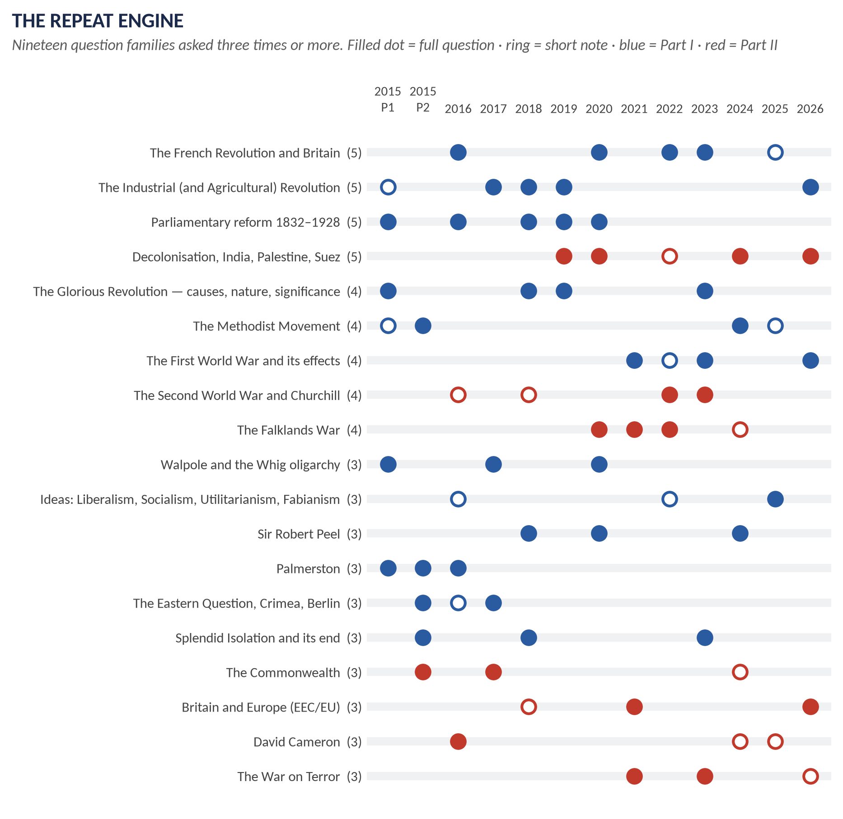
Figure 9 · The nineteen question families asked three times or more. Each dot is one appearance.
The central fact of this paper is that it repeats. Nineteen families have appeared three or more times, and they account for 70 of the 105 descriptive items (two-thirds). Twelve more families have appeared twice.

The families asked three times or more
Family | Times | Topic | When (Q = full question, sn = short note)
The French Revolution and Britain | 5 | T3 | 2016, 2020, 2022, 2023, 2025 sn
The Industrial (and Agricultural) Revolution | 5 | T4 | 2015 P1 sn, 2017, 2018, 2019, 2026
Parliamentary reform 1832–1928 | 5 | T5 | 2015 P1, 2016, 2018, 2019, 2020
Decolonisation, India, Palestine, Suez | 5 | T8 | 2019, 2020, 2022 sn, 2024, 2026
The Glorious Revolution — causes, nature, significance | 4 | T1 | 2015 P1, 2018, 2019, 2023
The Methodist Movement | 4 | T4 | 2015 P1 sn, 2015 P2, 2024, 2025 sn
The First World War and its effects | 4 | T7 | 2021, 2022 sn, 2023, 2026
The Second World War and Churchill | 4 | T8 | 2016 sn, 2018 sn, 2022, 2023
The Falklands War | 4 | T9 | 2020, 2021, 2022, 2024 sn
Walpole and the Whig oligarchy | 3 | T2 | 2015 P1, 2017, 2020
Ideas: Liberalism, Socialism, Utilitarianism, Fabianism | 3 | T4 | 2016 sn, 2022 sn, 2025
Sir Robert Peel | 3 | T5 | 2018, 2020, 2024
Palmerston | 3 | T6 | 2015 P1, 2015 P2, 2016
The Eastern Question, Crimea, Berlin | 3 | T6 | 2015 P2, 2016 sn, 2017
Splendid Isolation and its end | 3 | T6 | 2015 P2, 2018, 2023
The Commonwealth | 3 | T8 | 2015 P2, 2017, 2024 sn
Britain and Europe (EEC/EU) | 3 | T9 | 2018 sn, 2021, 2026
David Cameron | 3 | T10 | 2016, 2024 sn, 2025 sn
The War on Terror | 3 | T10 | 2021, 2023, 2026 sn

The families asked twice
Family | Times | Topic | When (Q = full question, sn = short note)
William's and Anne's wars (Augsburg, Spanish Succession) | 2 | T1 | 2015 P1, 2025
Chartism | 2 | T4 | 2017, 2024
Gladstone's domestic policy | 2 | T5 | 2017, 2022
Gladstone vs Disraeli; Disraeli abroad | 2 | T6 | 2015 P2, 2016
Inter-war foreign policy and the League | 2 | T7 | 2015 P2, 2020
Edwardian era and the rise of Labour | 2 | T7 | 2021, 2022
Thatcher and Thatcherism | 2 | T9 | 2016, 2024
John Major | 2 | T9 | 2019, 2026 sn
Diana, Princess of Wales | 2 | T10 | 2018 sn, 2026 sn
The 2008 financial crisis | 2 | T10 | 2023, 2025
Blair and New Labour | 2 | T10 | 2025, 2026

The families asked once
Family | Times | Topic | When (Q = full question, sn = short note)
Church parties after 1688 (Non-Jurors, High Church, Latitudinarians) | 1 | T1 | 2021
Union of England and Scotland, 1707 | 1 | T1 | 2021
American War of Independence | 1 | T2 | 2015 P1
The Jacobite risings | 1 | T2 | 2015 P1 sn
The Hanoverian succession | 1 | T2 | 2019
Pitt the Elder (Chatham) | 1 | T2 | 2022
Slavery, abolition and empire | 1 | T2 | 2026
Union with Ireland, 1801 | 1 | T3 | 2025
The Irish Question and Home Rule | 1 | T5 | 2024
Rise of the Conservative and Liberal parties | 1 | T5 | 2025
The special relationship with the USA | 1 | T8 | 2018
Attlee’s Labour government 1945–51 | 1 | T8 | 2019
Brexit | 1 | T10 | 2017

Exact and near repeats
Some questions have come back in the same or almost the same words. These are the clearest evidence of how the examiner works.
Pair or group | What stayed the same | What changed
2020 Q3 = 2022 Q5 | "Estimate the influence of the French Revolution on English society and political thought." — identical | Nothing. Two years apart.
2017 Q2 ≈ 2020 Q2 | Merits and demerits of Whig rule / Whig oligarchy; causes of its downfall | "Analyze comprehensively" became "critically examine"
2017 Q5 ≈ 2022 Q2 | "Gladstone's domestic policy was the climax of liberalism" | "During the 19th century" added
2015 P2 Q6 ≈ 2017 Q7 | How the Commonwealth developed; how it differs from the Empire | Also a short note, 2024
2020 Q8 ≈ 2022 Q6 | Causes (genesis) of the Falklands War; effect on relations with Latin America | "Causes" became "genesis". Also 2021 and a 2024 short note
2016 Q3 ≈ 2019 Q5 | The Reform Act of 1832 | 2019 asks about what it made possible afterwards
2018 Q5 ≈ 2020 Q4 | The democratisation of Parliament | 2020 fixes the dates: 1832–1928
2017 Q3 ≈ 2019 Q4 | Effects of the Industrial Revolution on social, economic, political and cultural life | 2019 adds its causes; 2026 turns it into "disruption or progress?"
2018 Q2 ≈ 2019 Q2 ≈ 2023 Q2 | The Glorious Revolution: how, why, and what followed | Each asks from a different angle: causes (2018), "so glorious" (2019), fallout at home and abroad (2023)
2015 P1 Q7 ≈ 2015 P2 Q2 ≈ 2016 Q4 | A quotation about Palmerston to evaluate | Three different quotations
2015 P2 Q7 ≈ 2018 Q6 ≈ 2023 Q4 | Splendid Isolation | Why adopted (2015, 2023); how ended (2018)
2018 Q4 ≈ 2020 Q5 ≈ 2024 Q1 | Sir Robert Peel | Policies (2018); a quotation (2020); compared with predecessors (2024)
2015 P2 Q3 ≈ 2024 Q4 (+ 2 short notes) | The emergence and features of Methodism | Effects (2015); reasons for success (2024)
2017 Q4 ≈ 2024 Q3 | Chartism | Why it failed (2017); why millions supported it (2024)
2021 Q5 ≈ 2022 Q4 | The rise of the Labour Party | Edwardian setting (2021); achievements (2022)
2021 Q8 ≈ 2023 Q7 ≈ 2026 sn | Britain and the War on Terror | Blair's policy (2021); a Bush quotation (2023)
2023 Q8 ≈ 2025 Q7 | The 2008 financial crisis and Britain | 2025 adds a Labour–Conservative comparison
2024 sn = 2025 sn | "Reforms under (the) Cameron (Government)" | Consecutive years
2018 sn = 2026 sn | Lady Diana (Spencer) | Eight years apart

KEY IDEA · How the repeat engine works
The examiner returns to a small number of favourite subjects and changes the angle. A subject asked for its causes comes back asking for its results; one asked through a quotation comes back as compare with predecessors. So preparing a family means preparing all its angles — causes, course, results, significance, critics, and comparison — not memorising one past answer. Every QA document in this set is organised around this rule.

3.5 The leaks between the sections
Section A is meant to carry syllabus Part I and Section B syllabus Part II. In practice the line leaks — mostly one way.
Paper | Item | Syllabus head | Topic
2016 §B · Q8(b) | Short note: Treaty of Berlin | IX · Part I head in Section B | T6
2016 §B · Q8(c) | Short note: Fabianism | VII · Part I head in Section B | T4
2017 §B · Q6 | Explain the Eastern Question and critically analyse the attitude of England towards this question from 1820 to 1913. | IX · Part I head in Section B | T6
2018 §B · Q6 | How did Britain put a halt to the Policy of Splendid Isolation? What were its positive and negative aspects? | X · Part I head in Section B | T6
2020 §B · Q7 | What do you know about the League of Nations? Explain the work of the League. What were the causes of its failure? | XI · Part I head in Section B | T7
2022 §B · Q8(a) | Short note: Lord Kitchener | XI · Part I head in Section B | T7
2022 §B · Q8(c) | Short note: Utilitarianism | VII · Part I head in Section B | T4
2025 §B · Q8(a) | Short note: Impact of the French Revolution on the British economy and society | VI · Part I head in Section B | T3
2025 §B · Q8(b) | Short note: Methodist Movement | VII · Part I head in Section B | T4
2026 §A · Q4 | How far was the decline of the British Empire after 1945 the result of global pressures rather than internal political decisions? Support your analysis with at least three major real end-of-decolonisation cases. | XIII · Part II head in Section A | T8

WHAT THE EXAMINER HAS ASKED · What the leaks mean
Nine Part I items have appeared in Section B since 2016 (three full questions and six short-note options), and in 2026 one Part II question (the end of empire after 1945) appeared in Section A. So your Section B choice can include a nineteenth-century question, and your Section A choice can include a post-1945 one. Prepare every topic to at least short-note level.

3.6 The blind spots — syllabus lines never asked
These are items the syllabus names that have never been set as a descriptive question (or appear only inside a larger question) in 2015–2026. A blind spot is not a safe place to skip: several are exactly where the next surprise will come from.
Head | Never asked descriptively | Comment
I | William III and Mary II's reign as a subject in itself | Asked only through the wars (2015) and the Church (2021).
II | The Jacobite rebellions as a full question | Only a 2015 short note. The '45 is a natural 2027 short note.
V | The Old Colonial System | Never — though 2026 Q2 (abolition and empire) comes closest. A full question on mercantilism and the Navigation Acts is overdue.
VI | Britain and the Napoleonic Wars (the fighting itself) | The Revolution's influence has been asked five times; the war — Trafalgar, the Peninsula, Waterloo, Vienna — never.
VII | Colonization; Socialism alone; Liberalism alone | Only in the 2025 comparison and short notes.
VIII | The Irish problem under Peel (Maynooth, the Famine) | Only inside 2018 Q4.
IX | Great Britain and Free Trade; Victorian internal reforms in general | Free trade only as a 2025 MCQ.
X | Edwardian foreign policy (Entente Cordiale, Anglo-Russian Convention) | Only as the end of Splendid Isolation.
XI | The peace settlement; the Great Depression; appeasement and rearmament | Only 2015 P2 Q8 (foreign policy 1919–39). Appeasement is the largest blind spot in Part I.
XII | The war conferences; the creation of the UN | Never.
XIII | NATO; home policies and the EEC before 1973 | Never directly.
XIV | Society and culture (beyond Diana); Brown's premiership | Society and culture is named in the syllabus and almost untouched.

3.7 Beyond the syllabus — what the examiner asked that the syllabus never names
The opposite of a blind spot: questions whose subjects are not in the syllabus's words.
- James II's Declarations of Indulgence (2015) and the Non-Jurors, High Churchmen and Latitudinarians (2021).
- The War of the League of Augsburg and the Treaty of Ryswick (2015).
- Pitt the Elder / Chatham (2022) and William IV (2015).
- Palmerston (three times), the Eastern Question, the Crimean War, the Treaty of Berlin and Splendid Isolation (three times) — under the thin heading "Foreign Policy".
- Utilitarianism and Fabianism (short notes).
- Lord Kitchener, Rudyard Kipling and Palestine.
- Brexit (2017) and Lady Diana (2018, 2026).
- Abolition and imperialism (2026).
VERDICT · The syllabus is a floor, not a ceiling
The examiner treats each head as a period, not a list. Anything important that happened in the period can be asked. The Knowledge Bases therefore cover each period fully, not only the named sub-heads.

3.8 The objective paper, 2024–2026
Sixty MCQs survive, twenty from each of the last three years. Their topic spread is in the right-hand chart of Part 3.3. What matters more is what kind of knowledge they test.
Topic | MCQs | What was asked (year · item → answer)
T1 Glorious Revolution & later Stuarts | 7 | 2024·8: The Act of Union between England and Scotland took effect in: → B. 1707  2024·18: The League of Augsburg was signed in: → D. None of these — the League was formed in 1686  2025·1: What key document affirmed parliamentary supremacy after the Glorious Revolution? → B. Bill of Rights  2025·2: Which dynasty came to power after the Glorious Revolution? → D. None of these — William III of Orange and Mary II (a Stuart) reigned jointly; the Hanoverians began in 1714  2025·5: The Act of Union between England and Scotland was passed in: → B. 1707  2026·1: Which monarch ruled jointly with William III after 1689? → D. None of these — Mary II  2026·2: The Act of Settlement 1701 secured the crown for which house? → A. Hanover
T2 Hanoverians, Whigs & first empire | 7 | 2024·1: Who is the longest-serving British Prime Minister? → A. Robert Walpole  2024·13: Who was the British monarch during the American Revolutionary War? → C. George III  2025·3: What was the primary cause of the Jacobite rebellions? → D. None of these — the central issue was the Stuart dynastic claim, intertwined with religion  2025·4: Which issue most directly led to the American War of Independence? → B. Taxation  2026·3: The Seven Years’ War established British dominance over: → C. French North America  2026·4: Who was Prime Minister during the American Declaration of Independence? → B. Lord North  2026·14: The American War of Independence ended with the: → A. Treaty of Paris 1783
T3 French Revolution, Napoleon & Ireland | 3 | 2024·15: The Battle of Waterloo was fought on: → A. 18 June 1815  2026·5: The Act of Union 1801 created the United Kingdom of: → C. Great Britain and Ireland  2026·15: The French Revolution led to Britain: → D. None of these — revolutionary France declared war on Great Britain on 1 February 1793
T4 Industrial Revolution & new society | 2 | 2025·6: Which religious movement emphasised personal piety and social reform? → C. Methodism  2025·7: What was the main political demand of the Chartists? → B. Universal male suffrage
T5 Age of Reform, parties & Ireland | 7 | 2024·19: Who was the longest-reigning Hanoverian monarch? → D. None of these — Queen Victoria  2025·8: Which Prime Minister repealed the Corn Laws? → C. Robert Peel  2025·10: Which economic policy dominated Victorian Britain? → B. Free trade  2026·6: The Peterloo Massacre occurred in which city? → D. None of these — Manchester  2026·7: The Irish Famine was chiefly caused by the failure of which crop? → C. Potato  2026·8: Women over the age of 30 first gained the parliamentary vote in: → D. None of these — 1918  2026·16: The Reform Act 1832 extended political representation mainly to: → C. Middle-class men
T6 Victorian foreign policy | 4 | 2024·2: The British colony of Singapore was established as a trading post along which important maritime route? → B. Strait of Malacca  2024·3: The “Scramble for Africa” refers to the period of intense European colonial expansion in Africa during which centuries? → C. 19th and 20th centuries  2024·17: The early Victorian Anglo-Russian rivalry known as the “Great Game” was: → D. None of these — it was a wider geopolitical rivalry in Central Asia  2026·17: The Crimean War was fought by Britain against: → A. Russia
T7 Edwardians, WWI & inter-war | 6 | 2024·5: The Treaty of Versailles was signed on: → C. 28 June 1919  2024·6: How many British Prime Ministers served during World War I? → A. Two — H. H. Asquith and David Lloyd George  2024·20: King Edward VIII announced his abdication from the British throne on: → C. 11 December 1936  2025·9: Which monarch gave the Edwardian era its name? → C. Edward VII  2025·12: What was Britain's policy toward Nazi Germany in the late 1930s called? → C. Appeasement  2026·18: The policy of appeasement is most closely associated with: → B. Neville Chamberlain
T8 WWII, Cold War & end of empire | 10 | 2024·7: Which adjective is commonly associated with London in the 1960s? → C. Swinging  2024·11: The Bank of England was nationalised in: → B. 1946  2024·12: Queen Elizabeth II was crowned on: → A. 2 June 1953  2024·14: Apartheid was implemented in which African country? → B. South Africa  2025·11: Which British Prime Minister made the “Iron Curtain” speech famous after Winston Churchill used the term? → D. None of these — Winston Churchill himself delivered the famous 1946 Fulton speech  2025·13: What is the process by which former colonies gained independence called? → C. Decolonization  2025·16: What was the codename for the Dunkirk evacuation? → B. Operation Dynamo  2025·17: What was the German bombing campaign against Britain during World War II called? → A. The Blitz  2026·9: Who was Prime Minister during the Winter of Discontent? → B. James Callaghan  2026·19: The Suez Crisis resulted in: → A. British withdrawal
T9 Thatcher & Major | 4 | 2024·9: Who succeeded Margaret Thatcher as Prime Minister? → D. None of these — John Major  2025·14: Which Prime Minister is most closely associated with large-scale privatisation of British industries? → A. Margaret Thatcher  2025·19: Which group led the major 1984–85 industrial action? → A. Miners  2026·10: Britain’s first female Prime Minister belonged to which party? → C. Conservative
T10 Blair to Burnham | 8 | 2024·10: Which Prime Minister sent British troops to Iraq in 2003? → B. Tony Blair  2025·15: Which party governed under Tony Blair? → B. Labour Party  2025·18: The global economic downturn beginning in 2008 is generally called the: → B. Financial Crisis  2025·20: David Cameron formed which type of government in 2010? → B. Coalition government  2026·11: The Good Friday Agreement addressed conflict in: → B. Northern Ireland  2026·12: The London 7/7 bombings occurred in: → D. None of these — 2005  2026·13: The 2010 coalition government joined the Conservatives with: → C. Liberal Democrats  2026·20: The 2010–15 coalition government was led by: → A. David Cameron
General knowledge | 2 | 2024·4: What is the highest rank in the British nobility? → B. Duke  2024·16: Which of the following was not part of the British Empire? → B. Spain

What the sixty MCQs teach
1. About one in six asks for an exact date or year — the Treaty of Versailles (28 June 1919), Elizabeth II's coronation (2 June 1953), Waterloo (18 June 1815), Edward VIII's abdication (11 December 1936), the Bank of England's nationalisation (1946), the 7/7 bombings (2005). Days and months matter, not only years.
2. About one in four asks for a person — especially Prime Ministers and monarchs.
3. Twelve of the sixty (20%) are keyed "None of these", because the options printed did not contain the right answer (for example: "longest-reigning Hanoverian?" with only Edwards offered — answer Victoria; "who made the Iron Curtain speech famous after Churchill used the term?" — it was Churchill himself). You must know the fact well enough to reject all three printed options with confidence.
4. The objective paper spreads across all ten topics, with T8 (10 items), T10 (8), T1, T2 and T5 (7 each) leading. Topics with few descriptive MCQs, like T3 and T4, still need their core facts.
TRAP — DO NOT FALL INTO IT · The "None of these" discipline
If you are sure the right answer is missing, choose D. Do not pick the "nearest" option. In 2024–2026 D was correct in 4, 3 and 5 items respectively.

3.9 How the questions are shaped
Every descriptive question falls into one of eight shapes. Knowing the shape tells you the structure of the answer before you know the history.
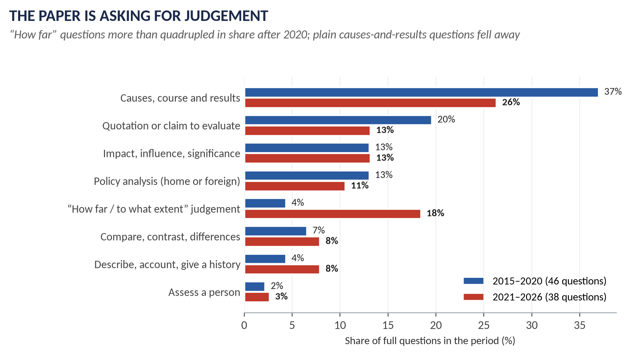
Figure 10 · The eight shapes of question, 2015–2020 against 2021–2026.
Shape | Typical wording | What the answer must do
Causes, course and results | "What led to…", "What were the causes and consequences…", "How did X occur? What was its fallout?" | Causes (long-term, short-term, trigger) → what happened → results (short- and long-term). Rank the causes.
Quotation or claim to evaluate | "'Peel was the most liberal of conservatives…' Examine." | Explain what the quotation means → the case for it → the case against → your verdict on how far it is true.
Impact, influence, significance | "Estimate the influence…", "What was the significance of…" | Name the areas of impact (political, social, economic, religious, international) → evidence in each → which impact mattered most and lasted longest.
Policy analysis | "Discuss the foreign policy of…", "Shed light on the interior and exterior policy…" | Aims → methods → achievements → failures → assessment.
"How far / to what extent" judgement | "How far was the decline of the Empire the result of global pressures rather than internal decisions?" | Weigh the named factor against the alternatives; give a clear percentage-style verdict ("largely", "only partly").
Compare / contrast / differences | "Compare and contrast Socialism and Liberalism…", "How does it differ from…" | Organise by point of comparison, not by one thing then the other; finish with the deepest difference.
Describe / account / give a history | "Give a history of parliamentary reforms 1832–1928" | Chronological, but every stage must say what changed and why it mattered.
Assess a person | "Discuss Churchill as a statesman, warrior and man of letters" | One heading per role the question names; strengths and weaknesses in each; overall verdict.

KEY IDEA · The shift you must prepare for
From 2015–2020 to 2021–2026 the share of "how far / to what extent" questions rose from 4% to 18%, while plain causes-and-results questions fell from 37% to 26%. The newest papers want argument and judgement: a clear thesis at the start, a counter-view, and a verdict. Narrative alone now scores in the middle band at best.

3.10 The command words, decoded
The first word of a question tells you what to do. These are all the command words used in 2015–2026, with how often each introduced a full question (a question can use more than one).
Command | Times | What it demands
What were / What was / What led to / What do you know / In what way | 25 | Explanation with evidence. Deceptively simple: still needs an argument about which causes or features mattered most.
How did / How far / How has | 20 | "How did" = the process, step by step. "How far" = a judgement of extent — you must say how far, in words like "largely" or "only partly".
Discuss | 17 | Examine from more than one side and reach a conclusion. Never a one-sided account.
Explain | 10 | Make clear why or how; causes and connections, not description.
Critically analyse / examine / evaluate | 7 | Break into parts, test each against evidence, show the weaknesses as well as strengths, and judge.
Analyse | 6 | Break the subject into its parts and show how they relate.
Why | 5 | Causes only — ranked, with the most important argued.
Examine | 3 | Investigate closely, weighing evidence.
Describe | 3 | Give an account — but add significance or you will stay in the middle band.
Shed light on / Elucidate | 4 | Explain clearly, often of a quotation — meaning first, then evidence.
Estimate / Assess | 4 | Weigh the importance and give a measured verdict.
Comment / Substantiate | 3 | React to a statement with evidence; "substantiate" means prove it true with evidence.
Do you agree / Argue / Was it… | 5 | Take a side, clearly, and defend it — while showing you understand the other side.
Give an account / a history / Provide an account / Account for | 4 | Chronological narrative that shows change over time.
Define | 2 | A precise one- or two-sentence definition first, before anything else.
Compare and contrast | 1 | Similarities and differences, point by point.
Enumerate / Highlight | 2 | List clearly, with a line or two on each.
Produce an analytical essay / Present a balanced critique | 2 | A full argued essay; balance is compulsory.

3.11 What changed between 2015 and 2026
1. From narrative to judgement. "How far" questions more than quadrupled in share (Part 3.9). The 2025 and 2026 papers ask candidates to argue for or against, to critically evaluate the extent, to assess whether — every question demands a verdict.
2. From high politics to ideas and society. Recent Section-A questions ask about Socialism against Liberalism (2025), party politics and the electorate (2025), abolition and imperialism (2026), and the Industrial Revolution as disruption (2026).
3. Victorian foreign policy has gone quiet. Palmerston, Crimea and the Eastern Question filled the 2015–2017 papers and have not been set since 2017 (Splendid Isolation returned in 2023). A quiet family is a due family.
4. Section B has moved towards the present. Topic 10 (1997 onwards) supplied 16% of Section B's weighted items in 2016–2020 (2.5 of 16) but 40% since 2021 (8 of 20).
5. Questions now name their requirements. "Use regional examples" (2026 Q3); "at least three major real end-of-decolonisation cases" (2026 Q4); "with particular reference to the debates surrounding the Maastricht Treaty and the UK's opt-out from the euro" (2026 Q6). An answer that ignores a named requirement cannot reach the top band.
6. Short notes are now routine in Section B — every year from 2024 to 2026.
7. The repeats continue: Cameron's reforms in consecutive years (2024, 2025); Diana in 2018 and 2026; the French Revolution's influence in the same words in 2020 and 2022.

3.12 Where the next paper could come from
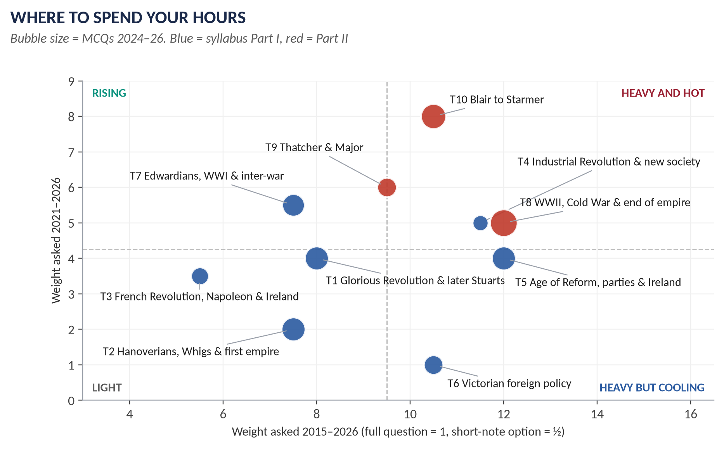
Figure 11 · Each topic's total weight (across) against its weight since 2021 (up). Topics top-right are heavy and still rising.

Tier 1 — prepare to full-answer depth from every angle
Topic | Families
T1 | The Glorious Revolution — causes, nature ("so glorious"?), results at home and abroad
T2 | Walpole and the Whig oligarchy — merits, demerits, downfall
T3 | The French Revolution's influence and impact on Britain
T4 | The Industrial (and Agricultural) Revolution — causes, effects, "disruption or progress"; Methodism; Chartism
T5 | Parliamentary reform 1832–1928; Peel; Gladstone's domestic policy and the Irish Question
T6 | Splendid Isolation — why adopted, why ended
T7 | The First World War — causes, effects on Britain, the decline of the Liberals and rise of Labour
T8 | The Second World War and Churchill; decolonisation (with India 1947 and Suez); the Commonwealth
T9 | Thatcherism; the Falklands; Britain and Europe to Maastricht
T10 | New Labour; the War on Terror; the 2008 crisis; Cameron's reforms; Brexit

Tier 2 — prepare to a full plan and a short-note answer
Union of 1707 · Hanoverian succession · Chatham · American War · Union of 1801 · Palmerston · the Eastern Question, Crimea and Berlin · Disraeli's foreign policy · the League of Nations and inter-war foreign policy · Attlee's government · the special relationship · John Major · the ideas (Utilitarianism, Fabianism, Socialism, Liberalism) · abolition and empire.

Tier 3 — the blind spots most likely to be broken
The Napoleonic Wars and the Congress of Vienna · the Old Colonial System · free trade and the Corn Laws · Edwardian foreign policy and the ententes · the Treaty of Versailles · the Great Depression in Britain · appeasement and rearmament · the war conferences and the UN · NATO · Britain's entry into the EEC (1973) and the 1975 referendum · society and culture since 1960 · the Good Friday Agreement · the post-2016 governments (May to Starmer).
VERDICT · The strategy in one sentence
Master Tier 1 completely, plan Tier 2 fully, and learn Tier 3 to short-note level — because Section B leaves almost no choice, the leaks move topics between sections, and 2023 and 2026 both broke pattern.

Part Four — The Ten Topic Dossiers
HOW TO USE THIS · What a dossier is
Each dossier is a two-to-three-page briefing on one topic: the story in brief, what the syllabus asks for, every question the examiner has set on it (in full), what the record reveals, the blind spots, the core facts, and what the topic's two documents will contain. Read the dossier just before you open that topic's Knowledge Base.

T1 · The Glorious Revolution and the Later Stuarts, 1685–1714
THE STORY IN SIMPLE WORDS
A Catholic king, James II, tries to give Catholics equal rights by royal command in a Protestant country. When a Catholic heir is born in 1688, the political class invites the Dutch Protestant William of Orange to invade. James flees; Parliament makes William and Mary joint monarchs and passes the Bill of Rights. Britain then fights Louis XIV's France in two great wars, wins a place among the great powers at Utrecht (1713), and unites England and Scotland in 1707. When Queen Anne dies in 1714, the crown passes by law to the German House of Hanover.

What the syllabus asks for
Head I — the Glorious Revolution: causes and results; William III and Mary II (1689–1702); Queen Anne (1702–1714). Head III — the Union of England and Scotland.

What the examiner has asked
Paper | The question as set | Family | Type
2015 P1 · Q2 | What forced James II to issue the various Declarations of Indulgence? | The Glorious Revolution | Causes / results
2015 P1 · Q3 | Account for the War of the League of Augsburg followed by the Treaty of Ryswick. | William's and Anne's wars (Augsburg, Spanish Succession) | Causes / results
2018 §A · Q2 | What led to the occurrence of the ultra-degree of mega development towards the close of the 17th century in Britain known as the 'Glorious Revolution'? | The Glorious Revolution | Causes / results
2019 §A · Q2 | What was so glorious about the Glorious Revolution? Discuss its significance in British history. | The Glorious Revolution | Impact / significance
2021 §A · Q2 | What were the political and ideological differences among Non-Jurors, High Churchmen and Latitudinarians? | Church parties after 1688 (Non-Jurors, High Church, Latitudinarians) | Compare / contrast
2021 §A · Q3 | What were the political and constitutional causes and consequences of the Act of Union 1707? | Union of England and Scotland, 1707 | Causes / results
2023 §A · Q2 | How did the Glorious Revolution occur in Britain? What was its fallout at home and abroad? | The Glorious Revolution | Causes / results
2025 §A · Q2 | Discuss the significance of Queen Anne's reign in shaping the course of the War of Spanish Succession and its impact on the balance of power in Europe. | William's and Anne's wars (Augsburg, Spanish Succession) | Impact / significance

What the record reveals
- The Revolution itself is the core — four questions (2015, 2018, 2019, 2023), each from a new angle: what forced James (2015), what led to it (2018), what was so glorious (2019), how it happened and its fallout at home and abroad (2023). Prepare causes, events, settlement, significance and the historians' debate as one block.
- The wars are the second strand — Augsburg and Ryswick (2015), Anne and the Spanish Succession (2025). Both are asked for their significance to Britain's place in Europe (the balance of power).
- The unusual questions — the Church parties after 1688 (2021) and the Union of 1707's political and constitutional causes and consequences (2021) — show the examiner reads the period deeply.

Blind spots and likely next questions
- William III's reign as a whole — his domestic settlement and his foreign policy — has never been set.
- The Act of Settlement (1701) and the Revolution Settlement as a constitutional package.
- Queen Anne's domestic politics (Whigs against Tories; the Sacheverell affair, 1710).
- The Union of 1707 from the Scottish side (the Darien disaster, the Alien Act, the Act of Security).

The core in one page
- People: James II · William III · Mary II · Anne · Marlborough · Louis XIV · the "Immortal Seven" · Archbishop Sancroft · Godolphin · Harley and Bolingbroke · John Locke.
- Dates: Monmouth's rebellion 1685 · Declarations of Indulgence 1687 and 1688 · Seven Bishops acquitted 30 June 1688 · William lands 5 November 1688 · Bill of Rights 1689 · Toleration Act 1689 · the Boyne 1690 · Bank of England 1694 · Ryswick 1697 · Act of Settlement 1701 · Blenheim 1704 · Union 1707 · Utrecht 1713.
- Terms: divine right · dispensing and suspending powers · Glorious Revolution · Revolution Settlement · constitutional monarchy · Non-Jurors · Latitudinarians · balance of power · Act of Union 1707.

What the T1 documents will carry
Maps: the British Isles 1688–1692 (Torbay, the Boyne, Killiecrankie, Glencoe); Europe in the wars against Louis XIV (Blenheim, the gains of Utrecht). Figures: the Stuart–Hanover family tree (why the crown went to Hanover); a time-line 1685–1714; the Revolution Settlement as a diagram of what the Crown lost to Parliament. The T1 Knowledge Base also opens with the full "ABC" section for readers starting from zero.
VERDICT · Priority
Tier 1 for the Glorious Revolution (asked four times); Tier 2 for the wars and the Union. Weight: 8% of the descriptive record; 7 MCQs in three years — one of the heaviest objective topics.

T2 · Hanoverian Britain, the Whig Oligarchy and the First Empire, 1714–1783
THE STORY IN SIMPLE WORDS
The German George I becomes king in 1714. The Tories are suspected of wanting the exiled Stuarts back, so the Whigs rule for nearly fifty years. Robert Walpole (1721–1742) keeps the peace and manages Parliament. The Stuarts try twice to return by force — the Jacobite risings of 1715 and 1745 — and fail at Culloden (1746). Meanwhile a trading empire grows on the Old Colonial System and the slave trade. Pitt the Elder wins the Seven Years' War (1756–1763): Canada and dominance in India. But taxing the American colonists to pay for it leads to the American War of Independence, lost in 1783.

What the syllabus asks for
Head II — the Hanoverian era (1714–1790): the Jacobite rebellions (1715 and 1745); Robert Walpole and the Whig oligarchy; the American War of Independence (1776). Head V — the Old Colonial System.

What the examiner has asked
Paper | The question as set | Family | Type
2015 P1 · Q4 | Evaluate analytically and critically the role of Walpole as Secretary of State, Prime Minister, party organiser and financier. | Walpole and the Whig oligarchy | Person
2015 P1 · Q5 | Shed light on the American War of Independence with special reference to its debit side and credit side for Great Britain. | American War of Independence | Causes / results
2015 P1 · Q8(c) | Short note: Jacobite Revolt of Scotland | The Jacobite risings | Short note
2017 §A · Q2 | What were the merits and demerits of Whig rule? What led to the downfall of Whig ascendancy? Analyze comprehensively. | Walpole and the Whig oligarchy | Causes / results
2019 §A · Q3 | What was the political and constitutional significance of the Hanoverian succession in England? | The Hanoverian succession | Impact / significance
2020 §A · Q2 | What are the merits and demerits of the Whig oligarchy? Critically examine the causes of the downfall of Whig ascendancy. | Walpole and the Whig oligarchy | Causes / results
2022 §A · Q3 | 'A glorious success until 1761 and then failure.' Do you agree with this estimate of the career of Chatham? | Pitt the Elder (Chatham) | Quotation / claim
2026 §A · Q2 | Examine the complex relationships between abolition, imperialism, and economic interests, and argue for or against the notion that Britain's anti-slavery movement was a thinly veiled justification for colonial expansion. | Slavery, abolition and empire | How far / extent

What the record reveals
- Walpole and the Whig oligarchy is the core family (2015, 2017, 2020). Twice it has been asked in nearly the same words: merits and demerits of Whig rule, and the causes of its downfall. This is a near-certain return.
- The Hanoverian succession's political and constitutional significance (2019) — the link between T1 and T2: why the Act of Settlement and a foreign king strengthened Parliament and the Cabinet.
- Chatham (2022) through a historian's verdict: "a glorious success until 1761 and then failure".
- 2026 Q2 opened a new line: abolition, imperialism and economic interests — using the Eric Williams debate.

Blind spots and likely next questions
- The Old Colonial System (Head V) — never set. Mercantilism, the Navigation Acts, and why the system broke in America.
- The Jacobite risings as a full question (only a 2015 short note).
- George III and the "King's Friends" — the end of the Whig ascendancy after 1760.
- The causes of the American war as a question in themselves.

The core in one page
- People: George I, II, III · Walpole · the Pelhams · Pitt the Elder (Chatham) · Lord Bute · Lord North · James the Old Pretender · Charles Edward Stuart · Clive · Wolfe · Washington · Wilberforce.
- Dates: the '15 1715 · Septennial Act 1716 · South Sea Bubble 1720 · Walpole 1721–42 · Excise crisis 1733 · the '45 and Culloden 1745–46 · Seven Years' War 1756–63 · Plassey 1757 · Stamp Act 1765 · Declaration of Independence 4 July 1776 · Saratoga 1777 · Yorktown 1781 · Treaty of Paris 1783 · slave trade abolished 1807.
- Terms: Whig oligarchy · patronage · Jacobitism · mercantilism · Navigation Acts · Old Colonial System · triangular trade · no taxation without representation · salutary neglect.

What the T2 documents will carry
Maps: the '45 (Glenfinnan → Derby → Culloden); the world in 1763 (the gains of the Seven Years' War); the Thirteen Colonies and the American war; the Atlantic triangular trade. Figures: the Hanoverian family tree; Walpole's system as a diagram; a causes-of-the-American-Revolution flow chart.
VERDICT · Priority
Tier 1 for Walpole and the Whigs; Tier 2 for the succession, Chatham, America and abolition; Tier 3 for the Old Colonial System and the Jacobites. Weight 8%; 7 MCQs — as heavy as T1 in the objective paper.

T3 · Pitt, the French Revolution, Napoleon and the Union with Ireland, 1783–1815
THE STORY IN SIMPLE WORDS
William Pitt the Younger becomes Prime Minister at 24 in 1783 and restores Britain's finances. In 1789 the French Revolution breaks out. British opinion divides — Burke against, Paine for — and when France declares war in 1793, Pitt's government clamps down on radicals at home. Ireland rebels in 1798; Pitt's answer is the Act of Union of 1801. Nelson wins at sea (Trafalgar, 1805), Wellington on land (the Peninsula, then Waterloo, 1815), and at the Congress of Vienna Britain emerges as the world's leading power.

What the syllabus asks for
Head IV — the Union of England and Ireland. Head VI — the French Revolution and Napoleonic Wars: causes; Britain and the Napoleonic Wars; impact on Britain.

What the examiner has asked
Paper | The question as set | Family | Type
2016 §A · Q2 | What measures were adopted by England to check the influence of the French Revolution of 1789 on England? | The French Revolution and Britain | Policy analysis
2020 §A · Q3 | Estimate the influence of the French Revolution on English society and political thought. | The French Revolution and Britain | Impact / significance
2022 §A · Q5 | Estimate the influence of the French Revolution on English society and political thought. | The French Revolution and Britain | Impact / significance
2023 §A · Q3 | 'The English people got so much frightened by the developments in France that there prevailed a sort of panic across the country.' Analyse the after-effects of the French Revolution on England. | The French Revolution and Britain | Quotation / claim
2025 §A · Q3 | Analyze the controversies surrounding the Act of Union 1801, focusing on the differing perspectives of Irish and British politicians. Assess its impact on Irish nationalism and the stability of the United Kingdom. | Union with Ireland, 1801 | How far / extent
2025 §B · Q8(a) | Short note: Impact of the French Revolution on the British economy and society | The French Revolution and Britain | Short note

What the record reveals
- One family dominates: the Revolution's influence on Britain — five items (2016, 2020, 2022, 2023, 2025). The question is always about Britain, never about France: the panic, the repression, Burke and Paine, radical societies, the war economy, and long-term effects on reform.
- 2020 Q3 and 2022 Q5 are word for word the same. A third appearance of this exact wording would surprise no one.
- The Union of 1801 (2025) was asked as a controversy: Irish and British perspectives, Irish nationalism, the stability of the UK — a question that bridges T3 and T5.

Blind spots and likely next questions
- Britain and the Napoleonic Wars — the fighting, the strategy (sea power, coalitions, subsidies), the Continental System, the Peninsular War, Waterloo — has never been set, although it is a named sub-head. It is the most likely surprise in Part I.
- The Congress of Vienna and Castlereagh.
- Pitt the Younger as a Prime Minister: finance, reform, war.

The core in one page
- People: Pitt the Younger · Charles James Fox · Edmund Burke · Thomas Paine · Mary Wollstonecraft · Wolfe Tone · Nelson · Wellington · Napoleon · Castlereagh.
- Dates: Pitt PM 1783 · Revolution 1789 · Burke's Reflections 1790 · Paine's Rights of Man 1791–92 · war 1 February 1793 · habeas corpus suspended 1794 · Two Acts 1795 · Irish rising 1798 · Combination Acts 1799–1800 · Union 1 January 1801 · Trafalgar 21 October 1805 · Peninsular War 1808–14 · Waterloo 18 June 1815 · Vienna 1815.
- Terms: Jacobin · radicalism · habeas corpus · Combination Acts · United Irishmen · Continental System · Concert of Europe.

What the T3 documents will carry
Maps: Napoleonic Europe at its height (1812); the campaigns (Nile, Trafalgar, the Peninsula, Waterloo); Ireland in 1798; Europe after Vienna (1815). Figures: the Burke–Paine debate as a two-column diagram; the chain from Revolution to repression to reform.
VERDICT · Priority
Tier 1 for the Revolution's influence on Britain; Tier 2 for the Union of 1801; Tier 3 (high risk) for the Napoleonic Wars. Weight 6% — the lightest topic, but with the most exact repeat in the whole record.

T4 · The Industrial and Agricultural Revolutions and the New Society, c.1750–1900
THE STORY IN SIMPLE WORDS
Between about 1750 and 1850 Britain became the first industrial nation. New farming and enclosure fed more people and pushed labourers into towns. Coal, iron, steam and cotton created factories and cities like Manchester; canals and then railways tied the country together. Life for workers was hard and dangerous. People answered this new world with new beliefs and movements: Methodism brought religion to the poor; Utilitarians and Liberals argued for reform and free markets; Socialists and later the Fabians for collective action; and the Chartists (1838–1848) demanded the vote for working men.

What the syllabus asks for
Head VII — Industrial and Agricultural Revolution: causes; effects on political and social life; party politics; the Methodist Movement; Socialism; Liberalism; Colonization; the Chartist Movement.

What the examiner has asked
Paper | The question as set | Family | Type
2015 P1 · Q8(a) | Short note: Industrial Revolution | The Industrial (and Agricultural) Revolution | Short note
2015 P1 · Q8(b) | Short note: Methodist Movement | The Methodist Movement | Short note
2015 P2 · Q3 | Describe the emergence of the Methodist Movement in England. What were its good and bad effects on the people? | The Methodist Movement | Causes / results
2016 §B · Q8(c) | Short note: Fabianism | Ideas: Liberalism, Socialism, Utilitarianism, Fabianism | Short note
2017 §A · Q3 | The Industrial Revolution drastically changed methods of production in England. How did it affect the social, economic, political and cultural life of the English people? | The Industrial (and Agricultural) Revolution | Impact / significance
2017 §A · Q4 | Give a comprehensive account of the Chartist Movement. Why did it fail? Explain and analyse. | Chartism | Causes / results
2018 §A · Q3 | 'The 18th century witnessed the emergence, rise and growth of two movements (Agrarian and Industrial) which revolutionised the lives of the English people in particular and later the world in general.' Comment on the statement. | The Industrial (and Agricultural) Revolution | Quotation / claim
2019 §A · Q4 | Explain the factors that led to the Industrial Revolution and discuss how it affected the social, political, economic and cultural life of the English people. | The Industrial (and Agricultural) Revolution | Causes / results
2022 §B · Q8(c) | Short note: Utilitarianism | Ideas: Liberalism, Socialism, Utilitarianism, Fabianism | Short note
2024 §A · Q3 | Describe the reasons due to which millions of people united in support of the Chartist Movement in the mid-19th century to attain democratic rights for the working classes. | Chartism | Causes / results
2024 §A · Q4 | How did the Methodist Movement begin? Also explain its salient features and reasons for success. | The Methodist Movement | Causes / results
2025 §A · Q5 | Compare and contrast the ideologies of Socialism and Liberalism in Britain during the 19th century, examining their differing approaches to issues such as economic inequality, social justice and the role of the state. | Ideas: Liberalism, Socialism, Utilitarianism, Fabianism | Compare / contrast
2025 §B · Q8(b) | Short note: Methodist Movement | The Methodist Movement | Short note
2026 §A · Q3 | Critically evaluate the extent to which the Industrial Revolution transformed British society more through disruption than through progress. Use regional examples to support your argument. | The Industrial (and Agricultural) Revolution | How far / extent

What the record reveals
- This is the most-asked topic by number of items (14). Three families: the Industrial Revolution (5), Methodism (4) and Chartism (2), plus the ideas (3).
- The Industrial Revolution has been asked for its causes and its effects on "social, economic, political and cultural life" (2017, 2019) — the same four areas each time — and in 2026 as a historians' debate: more disruption than progress? Use regional examples.
- Methodism has been asked for its emergence, effects, features and reasons for success — and set as a short note twice.
- Chartism has been asked for why it failed (2017) and why millions supported it (2024): prepare both.

Blind spots and likely next questions
- The Agricultural Revolution on its own (enclosure, Tull, Townshend, Bakewell).
- Colonization (named in the syllabus, never asked).
- Utilitarianism's influence on reform (Bentham, Chadwick, the Poor Law) as a full question.
- The factory reform movement (Factory Acts 1833, 1844, 1847).

The core in one page
- People: John Wesley · George Whitefield · James Watt · Richard Arkwright · George Stephenson · Jeremy Bentham · J. S. Mill · Robert Owen · Feargus O'Connor · William Lovett · Sidney and Beatrice Webb.
- Dates: Wesley's conversion 1738 · Watt's patent 1769 · Arkwright's Cromford mill 1771 · Liverpool–Manchester railway 1830 · Factory Act 1833 · Tolpuddle Martyrs 1834 · People's Charter 1838 · Newport Rising 1839 · Kennington Common 10 April 1848 · Great Exhibition 1851 · Fabian Society 1884.
- Terms: enclosure · factory system · laissez-faire · Methodism · the Halévy thesis · Utilitarianism · Chartism (the six points) · Fabianism · Owenite socialism.

What the T4 documents will carry
Maps: industrial Britain c.1850 (coalfields, textile and iron districts, canals and the first railways); Chartist Britain (Newport, Birmingham, Manchester, Kennington). Figures: the causes of the Industrial Revolution as a web; population and urban growth charts; the six points of the Charter and when each was granted; the family tree of the ideas (Liberalism → Utilitarianism → Socialism → Fabianism).
VERDICT · Priority
Tier 1 throughout. Weight 12% — the third-heaviest. Only 2 MCQs so far, but the descriptive weight makes this a must-master topic.

T5 · The Age of Reform: Parliament, Parties, Peel, Gladstone and Ireland, 1815–1928
THE STORY IN SIMPLE WORDS
After Waterloo the old Parliament — with its rotten boroughs and tiny electorate — faced a nation that had changed. Repression (Peterloo, 1819) gave way to reform: Catholic Emancipation (1829), the Great Reform Act (1832) and a decade of reforming laws. Peel built the Conservative Party, then split it by repealing the Corn Laws (1846). Out of the wreck came Gladstone's Liberals and Disraeli's Conservatives, who took turns to widen the vote (1867, 1884) and reform the state. Gladstone's great cause was Ireland; his Home Rule Bills failed in 1886 and 1893. The story ends with votes for women (1918, 1928) and the Irish Free State (1922).

What the syllabus asks for
Head VIII — Robert Peel and the return of the Tories: internal policies; the Irish problem. Head IX (home) — Victorian internal reforms; the Liberals; Disraeli, Gladstone and the problems in Ireland; Great Britain and free trade. With party politics from Head VII.

What the examiner has asked
Paper | The question as set | Family | Type
2015 P1 · Q6 | The short reign of William IV is considered to be the long era of bills and acts. Substantiate the statement with supportive arguments. | Parliamentary reform 1832–1928 | Quotation / claim
2016 §A · Q3 | Analyze critically the Reform Act of 1832. | Parliamentary reform 1832–1928 | Impact / significance
2017 §A · Q5 | 'Gladstone's domestic policy was the climax of liberalism.' Discuss comprehensively. | Gladstone's domestic policy | Quotation / claim
2018 §A · Q4 | Shed ample light on the interior as well as exterior policy of Sir Robert Peel as British Premier, with particular emphasis on the Irish issue. | Sir Robert Peel | Policy analysis
2018 §A · Q5 | What measures were taken for the democratisation of the British Parliament over the decades? | Parliamentary reform 1832–1928 | Describe / account
2019 §A · Q5 | The Reform Act of 1832 made possible the series of political and administrative reforms that laid the foundation of modern Britain. Discuss. | Parliamentary reform 1832–1928 | Quotation / claim
2020 §A · Q4 | Give a history of parliamentary reforms between 1832 and 1928. Also critically examine how England became a politically democratic country. | Parliamentary reform 1832–1928 | Describe / account
2020 §A · Q5 | 'Peel was the most liberal of conservatives and the most conservative of liberals.' Examine the statement critically. | Sir Robert Peel | Quotation / claim
2022 §A · Q2 | The domestic policy of Gladstone was the climax of liberalism during the 19th century. Discuss and analyze. | Gladstone's domestic policy | Quotation / claim
2024 §A · Q1 | How far did Robert Peel's methods of governance differ from those of his predecessors, viz. Liverpool, Canning and Wellington? | Sir Robert Peel | Compare / contrast
2024 §A · Q2 | Define the 'Irish Question'. Also discuss the policy of the Liberal Party on the said issue from 1886 to 1894. | The Irish Question and Home Rule | Policy analysis
2025 §A · Q4 | Examine the evolution of party politics in Britain during the 19th century, focusing on the rise of the Conservative and Liberal parties, and the changing relationship between government, parliament and the electorate. | Rise of the Conservative and Liberal parties | Describe / account

What the record reveals
- This is the heaviest topic by weight (12 full questions). Three families lead: parliamentary reform (5), Peel (3) and Gladstone's domestic policy (2, the same quotation).
- Reform has been asked as the 1832 Act (2016, 2019), the whole road to democracy (2018, 2020: 1832–1928) and William IV's reforming decade (2015). Prepare one master time-line of every Act and what it changed.
- Peel has been asked three ways — his policies, a quotation, and a comparison with Liverpool, Canning and Wellington (2024).
- Ireland entered through the Liberal policy of 1886–1894 (2024), and party politics through the rise of the Conservative and Liberal parties (2025).

Blind spots and likely next questions
- Disraeli's domestic policy ("Tory democracy", the 1867 Act, the social reforms of 1874–80).
- Free trade and the Anti-Corn Law League — a named sub-head, never set.
- The Irish Famine (1845–1849) and its political effects.
- The suffrage movement and votes for women.

The core in one page
- People: Lord Liverpool · Canning · Wellington · Earl Grey · William IV · Peel · Cobden and Bright · Daniel O'Connell · Gladstone · Disraeli · Parnell · Emmeline Pankhurst.
- Dates: Peterloo 1819 · Catholic Emancipation 1829 · Reform Act 1832 · slavery abolished 1833 · New Poor Law 1834 · Tamworth Manifesto 1834 · Corn Laws repealed 1846 · Second Reform Act 1867 · Irish Church disestablished 1869 · Education Act 1870 · Ballot Act 1872 · Third Reform Act 1884 · Home Rule Bills 1886 and 1893 · Parliament Act 1911 · women over 30 vote 1918 · Irish Free State 1922 · equal franchise 1928.
- Terms: rotten and pocket boroughs · franchise · Tamworth Manifesto · Corn Laws · Peelites · Gladstonian Liberalism ("peace, retrenchment and reform") · Tory democracy · Home Rule.

What the T5 documents will carry
Maps: rotten boroughs against the new industrial towns in 1832; Ireland 1845–1922 (the Famine's toll by county, Ulster, partition). Figures: the franchise ladder 1832–1928 (share of adults able to vote); a Peel-versus-predecessors comparison table; the two-party system's family tree (Whig → Liberal; Tory → Conservative; the Peelite split).
VERDICT · Priority
Tier 1. Weight 13% — joint heaviest. 7 MCQs. The reform time-line alone answers five past questions.

T6 · Victorian Britain and the World: Palmerston to Splendid Isolation, 1815–1907
THE STORY IN SIMPLE WORDS
Victorian Britain wanted three things abroad: a balance of power in Europe so that no single state dominated, safe sea routes to India, and free trade everywhere. Palmerston defended these interests with loud words and gunboats. The slow decline of the Ottoman Empire — the Eastern Question — brought war with Russia in the Crimea (1854–1856) and, under Disraeli, the Congress of Berlin (1878). Gladstone preferred morality and the Concert of Europe. At the end of the century Britain stood apart from Europe's alliances — Splendid Isolation — until Germany's rise pushed it into agreements with Japan (1902), France (1904) and Russia (1907).

What the syllabus asks for
Head IX — Victorian foreign policy (and Disraeli and Gladstone). Head X — Edwardian foreign policy (1901–1910).

What the examiner has asked
Paper | The question as set | Family | Type
2015 P1 · Q7 | 'Palmerston was at once a Radical and Jingo, but at heart neither a Whig nor a Tory.' Elucidate. | Palmerston | Quotation / claim
2015 P2 · Q2 | Palmerston was conservative at home and liberal abroad. Discuss and conclude with arguments. | Palmerston | Quotation / claim
2015 P2 · Q4 | Analyze the characters and policies of Gladstone and Disraeli with special reference to foreign affairs. | Gladstone vs Disraeli; Disraeli abroad | Compare / contrast
2015 P2 · Q5 | What was the background in the context of which the Crimean War broke out? Discuss and analyze the results that followed the cessation of hostilities. | The Eastern Question, Crimea, Berlin | Causes / results
2015 P2 · Q7 | Why did Britain adopt the Policy of Splendid Isolation from 1870 onwards in external affairs? How was this policy abandoned by the end of the 19th century? Discuss and analyze. | Splendid Isolation and its end | Causes / results
2016 §A · Q4 | 'Lord Palmerston was more successful as Foreign Minister than as Prime Minister.' Critically analyze. | Palmerston | Quotation / claim
2016 §A · Q5 | Explain the policy of Disraeli with special reference to 'Peace with Honour'. | Gladstone vs Disraeli; Disraeli abroad | Policy analysis
2016 §B · Q8(b) | Short note: Treaty of Berlin | The Eastern Question, Crimea, Berlin | Short note
2017 §B · Q6 | Explain the Eastern Question and critically analyse the attitude of England towards this question from 1820 to 1913. | The Eastern Question, Crimea, Berlin | Policy analysis
2018 §B · Q6 | How did Britain put a halt to the Policy of Splendid Isolation? What were its positive and negative aspects? | Splendid Isolation and its end | Causes / results
2023 §A · Q4 | Why did Britain initiate the Policy of Splendid Isolation? What is your personal opinion whether it was a right step in the right direction or proved detrimental? | Splendid Isolation and its end | How far / extent

What the record reveals
- Four families, all asked often until 2018: Palmerston (three quotations to evaluate, 2015–2016), Gladstone against Disraeli abroad (2015, 2016 — "Peace with Honour"), the Eastern Question (Crimea 2015, Berlin 2016, the whole question 1820–1913 in 2017) and Splendid Isolation (2015, 2018, 2023).
- Splendid Isolation is the living family — the only one set after 2018. It has been asked why adopted (twice) and how ended (once), with a demand for the student's own opinion in 2023.
- The quiet since 2018 is a warning, not a comfort. This topic supplied ten items between 2015 and 2018; it will return.

Blind spots and likely next questions
- Castlereagh and Canning (1815–1827) — the Congress system and Canning's break with it.
- The Scramble for Africa and the Boer War — imperialism as a question in itself.
- The Great Game in Central Asia (asked as a 2024 MCQ).
- Gladstone's foreign policy on its own (Alabama arbitration, Egypt, Gordon).

The core in one page
- People: Castlereagh · Canning · Palmerston · Disraeli · Gladstone · Lord Salisbury · Joseph Chamberlain · Lord Lansdowne · Edward Grey · Nicholas I · Bismarck.
- Dates: Belgian independence guaranteed 1839 · Opium War 1839–42 · Don Pacifico 1850 · Crimean War 1854–56 · Treaty of Paris 1856 · Indian Mutiny 1857 · Suez Canal opens 1869 · Suez shares 1875 · Royal Titles Act 1876 · San Stefano and Berlin 1878 · Egypt occupied 1882 · Boer War 1899–1902 · Anglo-Japanese Alliance 1902 · Entente Cordiale 1904 · Anglo-Russian Convention 1907.
- Terms: balance of power · Concert of Europe · gunboat diplomacy · Civis Romanus sum · Eastern Question · Straits question · Peace with Honour · Splendid Isolation · Entente.

What the T6 documents will carry
Maps: the Eastern Question (the Ottoman Empire, the Straits, the Crimea); the Balkans in 1878 (San Stefano against Berlin, side by side); the route to India (Gibraltar, Malta, Suez, Aden); Africa in 1914; Europe's alliances in 1907. Figures: Palmerston's principles; Gladstone against Disraeli comparison table; the end of Splendid Isolation as a three-step time-line.
VERDICT · Priority
Tier 1 for Splendid Isolation; Tier 2 for Palmerston, the Eastern Question and Disraeli abroad (quiet, therefore due). Weight 11%; 4 MCQs.

T7 · Edwardian Britain, the Great War and the Road to 1939
THE STORY IN SIMPLE WORDS
Edward VII (1901–1910) reigned over a confident but troubled country. The Liberals won a landslide in 1906 and began the welfare state (pensions, National Insurance); Lloyd George's budget led to the Parliament Act of 1911, which cut the power of the Lords. The new Labour Party entered Parliament. In 1914 Britain went to war with Germany. The Great War cost about three-quarters of a million British lives, changed society for ever and broke the Liberal Party. After the Treaty of Versailles and the League of Nations, Britain faced depression and, in the 1930s, the dictators. Chamberlain tried appeasement until Hitler invaded Poland in 1939.

What the syllabus asks for
Head X — the Edwardian era: domestic and foreign policies (1901–1910); the origins of the Labour Party. Head XI — Britain, World War I and its aftermath: causes; the peace settlement; effects of the war on Britain; the League of Nations; the Great Depression; appeasement and rearmament.

What the examiner has asked
Paper | The question as set | Family | Type
2015 P2 · Q8 | Describe and critically analyze the foreign policy of England from 1919 to 1939. | Inter-war foreign policy and the League | Policy analysis
2020 §B · Q7 | What do you know about the League of Nations? Explain the work of the League. What were the causes of its failure? | Inter-war foreign policy and the League | Causes / results
2021 §A · Q4 | Provide a detailed account of the causes of World War I and its effects on the social and economic aspects of Britain. | The First World War and its effects | Causes / results
2021 §A · Q5 | What is the Edwardian era? Elucidate the rise and significance of the Labour Movement in the Edwardian era. | Edwardian era and the rise of Labour | Describe / account
2022 §A · Q4 | Discuss the rise of the Labour Party in Britain and enumerate the achievements of this party. | Edwardian era and the rise of Labour | Describe / account
2022 §B · Q8(a) | Short note: Lord Kitchener | The First World War and its effects | Short note
2023 §A · Q5 | According to Rudyard Kipling, 'however the world pretends to divide itself, there are only two divisions in the world today — human beings and Germans.' In the light of this statement, was British policy in the First World War justified or not? Comment. | The First World War and its effects | Quotation / claim
2026 §A · Q5 | Critically evaluate the effects of World War I on British social structure, industrial relations, and the polity, highlighting the ways in which the war accelerated the decline of the Liberal Party and paved the way for Labour's rise to power. | The First World War and its effects | Impact / significance

What the record reveals
- The First World War is the core — its causes and effects (2021), British policy judged through Kipling (2023), and its effects on society, industrial relations and politics, including the decline of the Liberals and the rise of Labour (2026). Kitchener appeared as a short note (2022).
- The Labour Party's rise has been set twice in two years (2021, 2022). With 2026's Liberal-decline question, this is a family on the boil.
- The inter-war years have been asked only twice (foreign policy 1919–39 in 2015; the League in 2020).

Blind spots and likely next questions
- Appeasement and rearmament — a named sub-head, never set since 2015, and the most famous controversy of the period.
- The Treaty of Versailles and Britain's role in the peace settlement.
- The Great Depression in Britain (1929–1933: the National Government, the end of the gold standard, the hungry thirties).
- The Liberal reforms of 1906–1914 and the Parliament Act crisis.

The core in one page
- People: Edward VII · Campbell-Bannerman · Asquith · Lloyd George · Keir Hardie · Ramsay MacDonald · Edward Grey · Kitchener · Haig · Baldwin · Chamberlain · Churchill (in the 1930s).
- Dates: LRC founded 1900 · Taff Vale 1901 · Liberal landslide 1906 · pensions 1908 · People's Budget 1909 · Parliament Act 1911 · war declared 4 August 1914 · conscription 1916 · the Somme 1 July 1916 · Representation of the People Act 1918 · Armistice 11 November 1918 · Versailles 28 June 1919 · first Labour government 1924 · General Strike 1926 · National Government 1931 · Munich 30 September 1938 · war 3 September 1939.
- Terms: Edwardian era · New Liberalism · Lib-Lab pact · Taff Vale judgment · DORA · total war · collective security · appeasement · rearmament.

What the T7 documents will carry
Maps: Europe in 1914 (the two alliance blocs); the Western Front; Europe after Versailles (1919–23); Hitler's expansion 1936–39 (Rhineland, Austria, Sudetenland, Prague, Poland). Figures: the causes of WWI as a long-term/short-term/trigger diagram; Liberal and Labour seats 1900–1935 (the crossover); the appeasement debate as for-and-against columns.
VERDICT · Priority
Tier 1 for WWI and Labour; Tier 3 (high risk) for appeasement and Versailles. Weight 8%; 6 MCQs.

T8 · The Second World War, Attlee, the Cold War and the End of Empire, 1939–1979
THE STORY IN SIMPLE WORDS
Churchill led Britain from 1940 through Dunkirk, the Battle of Britain and the Blitz to victory in 1945, alongside the USA and the USSR. The war conferences and the United Nations shaped the peace. Attlee's Labour government built the welfare state and the NHS. The Cold War made Britain America's closest ally (NATO, 1949). The Empire came to an end: India and Pakistan in 1947, Palestine in 1948, humiliation at Suez in 1956, Africa in the 1960s. Britain turned to Europe, joining the EEC in 1973, and struggled with inflation and strikes until the Winter of Discontent of 1978–79.

What the syllabus asks for
Head XII — Britain, World War II and its aftermath: causes and events; Churchill and the war conferences; the creation of the UNO; effects of the war; reforms of the Labour government. Head XIII — Great Britain and the Cold War: the creation of the Commonwealth; NATO; decolonisation of the British Empire; internal policies and the EEC; foreign policy.

What the examiner has asked
Paper | The question as set | Family | Type
2015 P2 · Q6 | How has the idea of the British Commonwealth of Nations developed? In what ways does its significance differ from the term British Empire? | The Commonwealth | Compare / contrast
2016 §B · Q8(a) | Short note: Second World War | The Second World War and Churchill | Short note
2017 §B · Q7 | What do you understand by the British Commonwealth of Nations and how did it develop? How does it differ from the term British Empire? | The Commonwealth | Compare / contrast
2018 §B · Q7 | Why is it believed in certain circles that after decolonisation Britain was subservient to the US line of action during the Cold War and thereafter, down to 9/11 and subsequent years? Do you agree or not? Argue. | The special relationship with the USA | How far / extent
2018 §B · Q8(a) | Short note: Sir Winston Churchill | The Second World War and Churchill | Short note
2019 §B · Q6 | How successfully did the Labour government of 1945–51 tackle the economic and social problems of post-World War II Britain? | Attlee’s Labour government 1945–51 | How far / extent
2019 §B · Q7 | What were the motives behind Britain's move to decolonisation after 1945? Also explain why and how the British left India in 1947. | Decolonisation, India, Palestine, Suez | Causes / results
2020 §B · Q6 | What do you know about the Middle East and Suez Canal Crisis? Also explain why England withdrew from Palestine and the Suez Canal. Discuss. | Decolonisation, India, Palestine, Suez | Causes / results
2022 §B · Q7 | Discuss Winston Churchill as a statesman, warrior and a man of letters. | The Second World War and Churchill | Person
2022 §B · Q8(b) | Short note: Suez Canal Crisis | Decolonisation, India, Palestine, Suez | Short note
2023 §B · Q6 | Produce an analytical essay on the causes, major developments and aftermath of the Second World War. | The Second World War and Churchill | Causes / results
2024 §B · Q6 | How did World War II and the Cold War trigger the decolonization of the British Empire? | Decolonisation, India, Palestine, Suez | Causes / results
2024 §B · Q7(c) | Short note: Creation of the Commonwealth | The Commonwealth | Short note
2026 §A · Q4 | How far was the decline of the British Empire after 1945 the result of global pressures rather than internal political decisions? Support your analysis with at least three major real end-of-decolonisation cases. | Decolonisation, India, Palestine, Suez | How far / extent

What the record reveals
- Decolonisation is the dominant family — five items (2019, 2020, 2022, 2024, 2026). It has been asked through India (2019), Palestine and Suez (2020, 2022), WWII and the Cold War as triggers (2024), and global pressures against internal decisions, with three real cases (2026).
- The Commonwealth — its development and difference from the Empire — has been set twice in almost the same words (2015, 2017), plus a short note (2024).
- WWII and Churchill (four items) and Attlee's government (2019) complete the core; the special relationship (2018) is the link to T9 and T10.

Blind spots and likely next questions
- The war conferences (Tehran, Yalta, Potsdam) and the creation of the UN — never set.
- NATO and Britain's Cold War foreign policy.
- Britain's road into Europe (1961, 1963, 1967, 1973, 1975).
- Home policies 1951–1979 — "never had it so good", the 1960s, the 1970s crises.

The core in one page
- People: Churchill · Attlee · Bevin · Bevan · Beveridge · Eden · Macmillan · Wilson · Heath · Callaghan · Mountbatten · Jinnah · Nehru · Nasser · de Gaulle.
- Dates: Churchill PM 10 May 1940 · Dunkirk May–June 1940 · Beveridge Report 1942 · D-Day 6 June 1944 · Yalta February 1945 · UN Charter 1945 · Labour landslide July 1945 · independence 14–15 August 1947 · Palestine left May 1948 · NHS 5 July 1948 · NATO 4 April 1949 · London Declaration 1949 · Suez 1956 · Ghana 1957 · "wind of change" 1960 · EEC entry 1 January 1973 · referendum 1975 · Winter of Discontent 1978–79.
- Terms: total war · Beveridge's five giants · welfare state · nationalisation · special relationship · containment · decolonisation · Commonwealth · wind of change · post-war consensus ("Butskellism").

What the T8 documents will carry
Maps: Europe at war 1942; the partition of India, 1947; Palestine 1947–48; Suez 1956; decolonisation by date (a world map coloured by year of independence); NATO and the Warsaw Pact. Figures: Beveridge's five giants and the Acts that answered them; the three levels of decolonisation (international, British, colonial); the Commonwealth's growth.
VERDICT · Priority
Tier 1. Weight 13% — joint heaviest — and the heaviest objective topic (10 MCQs). In Section B it cannot be avoided.

T9 · Thatcher and Major: Thatcherism, the Falklands and Europe, 1979–1997
THE STORY IN SIMPLE WORDS
Margaret Thatcher came to power in 1979 promising to reverse Britain's decline. She fought inflation, cut the unions' power (defeating the miners' strike of 1984–85), sold state industries and council houses, and reformed education. She won the Falklands War in 1982 and stood with Reagan as the Cold War ended — but her hostility to European integration and the poll tax led her party to remove her in 1990. John Major signed the Maastricht Treaty (1992), won a surprise election, then lost authority after Black Wednesday and a party split over Europe, and was swept away by Blair in 1997.

What the syllabus asks for
Head XIV (first half) — internal policy; society and culture; foreign policy; the Falklands War; John Major and his policies; the European Common Market and Great Britain; the formation of the EU.

What the examiner has asked
Paper | The question as set | Family | Type
2016 §B · Q6 | 'Margaret Thatcher is judged to be the best post-war Prime Minister of England.' Discuss. | Thatcher and Thatcherism | Quotation / claim
2018 §B · Q8(b) | Short note: Britain's role in the EU | Britain and Europe (EEC/EU) | Short note
2019 §B · Q8 | Explain why John Major and the Conservatives won the general election of 1992 but lost the election of 1997. | John Major | Causes / results
2020 §B · Q8 | What were the causes of the Falkland War? In what way has it affected Britain's relationship with Latin American countries? | The Falklands War | Causes / results
2021 §B · Q6 | What was the Falkland Islands conflict? Why did the British invade the Falkland Islands and how did this war come to an end? | The Falklands War | Causes / results
2021 §B · Q7 | What was the contribution of Great Britain to the formation of the European Common Market and the European Union? Also highlight its impact on the foreign policy of Britain. | Britain and Europe (EEC/EU) | Policy analysis
2022 §B · Q6 | Explain the genesis of the Falkland War. How has it affected Britain's relationship with Latin American countries? | The Falklands War | Causes / results
2024 §B · Q5 | Define the term 'Thatcherism'. Discuss Margaret Thatcher's economic and educational reforms and their impacts on people's lives. | Thatcher and Thatcherism | Policy analysis
2024 §B · Q7(a) | Short note: Falkland War | The Falklands War | Short note
2026 §B · Q6 | Discuss the impact of European integration on British politics and identity since 1973, with particular reference to the debates surrounding the Maastricht Treaty and the UK's opt-out from the euro. | Britain and Europe (EEC/EU) | Impact / significance
2026 §B · Q8(c) | Short note: John Major's foreign policy | John Major | Short note

What the record reveals
- The Falklands War is the most-repeated modern family — three full questions in three consecutive years (2020, 2021, 2022) and a short note (2024). Twice the question has asked about relations with Latin America afterwards.
- Thatcher has been asked as a judgement ("the best post-war PM", 2016) and as a definition plus policies (economic and educational reforms, 2024).
- Britain and Europe runs through T8, T9 and T10: the contribution to the Common Market and the EU (2021), a short note (2018) and European integration since 1973, Maastricht and the euro opt-out (2026).
- John Major: why he won in 1992 and lost in 1997 (2019), and his foreign policy (2026 short note).

Blind spots and likely next questions
- Society and culture in the 1980s (a named sub-head).
- Thatcher's foreign policy as a whole (the Cold War, Reagan, Gorbachev, Hong Kong, South Africa).
- Northern Ireland from 1979 to 1997 (hunger strikes, Brighton, the Anglo-Irish Agreement, the Downing Street Declaration).
- The miners' strike and the trade union laws.

The core in one page
- People: Margaret Thatcher · Geoffrey Howe · Nigel Lawson · Arthur Scargill · Michael Heseltine · Galtieri · Reagan · Gorbachev · Jacques Delors · John Major · Norman Lamont.
- Dates: Thatcher PM 4 May 1979 · Argentine invasion 2 April 1982 · Belgrano sunk 2 May 1982 · Stanley surrenders 14 June 1982 · miners' strike March 1984 – March 1985 · Single European Act 1986 · Big Bang 1986 · Education Reform Act 1988 · Bruges speech 1988 · Thatcher resigns 22 November 1990 · Maastricht 1992 · election 9 April 1992 · Black Wednesday 16 September 1992 · Labour landslide 1 May 1997.
- Terms: Thatcherism · monetarism · privatisation · Right to Buy · the enemy within · Total Exclusion Zone · Single European Act · ERM · opt-out · Euroscepticism.

What the T9 documents will carry
Maps: the Falklands War (South Atlantic, the Exclusion Zone, the Belgrano, San Carlos, Goose Green, Stanley); the coalfields of the miners' strike; the European Community's enlargement 1973–1995. Figures: inflation and unemployment under Thatcher; privatisations time-line; the Maastricht "three pillars" and the opt-outs.
VERDICT · Priority
Tier 1. Weight 10%; 4 MCQs. The Falklands and Europe are the likeliest Section-B choices after decolonisation.

T10 · Blair to Burnham: New Labour, the War on Terror, Crisis and Brexit, 1997–2026
THE STORY IN SIMPLE WORDS
Tony Blair's New Labour won in 1997 with a promise of modernisation: devolution, peace in Northern Ireland (1998), an independent Bank of England and heavy investment in public services. After 9/11 Blair joined the USA in Afghanistan and Iraq (2003) — the most divisive decision of the era. Gordon Brown faced the 2008 financial crisis. David Cameron's coalition imposed austerity and reformed welfare, schools and marriage law, then lost the EU referendum of 2016. May and Johnson delivered Brexit (2020); Johnson led through the pandemic; Elizabeth II died in 2022; Truss fell after 49 days; Sunak steadied the ship; and Starmer won a landslide in 2024.

What the syllabus asks for
Head XIV (second half) — Tony Blair, "New Labour", the economic crunch, the War on Terror and his policies; the Global Financial Crisis 2008 and Great Britain; reforms under Cameron. These notes extend the topic to 2026.

What the examiner has asked
Paper | The question as set | Family | Type
2016 §B · Q7 | Discuss the main features of the foreign policy of David Cameron with special reference to the Middle East. | David Cameron | Policy analysis
2017 §B · Q8 | What are the advantages and disadvantages of Brexit for England? Analyse with arguments. | Brexit | Impact / significance
2018 §B · Q8(c) | Short note: Lady Diana | Diana, Princess of Wales | Short note
2021 §B · Q8 | What were the salient features of Tony Blair's policy on the War on Terror? How did his policy affect US-Britain relations? | The War on Terror | Policy analysis
2023 §B · Q7 | 'We will find those who did it, we will smoke them out of their holes, we will get them running and we will bring them to justice.' In the context of this remark, present a balanced critique of the War on Terror with special emphasis on the role of Great Britain. | The War on Terror | Quotation / claim
2023 §B · Q8 | How did the global financial crisis plunge Britain into recession in the 21st century and how did it respond? | The 2008 financial crisis | Causes / results
2024 §B · Q7(b) | Short note: Reforms under David Cameron | David Cameron | Short note
2025 §B · Q6 | How did the policies of New Labour under Tony Blair differ from those of previous Labour governments? Was it a continuation of Thatcherism by other means, or did it represent a distinct political project? | Blair and New Labour | How far / extent
2025 §B · Q7 | How did the global financial crisis of 2008 impact British politics and society? How did the responses of the Labour and Conservative governments differ, and what were their long-term effects? | The 2008 financial crisis | Impact / significance
2025 §B · Q8(c) | Short note: Reforms under Cameron Government | David Cameron | Short note
2026 §B · Q7 | From 1997 to 2012, Britain saw dramatic shifts in foreign policy, constitutional reform and international identity. Assess whether the period should be interpreted as one of renewal or of unresolved contradictions in British governance. | Blair and New Labour | How far / extent
2026 §B · Q8(a) | Short note: Britain's role in the War on Terror | The War on Terror | Short note
2026 §B · Q8(b) | Short note: Lady Diana Spencer | Diana, Princess of Wales | Short note

What the record reveals
- The newest topic is the fastest-rising: 8 of its 10.5 weighted items came in 2021–2026, and it was asked in every paper from 2023 to 2026.
- Four families lead: the War on Terror (2021, 2023, 2026 sn), the 2008 crisis (2023, 2025), New Labour (2025, 2026 — both judgement questions) and Cameron (2016 foreign policy; reforms as short notes in 2024 and 2025).
- Brexit was asked in 2017, a year after the referendum. Diana has been a short note twice (2018, 2026).

Blind spots and likely next questions
- Brexit's causes and consequences (not asked since 2017, and now a finished story).
- Devolution and the Union — the Scottish referendum of 2014, Northern Ireland after Brexit.
- Brown's premiership as a whole.
- The post-2016 governments — May, Johnson, Truss, Sunak, Starmer — and the monarchy (Elizabeth II's reign, Charles III).

The core in one page
- People: Tony Blair · Gordon Brown · Alastair Campbell · George W. Bush · Saddam Hussein · David Cameron · Nick Clegg · George Osborne · Theresa May · Boris Johnson · Liz Truss · Rishi Sunak · Keir Starmer · Diana · Charles III.
- Dates: Blair's landslide 1 May 1997 · Diana dies 31 August 1997 · Good Friday Agreement 10 April 1998 · devolved parliaments 1999 · 9/11 2001 · Iraq invaded 20 March 2003 · 7/7 2005 · Northern Rock 2007 · Lehman collapse 15 September 2008 · coalition May 2010 · Scottish referendum 18 September 2014 · EU referendum 23 June 2016 · Brexit 31 January 2020 · Elizabeth II dies 8 September 2022 · Starmer's landslide 4 July 2024.
- Terms: New Labour · Third Way · devolution · liberal interventionism · War on Terror · Chilcot Report · credit crunch · quantitative easing · austerity · Big Society · Brexit · Article 50.

What the T10 documents will carry
Maps: Iraq and Afghanistan (Basra, Helmand); the 2016 referendum result by nation and region; devolved Britain. Figures: the 2008 crisis as a chain from sub-prime to austerity; New Labour against Old Labour and Thatcherism (a three-column comparison); Prime Ministers 1997–2026 time-line; election results 1997–2024.
VERDICT · Priority
Tier 1. Weight 11%; 8 MCQs. The most current topic and, since 2021, the most frequently asked.

Part Five — How a British History Answer Scores

5.1 What the examiner is actually marking
A British History examiner reads hundreds of scripts that tell the same story. What separates the marks is not how much history a candidate knows but what the candidate does with it. Five things are rewarded, in roughly this order:
1. Relevance — every paragraph answers the question that was set, in its own words.
2. Argument — a clear thesis in the introduction, carried through the answer, ending in a verdict.
3. Evidence — dates, names, laws, numbers, places; accurate and specific.
4. Balance — the other side of the case, and the historians who argue it.
5. Structure and presentation — headings, a map or diagram, a table where it helps, clean paragraphs.
Band | Typical marks out of 20 | What the script looks like
Top | 15–17 | Answers every limb; clear thesis and verdict; dense, accurate evidence; a counter-view with a historian; a relevant map or figure; headings that echo the question
Good | 12–14 | Relevant and accurate; some argument; evidence present but thinner; balance weak or verdict vague
Middle | 9–11 | Mostly narrative; some relevance; few dates; no real argument; one limb of the question neglected
Weak | below 9 | A prepared essay on a neighbouring subject; errors of fact; no structure

NOTE · Honest expectations
CSS optional papers are marked strictly. A score of 60–70 out of 100 in British History is a strong result. The model answers in this set aim at the top band — but a disciplined middle-to-good answer on all four questions beats two brilliant answers and two weak ones.

5.2 The eight moves
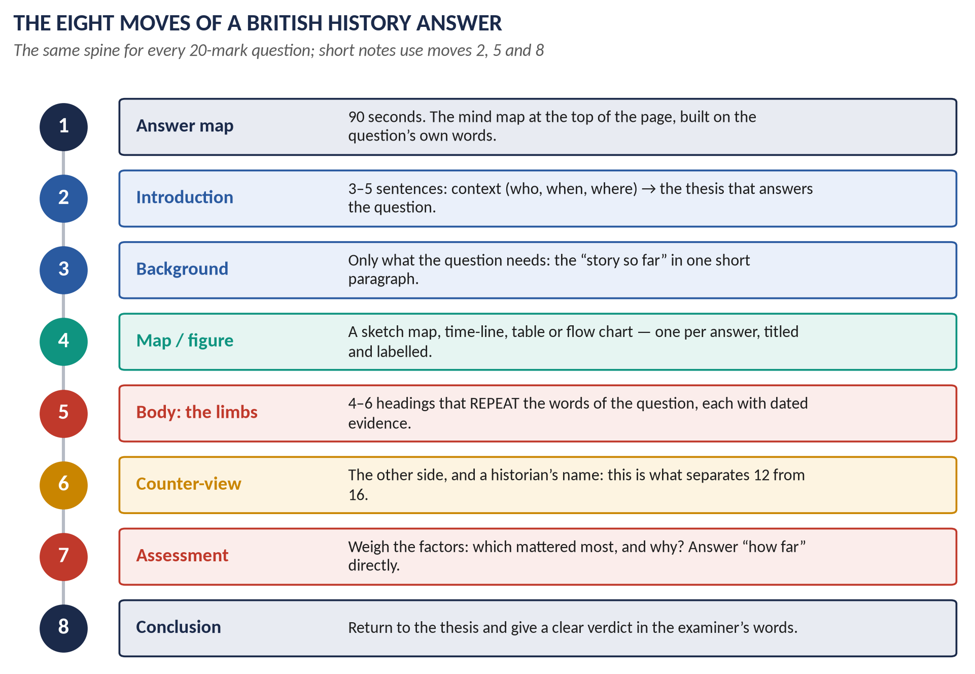
Figure 12 · The eight moves of a British History answer. Every model answer in the QA documents follows this spine.

Move 1 — the answer map (90 seconds)
At the top of the first page, draw the answer map: the question's key words in the centre, one branch for each heading you will write, two or three evidence points on each branch, and a one-line verdict. It forces you to plan, it shows the examiner your structure before he reads a word, and it protects the fourth answer from running out of time. Part 5.3 shows how to build one.

Move 2 — the introduction (3–5 sentences)
Set the scene (who, when, where) in one sentence, define any key term the question uses, and state your thesis — your answer to the question — in one sentence. Do not tell the story in the introduction.

Move 3 — the background (one short paragraph)
Only the background the question needs. For a question on the Reform Act of 1832, that is the unreformed system in five lines — not the history of Parliament since 1688.

Move 4 — the map or figure
One per answer. A sketch map for anything that happened somewhere (a war, a partition, an empire); a time-line for anything that unfolded over years; a table for any comparison; a flow chart for causes and consequences. Title it, label it, and refer to it in the text.

Move 5 — the body: the limbs of the question
Four to six headings. Each heading repeats words from the question (Part 5.5). Under each: a topic sentence that makes a point, then dated evidence, then a sentence that links back to the question.

Move 6 — the counter-view
The other side of the case, with a named historian where possible. This is what separates 12 from 16.

Move 7 — the assessment
Weigh the factors. Which mattered most, and why? If the question says "how far", answer it: largely, to a considerable extent, only partly, hardly at all.

Move 8 — the conclusion
Return to the thesis. Give the verdict in the examiner's own words. Two or three sentences; no new evidence.

5.3 The answer map — the house rule
The answer map is a mind map built from the words of the question. It is not a general diagram of the topic. Every branch must be traceable to a word or phrase in the question, so that anyone reading the map — even someone who knows no British history — can see exactly how the answer is organised and why.
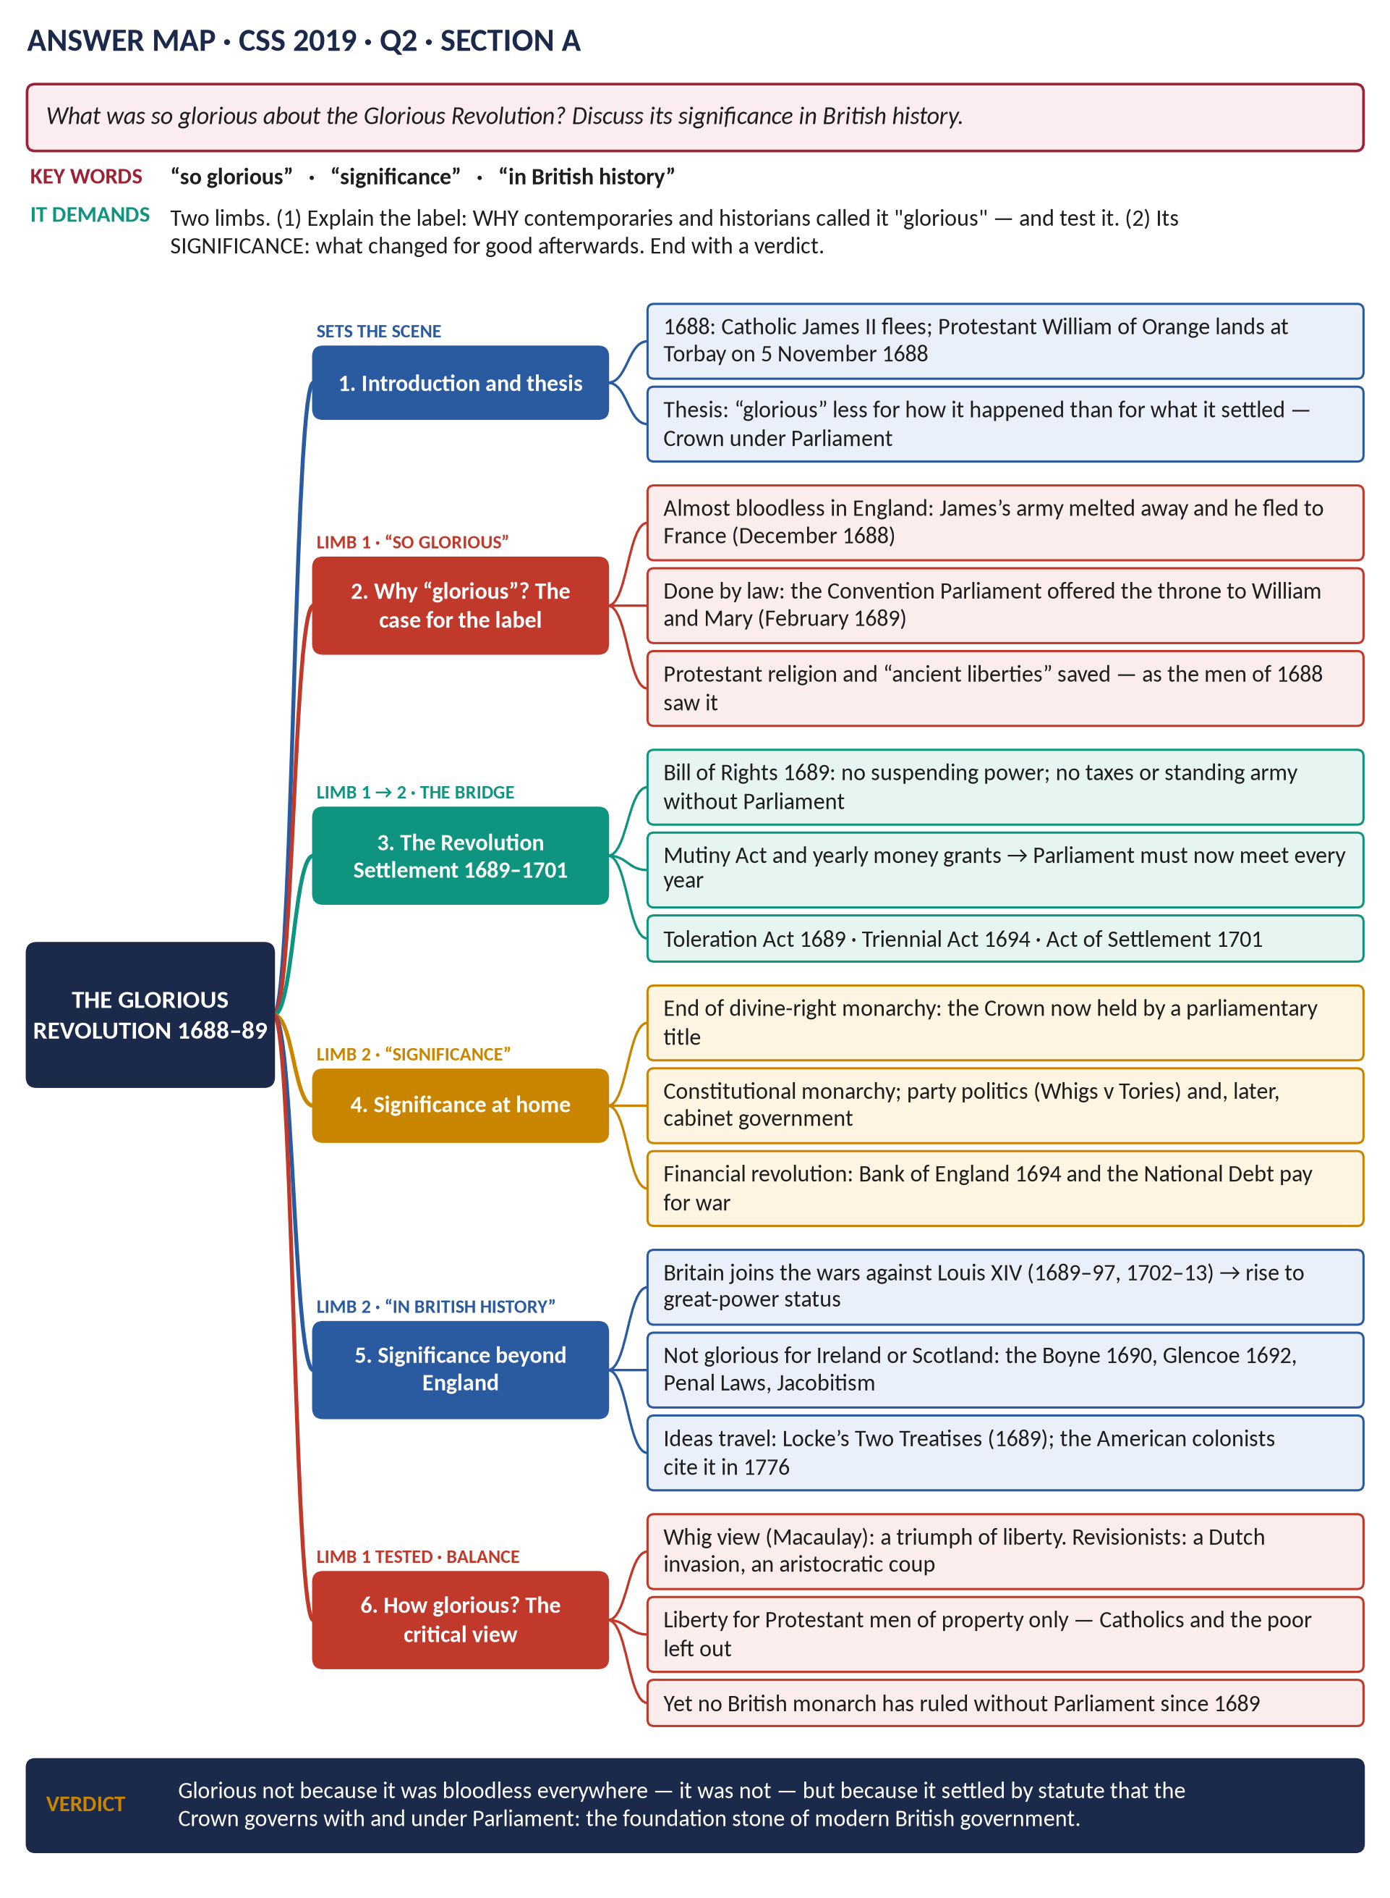
Figure 13 · A model answer map for CSS 2019 Q2. The coloured tags above each branch show which part of the question that branch answers.

How to build it — five steps
1. Underline the key words. In "What was so glorious about the Glorious Revolution? Discuss its significance in British history" they are so glorious, significance and in British history.
2. Count the limbs. Here there are two: explain and test the label "glorious"; then assess the significance.
3. Turn each limb into branches. Limb 1 becomes "why glorious — the case for" and "how glorious — the critical view"; limb 2 becomes "significance at home" and "significance beyond England". Add the introduction and a bridge branch (the settlement).
4. Hang two or three pieces of evidence on each branch — each with a date or a name.
5. Write the verdict in one line at the bottom, in the question's words.
THE RULE · Every answer map in this set follows six rules
One: the question is printed at the top, with its key words picked out. Two: a line says what the question demands. Three: every branch is numbered and matches a heading in the answer. Four: every branch is tagged with the limb of the question it answers. Five: every leaf is a full phrase with a date or name — no single words. Six: a verdict closes the map.

5.4 The introduction that earns marks
A good introduction does three jobs in about 80–100 words: context, definition, thesis.
THE EVIDENCE · Model introduction · CSS 2019 Q5 · "The Reform Act of 1832 made possible the series of political and administrative reforms that laid the foundation of modern Britain. Discuss."
Context: In 1832 the Whig government of Earl Grey, after a year of crisis and riots, carried the first Reform Act through a reluctant House of Lords. Definition: The Act abolished 56 rotten boroughs, gave seats to the new industrial towns and extended the vote to middle-class householders. Thesis: It did not create democracy — about four adult men in five still could not vote — but it broke the principle that the constitution could not be changed, and so made possible the reforming decade that followed and the Reform Acts of 1867, 1884 and 1918: in that sense it did lay the foundation of modern Britain.

5.5 Headings that repeat the question
The headings are the argument. An examiner skimming your headings should be able to see that you answered the question.
The question's words | Headings that echo them
"What were the merits and demerits of Whig rule? What led to the downfall of Whig ascendancy?" (2017) | (1) The Whig ascendancy, 1714–1760 · (2) The merits of Whig rule: stability, peace, prosperity · (3) The demerits: corruption, oligarchy, neglect · (4) What led to the downfall: George III, Bute, the King's Friends · (5) The downfall assessed · (6) Conclusion
"How far was the decline of the British Empire after 1945 the result of global pressures rather than internal political decisions?" (2026) | (1) The decline of empire, 1945–1980 · (2) Global pressures: the superpowers, the UN, nationalism, war debts · (3) Internal political decisions: Attlee, Macmillan, the end of national service, East of Suez · (4) Case one — India 1947 · (5) Case two — Suez 1956 · (6) Case three — Kenya and Africa 1960–63 · (7) How far? Weighing the two · (8) Conclusion

5.6 Evidence — and the historians worth quoting
Evidence is specific: a date, a law, a number, a name, a place. "The Reform Act gave more people the vote" is a claim; "the Reform Act raised the electorate of England and Wales from roughly 400,000 to about 650,000" is evidence.
Historians turn a narrative into an argument. You do not need many — one name and one idea per answer is enough — but they must be accurate. These are the ones that serve the most questions.
Historian | Topic | The idea to quote
Thomas Babington Macaulay, History of England (1848–61) | T1 | The Whig view: 1688 was the triumph of liberty that saved England from revolution.
G. M. Trevelyan, The English Revolution 1688–1689 (1938) | T1 | The Revolution was "glorious" because it was bloodless and conservative.
J. H. Plumb, The Growth of Political Stability in England 1675–1725 (1967) | T1, T2 | Stability after 1688 was made by Walpole's system of patronage and one-party rule.
Lewis Namier, The Structure of Politics at the Accession of George III (1929) | T2 | Eighteenth-century politics was about interest and patronage, not parties or principle.
Linda Colley, Britons: Forging the Nation 1707–1837 (1992) | T1–T3 | Protestantism, war with France and empire forged a British identity.
Eric Williams, Capitalism and Slavery (1944) | T2, T4 | Abolition came because slavery had become less profitable, not only from humanitarian motives.
Seymour Drescher, Econocide (1977) | T2, T4 | Against Williams: Britain abolished the slave trade when it was still profitable — a moral and political choice.
Edmund Burke and Thomas Paine (1790–92) | T3 | The two poles of the British debate on the French Revolution.
Élie Halévy (from 1913) | T3, T4 | Methodism channelled discontent into religion and helped Britain avoid revolution.
E. P. Thompson, The Making of the English Working Class (1963) | T3, T4 | The working class "made itself" in 1790–1830; Methodism was partly a "chiliasm of despair".
Eric Hobsbawm, The Age of Revolution (1962) | T3, T4 | The "dual revolution" — French political and British industrial.
T. S. Ashton, The Industrial Revolution 1760–1830 (1948) | T4 | The optimistic view: industrialisation raised living standards.
N. F. R. Crafts (1985) | T4 | Growth was slower and more gradual than "revolution" suggests.
Norman Gash, Sir Robert Peel (1972) | T5 | Peel as the founder of modern Conservatism who put nation before party.
Robert Blake, Disraeli (1966) | T5, T6 | Disraeli the opportunist genius who made the Conservatives a national party.
Robinson and Gallagher, "The Imperialism of Free Trade" (1953) | T6 | Britain preferred informal empire through trade; formal rule only when necessary.
George Dangerfield, The Strange Death of Liberal England (1935) | T7 | The Liberal Party was already dying before 1914.
Trevor Wilson, The Downfall of the Liberal Party 1914–1935 (1966) | T7 | The war, like a "rampant omnibus", ran the Liberals down.
A. J. P. Taylor, The Origins of the Second World War (1961) | T7, T8 | Hitler was an opportunist; appeasement was a rational policy that failed.
Correlli Barnett, The Audit of War (1986) | T8 | Attlee's "New Jerusalem" welfare state was bought at the cost of modernising industry.
Peter Hennessy, Never Again: Britain 1945–51 (1992) | T8 | The Attlee years as the foundation of post-war Britain.
John Darwin, Britain and Decolonisation (1988) | T8 | Empire ended through international, British and colonial pressures together.
Dean Acheson (1962) | T8 | "Great Britain has lost an empire and has not yet found a role."
Stuart Hall (1979) and Andrew Gamble, The Free Economy and the Strong State (1988) | T9 | Thatcherism combined a free market with a strong, authoritarian state.
Hugo Young, This Blessed Plot (1998) | T8–T10 | Britain's half-hearted relationship with Europe since 1945.
Anthony Giddens, The Third Way (1998) | T10 | The intellectual basis of New Labour.
The Chilcot Report (2016) | T10 | The UK went to war in Iraq before peaceful options were exhausted.

5.7 Maps and diagrams in a history answer
A map earns marks when it shows something the words cannot show as quickly — where the fighting was, what was gained, how a border moved. Draw it in three minutes with a pencil: outline, three to six labelled places, arrows for movement, shading for gains, a title and a key.

The twelve master maps to practise
# | Map | Answers questions on
1 | The British Isles 1688–1746 (Torbay, the Boyne, Glencoe, Culloden) | The Glorious Revolution, the Union of 1707, the Jacobites (T1, T2)
2 | Europe in the wars against Louis XIV (Blenheim, Utrecht gains) | Augsburg, Ryswick, the Spanish Succession (T1)
3 | The world in 1763 and the Thirteen Colonies | The Seven Years' War, Chatham, the American war (T2)
4 | Napoleonic Europe (Trafalgar, the Peninsula, Waterloo) | The French Revolution and Napoleonic Wars (T3)
5 | Industrial Britain c.1850 | The Industrial Revolution, Chartism (T4)
6 | Ireland 1798–1922 | The Union of 1801, the Famine, Home Rule, partition (T3, T5)
7 | The Ottoman Empire, the Straits and the Balkans in 1878 | The Eastern Question, Crimea, Berlin (T6)
8 | Europe's alliances 1902–1914 | Splendid Isolation and its end; the causes of WWI (T6, T7)
9 | Hitler's expansion 1936–1939 | Appeasement, the causes of WWII (T7, T8)
10 | The partition of India 1947 | Decolonisation (T8)
11 | Decolonisation by date (Asia, Middle East, Africa) | The end of empire, the Commonwealth, Suez (T8)
12 | The Falkland Islands and the South Atlantic 1982 | The Falklands War (T9)

Each map is drawn in full, with the three-minute sketch version, in the topic documents.

5.8 The counter-view and the verdict
The newest papers ask for judgement (Part 3.9). A judgement needs a method:
1. Name the factors. For "how far was X the result of Y?", Y is one factor; list the others.
2. Give each a fair case. Evidence for its importance, and its limits.
3. Rank them. Which was necessary? Which was sufficient? Which was the trigger, and which the underlying cause?
4. State the verdict in the question's words — "largely", "to a limited extent" — and give the single strongest reason.
VERDICT · A verdict is a sentence, not a shrug
Weak: "There were many factors, and all played their part." Strong: "Global pressures made the end of empire inevitable, but British decisions — above all Attlee's in 1947 and Macmillan's after 1959 — decided that it would come quickly and, outside Kenya and Aden, largely peacefully."

5.9 Short notes — ten marks each
A short note is not a short essay. It is a precise, dense summary in about 450–600 words, written in 17 minutes. Use five parts:
1. Definition or identification (1–2 sentences): who or what, when, where.
2. Background (2–3 sentences): why it came about.
3. Main features or events (the core, with dates): 4–6 points under a small heading or bold phrases.
4. Significance (3–4 sentences): what it changed, and why the examiner cares.
5. One-line assessment, with a historian or a quotation if you have one.
WHAT THE EXAMINER HAS ASKED · The short notes set in 2015–2026
Industrial Revolution · Methodist Movement (twice) · Jacobite Revolt · Second World War · Treaty of Berlin · Fabianism · Sir Winston Churchill · Britain's role in the EU · Lady Diana (twice) · Lord Kitchener · Suez Canal Crisis · Utilitarianism · Falkland War · Reforms under David Cameron (twice) · Creation of the Commonwealth · Impact of the French Revolution on the British economy and society · Britain's role in the War on Terror · John Major's foreign policy. Every one is answered in the QA documents.

5.10 Ten mistakes that cost marks
# | The mistake | The cure
1 | Writing the prepared answer to a different question | Build the answer map from the question's own words, every time.
2 | Ignoring the second limb of a two-part question | Count the limbs before writing; give each its own heading.
3 | Telling the story without an argument | State a thesis in the introduction; end with a verdict.
4 | No dates | Put a date in almost every evidence sentence.
5 | Wrong country name for the period | England before 1707; Great Britain 1707–1800; the UK from 1801.
6 | One-sided answers | Always a counter-view, with a historian where possible.
7 | A vague "how far" | Answer it in words of degree: largely, partly, hardly.
8 | Ignoring the requirement the question names | "Use regional examples" or "three cases" means exactly that.
9 | A brilliant first answer and a starved fourth | Watch the clock: 35 minutes each.
10 | Unlabelled or irrelevant maps | Title, labels, key — and refer to it in the text.

5.11 The objective part in thirty minutes
- Do the paper in one pass, answering everything you know at once; mark the rest.
- Return to the marked items with the remaining time. Eliminate options you know are wrong.
- If all three printed options are wrong, choose D "None of these". In 2024–2026 it was correct in 12 of 60 items.
- Exact dates matter. Several items test the day and month (28 June 1919; 2 June 1953; 18 June 1815; 11 December 1936). The One-Liner Bank in this set drills these.

Part Six — The Plan

6.1 A sixteen-week plan
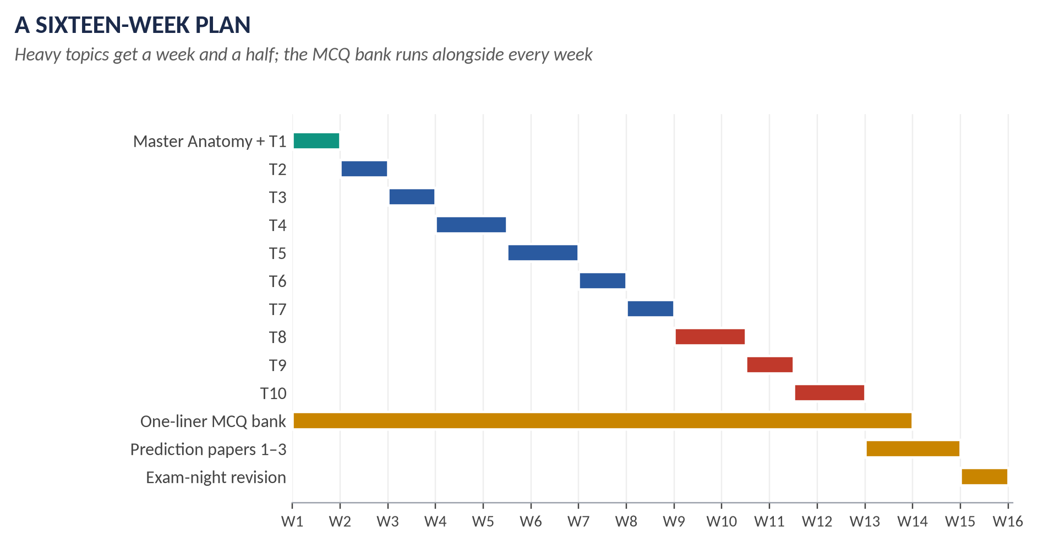
Figure 14 · Sixteen weeks from the first page to the exam. The heaviest topics (T4, T5, T8, T10) get a week and a half each.
Weeks | Topic | What to do
1 | Master Anatomy + T1 | Read Part Zero twice. Then T1KB; then T1QA. Draw the British Isles map from memory.
2 | T2 | T2KB, T2QA. Practise the Walpole answer under time (35 minutes).
3 | T3 | T3KB, T3QA. Learn the French-Revolution-in-Britain answer until you can plan it in 90 seconds.
4–5 | T4 | T4KB, T4QA. Three families: Industrial Revolution, Methodism, Chartism. Write one timed answer on each.
5–6 | T5 | T5KB, T5QA. Build the one-page reform time-line 1832–1928. Peel three ways.
7 | T6 | T6KB, T6QA. Splendid Isolation first; then Palmerston, the Eastern Question and Berlin.
8 | T7 | T7KB, T7QA. WWI and Labour; then the blind spots — Versailles and appeasement.
9–10 | T8 | T8KB, T8QA. Decolonisation with three cases; the Commonwealth; Churchill; Attlee.
10–11 | T9 | T9KB, T9QA. The Falklands map; Thatcherism defined; Europe to Maastricht.
11–12 | T10 | T10KB, T10QA. New Labour, the War on Terror, 2008, Cameron's reforms, Brexit, to 2026.
1–14 | One-Liner Bank | Twenty to thirty one-liners every day, from each topic as you finish it; the combined bank after week 12.
13–14 | Prediction papers | Sit Set 1 open-book, Set 2 closed-book untimed, Set 3 under exam conditions.
15 | Exam-night revision | The combined revision sheets; the Tier 1 families; the twelve master maps.
16 | Buffer | Illness, other papers, rest — or a second pass of Tier 1.

KEY IDEA · The one rule of the plan
Finish every topic's QA document before starting the next topic. Reading a Knowledge Base feels like progress; answering questions is progress. Each week should end with at least one answer written by hand under a 35-minute clock.

6.2 How to use each document

The Knowledge Base, in three readings
1. First reading — the story. Read the story section and the story boxes only. Look at every map. Do not take notes.
2. Second reading — the structure. Read everything. Fill in the blank time-line at the back from memory. Learn the key terms (crimson) and the dates (teal).
3. Third reading — the revision sheet. Read only the revision sheet, and test yourself with the topic's one-liners.

The Question Answers, in three passes
1. Read every answer with its answer map.
2. Re-draw the answer map for each question from memory, then check it.
3. Write at least two answers per topic by hand under the clock — then compare with the model.

6.3 The last fortnight
- Re-read Part Three of this document (the record and the tiers) and decide your Section B plan: which two of T8, T9, T10 families you will be strongest in, and which third you will be ready to fall back on.
- Re-draw the twelve master maps (Part 5.7) — one a day.
- Re-plan every Tier 1 family: 90 seconds each, from memory.
- Sit the three prediction papers under exam conditions.
- Drill the One-Liner Bank daily — especially exact dates.

6.4 The day of the paper
1. In the thirty-minute objective part, answer everything, then return to the marked items. Trust D when the options are all wrong.
2. In the first five minutes of Part II, read all seven questions. Tick the two you will answer in each section. For Section B, decide in the first minute.
3. Draw each answer map before writing that answer.
4. Keep to 35 minutes per answer. Check the clock at 1:05, 1:40, 2:15 and 2:50.
5. Spend the last five minutes checking that every heading echoes the question and every answer has a verdict.

6.5 After the ten topics
When all ten topics are finished, four combined documents will be built from them:
- The One-Liner Bank (OL) — all the topics' one-liner MCQs in one place, by topic.
- The QA print volume — only the questions and answers of all ten QA documents, in one Word file, with nothing else, for printing.
- The Exam-Night Revision (RN) — all ten revision sheets, each complete on its own.
- The Prediction Papers (PR) — three complete papers modelled on the record, each with full answer plans.

Appendix A — Every Descriptive Question, 2015–2026, by Year
The complete descriptive record as set, with each item's topic and family. "A" and "B" are the sections; in 2015, "P1" and "P2" are the two papers of the former scheme. Short-note options are marked.

2015 — the former two-paper scheme
Q | The question as set | Topic · family
P1 · Q2 | What forced James II to issue the various Declarations of Indulgence? | T1 · The Glorious Revolution
P1 · Q3 | Account for the War of the League of Augsburg followed by the Treaty of Ryswick. | T1 · William's and Anne's wars (Augsburg, Spanish Succession)
P1 · Q4 | Evaluate analytically and critically the role of Walpole as Secretary of State, Prime Minister, party organiser and financier. | T2 · Walpole and the Whig oligarchy
P1 · Q5 | Shed light on the American War of Independence with special reference to its debit side and credit side for Great Britain. | T2 · American War of Independence
P1 · Q6 | The short reign of William IV is considered to be the long era of bills and acts. Substantiate the statement with supportive arguments. | T5 · Parliamentary reform 1832–1928
P1 · Q7 | 'Palmerston was at once a Radical and Jingo, but at heart neither a Whig nor a Tory.' Elucidate. | T6 · Palmerston
P1 · Q8(a) | Short note: Industrial Revolution | T4 · The Industrial (and Agricultural) Revolution
P1 · Q8(b) | Short note: Methodist Movement | T4 · The Methodist Movement
P1 · Q8(c) | Short note: Jacobite Revolt of Scotland | T2 · The Jacobite risings
P2 · Q2 | Palmerston was conservative at home and liberal abroad. Discuss and conclude with arguments. | T6 · Palmerston
P2 · Q3 | Describe the emergence of the Methodist Movement in England. What were its good and bad effects on the people? | T4 · The Methodist Movement
P2 · Q4 | Analyze the characters and policies of Gladstone and Disraeli with special reference to foreign affairs. | T6 · Gladstone vs Disraeli; Disraeli abroad
P2 · Q5 | What was the background in the context of which the Crimean War broke out? Discuss and analyze the results that followed the cessation of hostilities. | T6 · The Eastern Question, Crimea, Berlin
P2 · Q6 | How has the idea of the British Commonwealth of Nations developed? In what ways does its significance differ from the term British Empire? | T8 · The Commonwealth
P2 · Q7 | Why did Britain adopt the Policy of Splendid Isolation from 1870 onwards in external affairs? How was this policy abandoned by the end of the 19th century? Discuss and analyze. | T6 · Splendid Isolation and its end
P2 · Q8 | Describe and critically analyze the foreign policy of England from 1919 to 1939. | T7 · Inter-war foreign policy and the League

2016
Q | The question as set | Topic · family
A · Q2 | What measures were adopted by England to check the influence of the French Revolution of 1789 on England? | T3 · The French Revolution and Britain
A · Q3 | Analyze critically the Reform Act of 1832. | T5 · Parliamentary reform 1832–1928
A · Q4 | 'Lord Palmerston was more successful as Foreign Minister than as Prime Minister.' Critically analyze. | T6 · Palmerston
A · Q5 | Explain the policy of Disraeli with special reference to 'Peace with Honour'. | T6 · Gladstone vs Disraeli; Disraeli abroad
B · Q6 | 'Margaret Thatcher is judged to be the best post-war Prime Minister of England.' Discuss. | T9 · Thatcher and Thatcherism
B · Q7 | Discuss the main features of the foreign policy of David Cameron with special reference to the Middle East. | T10 · David Cameron
B · Q8(a) | Short note: Second World War | T8 · The Second World War and Churchill
B · Q8(b) | Short note: Treaty of Berlin | T6 · The Eastern Question, Crimea, Berlin
B · Q8(c) | Short note: Fabianism | T4 · Ideas: Liberalism, Socialism, Utilitarianism, Fabianism

2017
Q | The question as set | Topic · family
A · Q2 | What were the merits and demerits of Whig rule? What led to the downfall of Whig ascendancy? Analyze comprehensively. | T2 · Walpole and the Whig oligarchy
A · Q3 | The Industrial Revolution drastically changed methods of production in England. How did it affect the social, economic, political and cultural life of the English people? | T4 · The Industrial (and Agricultural) Revolution
A · Q4 | Give a comprehensive account of the Chartist Movement. Why did it fail? Explain and analyse. | T4 · Chartism
A · Q5 | 'Gladstone's domestic policy was the climax of liberalism.' Discuss comprehensively. | T5 · Gladstone's domestic policy
B · Q6 | Explain the Eastern Question and critically analyse the attitude of England towards this question from 1820 to 1913. | T6 · The Eastern Question, Crimea, Berlin
B · Q7 | What do you understand by the British Commonwealth of Nations and how did it develop? How does it differ from the term British Empire? | T8 · The Commonwealth
B · Q8 | What are the advantages and disadvantages of Brexit for England? Analyse with arguments. | T10 · Brexit

2018
Q | The question as set | Topic · family
A · Q2 | What led to the occurrence of the ultra-degree of mega development towards the close of the 17th century in Britain known as the 'Glorious Revolution'? | T1 · The Glorious Revolution
A · Q3 | 'The 18th century witnessed the emergence, rise and growth of two movements (Agrarian and Industrial) which revolutionised the lives of the English people in particular and later the world in general.' Comment on the statement. | T4 · The Industrial (and Agricultural) Revolution
A · Q4 | Shed ample light on the interior as well as exterior policy of Sir Robert Peel as British Premier, with particular emphasis on the Irish issue. | T5 · Sir Robert Peel
A · Q5 | What measures were taken for the democratisation of the British Parliament over the decades? | T5 · Parliamentary reform 1832–1928
B · Q6 | How did Britain put a halt to the Policy of Splendid Isolation? What were its positive and negative aspects? | T6 · Splendid Isolation and its end
B · Q7 | Why is it believed in certain circles that after decolonisation Britain was subservient to the US line of action during the Cold War and thereafter, down to 9/11 and subsequent years? Do you agree or not? Argue. | T8 · The special relationship with the USA
B · Q8(a) | Short note: Sir Winston Churchill | T8 · The Second World War and Churchill
B · Q8(b) | Short note: Britain's role in the EU | T9 · Britain and Europe (EEC/EU)
B · Q8(c) | Short note: Lady Diana | T10 · Diana, Princess of Wales

2019
Q | The question as set | Topic · family
A · Q2 | What was so glorious about the Glorious Revolution? Discuss its significance in British history. | T1 · The Glorious Revolution
A · Q3 | What was the political and constitutional significance of the Hanoverian succession in England? | T2 · The Hanoverian succession
A · Q4 | Explain the factors that led to the Industrial Revolution and discuss how it affected the social, political, economic and cultural life of the English people. | T4 · The Industrial (and Agricultural) Revolution
A · Q5 | The Reform Act of 1832 made possible the series of political and administrative reforms that laid the foundation of modern Britain. Discuss. | T5 · Parliamentary reform 1832–1928
B · Q6 | How successfully did the Labour government of 1945–51 tackle the economic and social problems of post-World War II Britain? | T8 · Attlee’s Labour government 1945–51
B · Q7 | What were the motives behind Britain's move to decolonisation after 1945? Also explain why and how the British left India in 1947. | T8 · Decolonisation, India, Palestine, Suez
B · Q8 | Explain why John Major and the Conservatives won the general election of 1992 but lost the election of 1997. | T9 · John Major

2020
Q | The question as set | Topic · family
A · Q2 | What are the merits and demerits of the Whig oligarchy? Critically examine the causes of the downfall of Whig ascendancy. | T2 · Walpole and the Whig oligarchy
A · Q3 | Estimate the influence of the French Revolution on English society and political thought. | T3 · The French Revolution and Britain
A · Q4 | Give a history of parliamentary reforms between 1832 and 1928. Also critically examine how England became a politically democratic country. | T5 · Parliamentary reform 1832–1928
A · Q5 | 'Peel was the most liberal of conservatives and the most conservative of liberals.' Examine the statement critically. | T5 · Sir Robert Peel
B · Q6 | What do you know about the Middle East and Suez Canal Crisis? Also explain why England withdrew from Palestine and the Suez Canal. Discuss. | T8 · Decolonisation, India, Palestine, Suez
B · Q7 | What do you know about the League of Nations? Explain the work of the League. What were the causes of its failure? | T7 · Inter-war foreign policy and the League
B · Q8 | What were the causes of the Falkland War? In what way has it affected Britain's relationship with Latin American countries? | T9 · The Falklands War

2021
Q | The question as set | Topic · family
A · Q2 | What were the political and ideological differences among Non-Jurors, High Churchmen and Latitudinarians? | T1 · Church parties after 1688 (Non-Jurors, High Church, Latitudinarians)
A · Q3 | What were the political and constitutional causes and consequences of the Act of Union 1707? | T1 · Union of England and Scotland, 1707
A · Q4 | Provide a detailed account of the causes of World War I and its effects on the social and economic aspects of Britain. | T7 · The First World War and its effects
A · Q5 | What is the Edwardian era? Elucidate the rise and significance of the Labour Movement in the Edwardian era. | T7 · Edwardian era and the rise of Labour
B · Q6 | What was the Falkland Islands conflict? Why did the British invade the Falkland Islands and how did this war come to an end? | T9 · The Falklands War
B · Q7 | What was the contribution of Great Britain to the formation of the European Common Market and the European Union? Also highlight its impact on the foreign policy of Britain. | T9 · Britain and Europe (EEC/EU)
B · Q8 | What were the salient features of Tony Blair's policy on the War on Terror? How did his policy affect US-Britain relations? | T10 · The War on Terror

2022
Q | The question as set | Topic · family
A · Q2 | The domestic policy of Gladstone was the climax of liberalism during the 19th century. Discuss and analyze. | T5 · Gladstone's domestic policy
A · Q3 | 'A glorious success until 1761 and then failure.' Do you agree with this estimate of the career of Chatham? | T2 · Pitt the Elder (Chatham)
A · Q4 | Discuss the rise of the Labour Party in Britain and enumerate the achievements of this party. | T7 · Edwardian era and the rise of Labour
A · Q5 | Estimate the influence of the French Revolution on English society and political thought. | T3 · The French Revolution and Britain
B · Q6 | Explain the genesis of the Falkland War. How has it affected Britain's relationship with Latin American countries? | T9 · The Falklands War
B · Q7 | Discuss Winston Churchill as a statesman, warrior and a man of letters. | T8 · The Second World War and Churchill
B · Q8(a) | Short note: Lord Kitchener | T7 · The First World War and its effects
B · Q8(b) | Short note: Suez Canal Crisis | T8 · Decolonisation, India, Palestine, Suez
B · Q8(c) | Short note: Utilitarianism | T4 · Ideas: Liberalism, Socialism, Utilitarianism, Fabianism

2023
Q | The question as set | Topic · family
A · Q2 | How did the Glorious Revolution occur in Britain? What was its fallout at home and abroad? | T1 · The Glorious Revolution
A · Q3 | 'The English people got so much frightened by the developments in France that there prevailed a sort of panic across the country.' Analyse the after-effects of the French Revolution on England. | T3 · The French Revolution and Britain
A · Q4 | Why did Britain initiate the Policy of Splendid Isolation? What is your personal opinion whether it was a right step in the right direction or proved detrimental? | T6 · Splendid Isolation and its end
A · Q5 | According to Rudyard Kipling, 'however the world pretends to divide itself, there are only two divisions in the world today — human beings and Germans.' In the light of this statement, was British policy in the First World War justified or not? Comment. | T7 · The First World War and its effects
B · Q6 | Produce an analytical essay on the causes, major developments and aftermath of the Second World War. | T8 · The Second World War and Churchill
B · Q7 | 'We will find those who did it, we will smoke them out of their holes, we will get them running and we will bring them to justice.' In the context of this remark, present a balanced critique of the War on Terror with special emphasis on the role of Great Britain. | T10 · The War on Terror
B · Q8 | How did the global financial crisis plunge Britain into recession in the 21st century and how did it respond? | T10 · The 2008 financial crisis

2024
Q | The question as set | Topic · family
A · Q1 | How far did Robert Peel's methods of governance differ from those of his predecessors, viz. Liverpool, Canning and Wellington? | T5 · Sir Robert Peel
A · Q2 | Define the 'Irish Question'. Also discuss the policy of the Liberal Party on the said issue from 1886 to 1894. | T5 · The Irish Question and Home Rule
A · Q3 | Describe the reasons due to which millions of people united in support of the Chartist Movement in the mid-19th century to attain democratic rights for the working classes. | T4 · Chartism
A · Q4 | How did the Methodist Movement begin? Also explain its salient features and reasons for success. | T4 · The Methodist Movement
B · Q5 | Define the term 'Thatcherism'. Discuss Margaret Thatcher's economic and educational reforms and their impacts on people's lives. | T9 · Thatcher and Thatcherism
B · Q6 | How did World War II and the Cold War trigger the decolonization of the British Empire? | T8 · Decolonisation, India, Palestine, Suez
B · Q7(a) | Short note: Falkland War | T9 · The Falklands War
B · Q7(b) | Short note: Reforms under David Cameron | T10 · David Cameron
B · Q7(c) | Short note: Creation of the Commonwealth | T8 · The Commonwealth

2025
Q | The question as set | Topic · family
A · Q2 | Discuss the significance of Queen Anne's reign in shaping the course of the War of Spanish Succession and its impact on the balance of power in Europe. | T1 · William's and Anne's wars (Augsburg, Spanish Succession)
A · Q3 | Analyze the controversies surrounding the Act of Union 1801, focusing on the differing perspectives of Irish and British politicians. Assess its impact on Irish nationalism and the stability of the United Kingdom. | T3 · Union with Ireland, 1801
A · Q4 | Examine the evolution of party politics in Britain during the 19th century, focusing on the rise of the Conservative and Liberal parties, and the changing relationship between government, parliament and the electorate. | T5 · Rise of the Conservative and Liberal parties
A · Q5 | Compare and contrast the ideologies of Socialism and Liberalism in Britain during the 19th century, examining their differing approaches to issues such as economic inequality, social justice and the role of the state. | T4 · Ideas: Liberalism, Socialism, Utilitarianism, Fabianism
B · Q6 | How did the policies of New Labour under Tony Blair differ from those of previous Labour governments? Was it a continuation of Thatcherism by other means, or did it represent a distinct political project? | T10 · Blair and New Labour
B · Q7 | How did the global financial crisis of 2008 impact British politics and society? How did the responses of the Labour and Conservative governments differ, and what were their long-term effects? | T10 · The 2008 financial crisis
B · Q8(a) | Short note: Impact of the French Revolution on the British economy and society | T3 · The French Revolution and Britain
B · Q8(b) | Short note: Methodist Movement | T4 · The Methodist Movement
B · Q8(c) | Short note: Reforms under Cameron Government | T10 · David Cameron

2026
Q | The question as set | Topic · family
A · Q2 | Examine the complex relationships between abolition, imperialism, and economic interests, and argue for or against the notion that Britain's anti-slavery movement was a thinly veiled justification for colonial expansion. | T2 · Slavery, abolition and empire
A · Q3 | Critically evaluate the extent to which the Industrial Revolution transformed British society more through disruption than through progress. Use regional examples to support your argument. | T4 · The Industrial (and Agricultural) Revolution
A · Q4 | How far was the decline of the British Empire after 1945 the result of global pressures rather than internal political decisions? Support your analysis with at least three major real end-of-decolonisation cases. | T8 · Decolonisation, India, Palestine, Suez
A · Q5 | Critically evaluate the effects of World War I on British social structure, industrial relations, and the polity, highlighting the ways in which the war accelerated the decline of the Liberal Party and paved the way for Labour's rise to power. | T7 · The First World War and its effects
B · Q6 | Discuss the impact of European integration on British politics and identity since 1973, with particular reference to the debates surrounding the Maastricht Treaty and the UK's opt-out from the euro. | T9 · Britain and Europe (EEC/EU)
B · Q7 | From 1997 to 2012, Britain saw dramatic shifts in foreign policy, constitutional reform and international identity. Assess whether the period should be interpreted as one of renewal or of unresolved contradictions in British governance. | T10 · Blair and New Labour
B · Q8(a) | Short note: Britain's role in the War on Terror | T10 · The War on Terror
B · Q8(b) | Short note: Lady Diana Spencer | T10 · Diana, Princess of Wales
B · Q8(c) | Short note: John Major's foreign policy | T9 · John Major

Appendix B — The Objective Papers, 2024–2026
All sixty recoverable MCQs, with their keyed answers and topics. Where the printed options did not contain the correct answer, the key is "None of these" with the fact supplied.

2024 objective paper
# | Stem | Keyed answer | Topic
1 | Who is the longest-serving British Prime Minister? | A. Robert Walpole | T2
2 | The British colony of Singapore was established as a trading post along which important maritime route? | B. Strait of Malacca | T6
3 | The “Scramble for Africa” refers to the period of intense European colonial expansion in Africa during which centuries? | C. 19th and 20th centuries | T6
4 | What is the highest rank in the British nobility? | B. Duke | G
5 | The Treaty of Versailles was signed on: | C. 28 June 1919 | T7
6 | How many British Prime Ministers served during World War I? | A. Two — H. H. Asquith and David Lloyd George | T7
7 | Which adjective is commonly associated with London in the 1960s? | C. Swinging | T8
8 | The Act of Union between England and Scotland took effect in: | B. 1707 | T1
9 | Who succeeded Margaret Thatcher as Prime Minister? | D. None of these — John Major | T9
10 | Which Prime Minister sent British troops to Iraq in 2003? | B. Tony Blair | T10
11 | The Bank of England was nationalised in: | B. 1946 | T8
12 | Queen Elizabeth II was crowned on: | A. 2 June 1953 | T8
13 | Who was the British monarch during the American Revolutionary War? | C. George III | T2
14 | Apartheid was implemented in which African country? | B. South Africa | T8
15 | The Battle of Waterloo was fought on: | A. 18 June 1815 | T3
16 | Which of the following was not part of the British Empire? | B. Spain | G
17 | The early Victorian Anglo-Russian rivalry known as the “Great Game” was: | D. None of these — it was a wider geopolitical rivalry in Central Asia | T6
18 | The League of Augsburg was signed in: | D. None of these — the League was formed in 1686 | T1
19 | Who was the longest-reigning Hanoverian monarch? | D. None of these — Queen Victoria | T5
20 | King Edward VIII announced his abdication from the British throne on: | C. 11 December 1936 | T7

2025 objective paper
# | Stem | Keyed answer | Topic
1 | What key document affirmed parliamentary supremacy after the Glorious Revolution? | B. Bill of Rights | T1
2 | Which dynasty came to power after the Glorious Revolution? | D. None of these — William III of Orange and Mary II (a Stuart) reigned jointly; the Hanoverians began in 1714 | T1
3 | What was the primary cause of the Jacobite rebellions? | D. None of these — the central issue was the Stuart dynastic claim, intertwined with religion | T2
4 | Which issue most directly led to the American War of Independence? | B. Taxation | T2
5 | The Act of Union between England and Scotland was passed in: | B. 1707 | T1
6 | Which religious movement emphasised personal piety and social reform? | C. Methodism | T4
7 | What was the main political demand of the Chartists? | B. Universal male suffrage | T4
8 | Which Prime Minister repealed the Corn Laws? | C. Robert Peel | T5
9 | Which monarch gave the Edwardian era its name? | C. Edward VII | T7
10 | Which economic policy dominated Victorian Britain? | B. Free trade | T5
11 | Which British Prime Minister made the “Iron Curtain” speech famous after Winston Churchill used the term? | D. None of these — Winston Churchill himself delivered the famous 1946 Fulton speech | T8
12 | What was Britain's policy toward Nazi Germany in the late 1930s called? | C. Appeasement | T7
13 | What is the process by which former colonies gained independence called? | C. Decolonization | T8
14 | Which Prime Minister is most closely associated with large-scale privatisation of British industries? | A. Margaret Thatcher | T9
15 | Which party governed under Tony Blair? | B. Labour Party | T10
16 | What was the codename for the Dunkirk evacuation? | B. Operation Dynamo | T8
17 | What was the German bombing campaign against Britain during World War II called? | A. The Blitz | T8
18 | The global economic downturn beginning in 2008 is generally called the: | B. Financial Crisis | T10
19 | Which group led the major 1984–85 industrial action? | A. Miners | T9
20 | David Cameron formed which type of government in 2010? | B. Coalition government | T10

2026 objective paper
# | Stem | Keyed answer | Topic
1 | Which monarch ruled jointly with William III after 1689? | D. None of these — Mary II | T1
2 | The Act of Settlement 1701 secured the crown for which house? | A. Hanover | T1
3 | The Seven Years’ War established British dominance over: | C. French North America | T2
4 | Who was Prime Minister during the American Declaration of Independence? | B. Lord North | T2
5 | The Act of Union 1801 created the United Kingdom of: | C. Great Britain and Ireland | T3
6 | The Peterloo Massacre occurred in which city? | D. None of these — Manchester | T5
7 | The Irish Famine was chiefly caused by the failure of which crop? | C. Potato | T5
8 | Women over the age of 30 first gained the parliamentary vote in: | D. None of these — 1918 | T5
9 | Who was Prime Minister during the Winter of Discontent? | B. James Callaghan | T8
10 | Britain’s first female Prime Minister belonged to which party? | C. Conservative | T9
11 | The Good Friday Agreement addressed conflict in: | B. Northern Ireland | T10
12 | The London 7/7 bombings occurred in: | D. None of these — 2005 | T10
13 | The 2010 coalition government joined the Conservatives with: | C. Liberal Democrats | T10
14 | The American War of Independence ended with the: | A. Treaty of Paris 1783 | T2
15 | The French Revolution led to Britain: | D. None of these — revolutionary France declared war on Great Britain on 1 February 1793 | T3
16 | The Reform Act 1832 extended political representation mainly to: | C. Middle-class men | T5
17 | The Crimean War was fought by Britain against: | A. Russia | T6
18 | The policy of appeasement is most closely associated with: | B. Neville Chamberlain | T7
19 | The Suez Crisis resulted in: | A. British withdrawal | T8
20 | The 2010–15 coalition government was led by: | A. David Cameron | T10

Appendix C — Sources and Editorial Note
NOTE · Sources for the record
Descriptive papers: the transcriptions in CSS British History — Descriptive Past Papers 2015–2026 (in the BH_PP_Past Papers folder of this set), compiled from FPSC paper scans mirrored by VShyne, CSS Aspirants, PakExam, Legalversity and CSSMPT. Objective papers: CSS British History — Solved Objective Papers 2015–2026 (same folder); only 2024, 2025 and 2026 are complete. Syllabus: FPSC, Revised Scheme and Syllabus for CSS Competitive Examination (CE-2016 and onwards), pp. 44–46.

NOTE · Maps and data
The historical boundaries on the maps are drawn from the open historical-basemaps project (A. Ourednik) and Natural Earth; they are simplified for teaching and should not be read as exact legal borders. All counts, tables and charts in this document are computed from the tagged record, so every number can be traced back to Appendix A.

NOTE · Accuracy and currency
Facts after 2012 are stated as of September 2026. The instructions printed on the paper in the examination hall are the only authority on how many questions to attempt and from which sections.

